Whale Type | Feeding Strategy | Scenario
Blue Whale  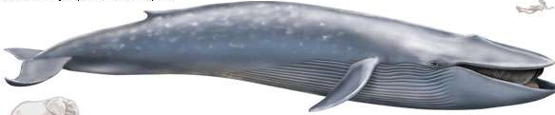 | Baleen | The blue whales tried to eat a plastic bag, which got caught in their throats, so now it is difficult to swallow. Blue whale players must put one hand around their throat and may use their one free hand to pick up AND hold their beads.
Gray Whale  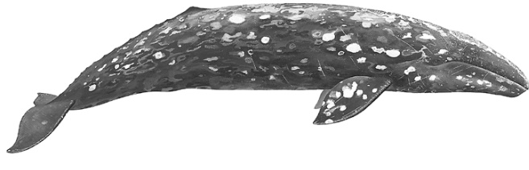 | Sucker | The gray whale mistook microplastics for food and ingested them! The grey whale has a stomach ache and has slowed down tremendously, to symbolize this, grey whale players must count 3 ‘mississippis’ before grabbing each bead.
Humpback Whale  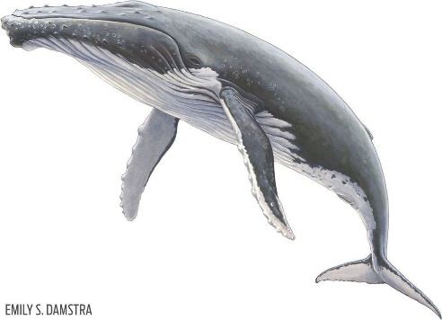 | Gulper | The humpback whale got its tale tangled in plastic fishing line leftover from old fishing boats. To symbolize this, humpback whale players must hop on one foot during the next round.
Minke Whale  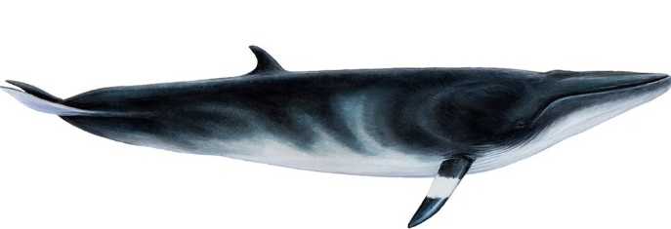 | Lunge Feeder | The minke whale swam into a six-pack ring and got its fin stuck. Minke Whale players must keep their little fingers clasped together behind their backs during the next round, even while picking up the beads.
Killer Whale  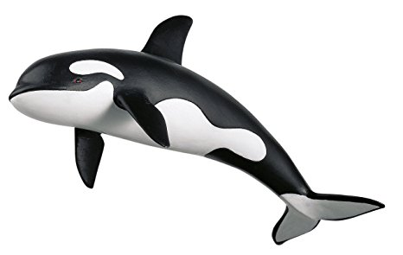 | Toothed Whale | The killer whale were curious about something they saw floating in the water and got tangled in a plastic strap. To symbolize this, killer whale players must grab their ankles with their hands and waddle (they can still use their hands to pick beads up).

