Systems Thinking Workshop
Concept Cheat Sheet
Distinctions: how we draw or define the boundaries of an element or a system of elements. This boundary defines what is and what is not that element or system.
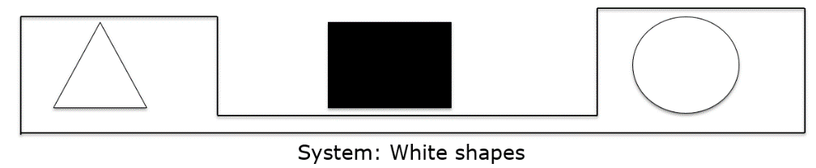
Relationships: help us understand how the elements within a system interact with each other.
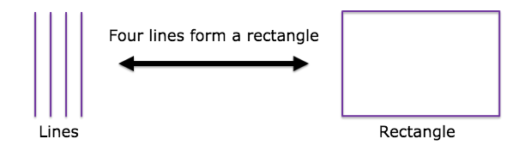
Perspectives: a particular point of view that we use to understand a system.
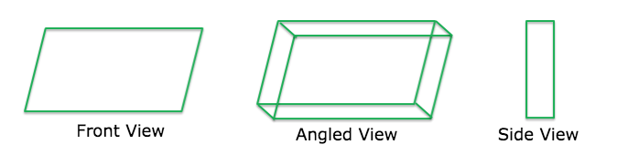
Emergent Properties: things that a whole system can do, but that its elements cannot do by themselves.
Subsystems: smaller systems that together make up a larger system.
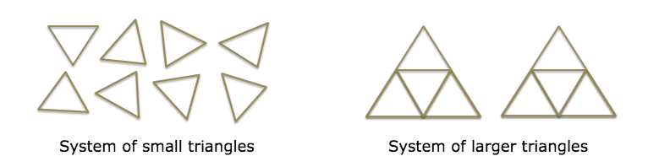
Patterns: exist within systems. Patterns can help us predict what will happen in a system.

