Spaghetti Quake Activity

Lesson Summary
Learn about earthquake magnitude by breaking different size bundles of uncooked spaghetti noodles. Short classroom activity for grades 4 and up emphasizes the difference between magnitudes.

Materials
5 32 oz. packages of spaghetti noodles, calculator, measuring tape

Next Generation Science Standards: Performance Expectations and Crosscutting Concepts

Performance Expectations | Crosscutting Concepts
2-ESS1-1. Use information from several sources to provide evidence that Earth events can occur quickly or slowly.  MS-ESS2-2. Construct an explanation based on evidence for how geoscience processes have changed Earth’s surface at varying time and spatial scales.  HS-ESS2-2. Analyze geoscience data to make the claim that one change to Earth’s surface can create feedback(s) that cause changes to other Earth systems. | 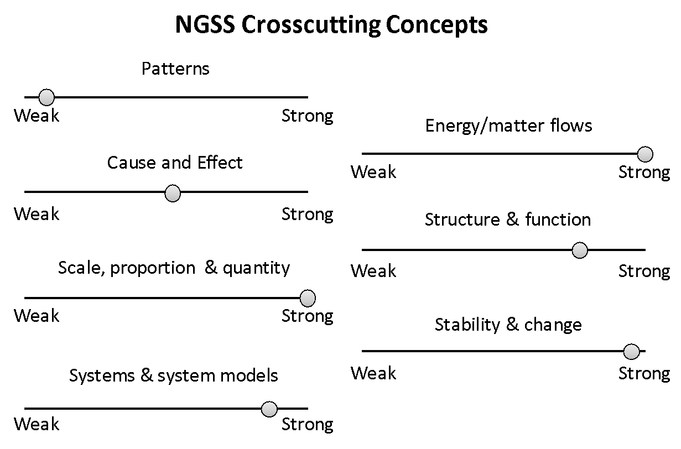
Strong connection to crosscutting concepts means that the activity has clear connections that are exemplars of the crosscutting concept. A weak connection indicates that there is either no part of the crosscutting concepts applies to the activity or the activity would have to be modified to develop these connections.

Introduction
The severity of an earthquake can be expressed in terms of both intensity and magnitude. However, the two terms are quite different, and they are often confused.
Intensity is based on the observed effects of ground shaking on people, buildings, and natural features. It varies from place to place within the disturbed region depending on the location of the observer with respect to the earthquake epicenter, the local geology and the size and depth of the earthquake.
Magnitude is related to the amount of seismic energy released at the hypocenter of the earthquake. It is based on the amplitude f the earthquake waves recorded on instruments, which have a common calibration. The magnitude of an earthquake is thus represented by a single, instrumentally determined value.

Procedure
- Hold up one piece of spaghetti. Bend the piece between your hands until it breaks. Notice the work it takes to break the spaghetti. Call this a 5 on the Pasta Magnitude scale (M5). Now ask, “What would you need to multiply this single piece of spaghetti by to equal a Pasta Magnitude 6? (The answer is 32.)

