<<School>> SMILE Club

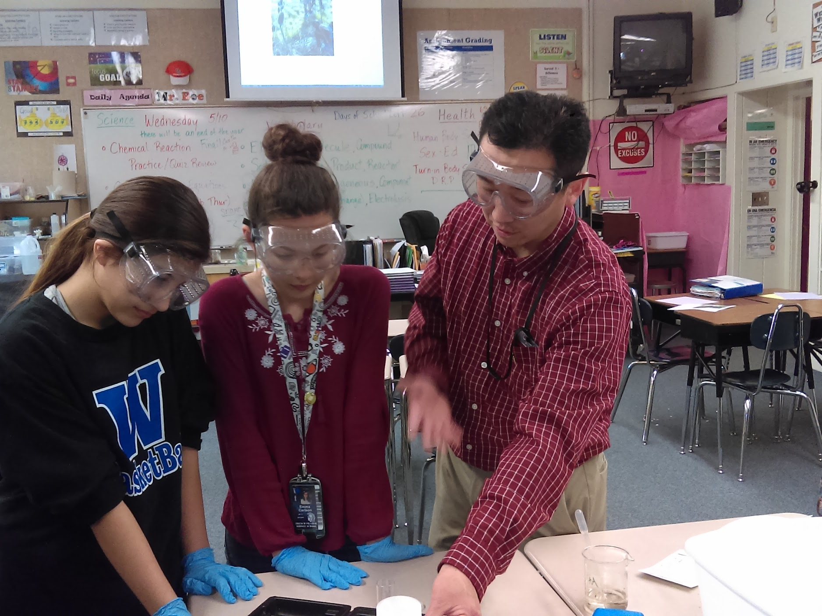
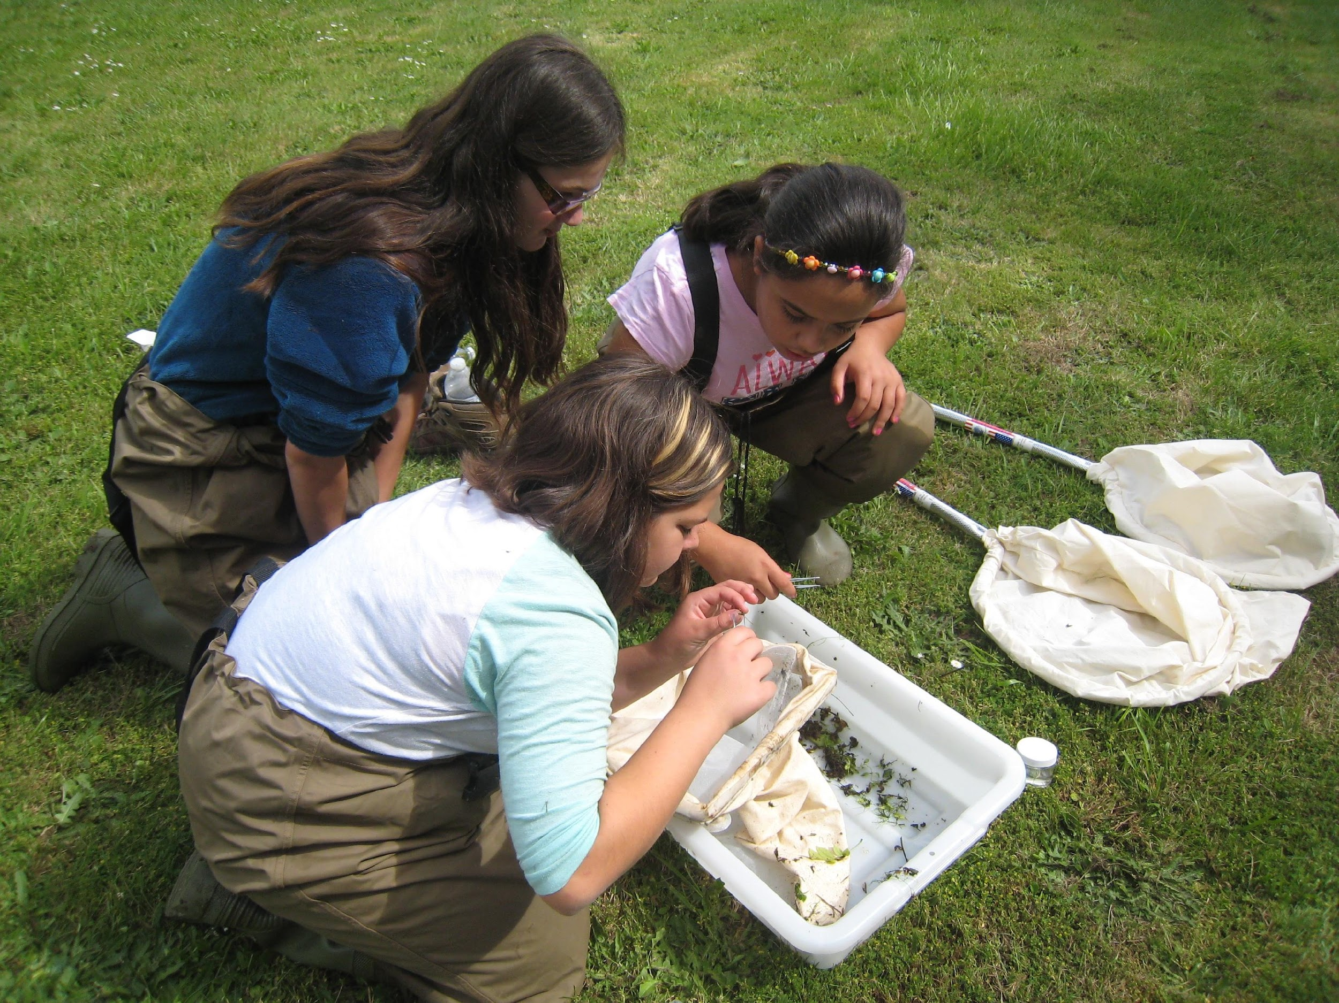
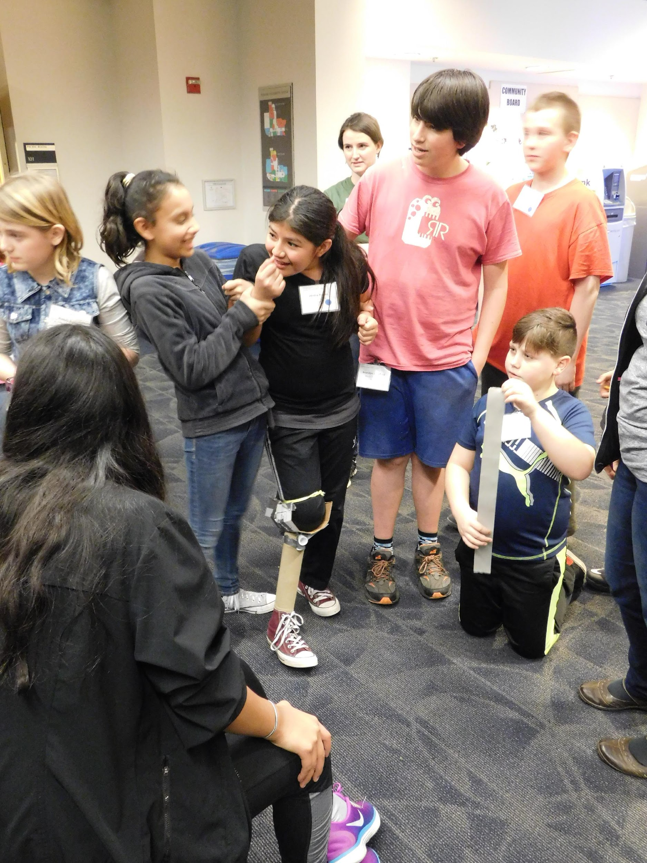

- Do you want to be part of an awesome after-school club?
- Do you want to do hands-on science activities?
- Do you want to visit a college campus?
Join us for an Informational Meeting!
Where: <<School name, room>>
When: <<Time and date>>
For more information: Email <<Teacher’s email address>>

