Tracking Ice

Sea ice is frozen seawater. It only forms on seas when temperatures are cold enough to cool the surface water to 28°F. The freezing point of seawater is lower that fresh water because it contains salt and other impurities. The Arctic and Southern Oceans are remote and difficult to travel in, because they are ice covered. Hence autonomous drifters (which may also be called buoys because they drift with the ocean) with a variety of sensors are used to study these regions. These drifters are placed on ice and drift across the ocean with the ice.
Drifters provide data to scientists and the public in the comfort of their homes or offices. This is achieved by relaying data through a satellite link. The drifters must track their position accurately, which is achieved with the global positioning system (GPS). We can use GPS drifters to understand the movement of the sea ice pack. In parts of the polar regions where humans are active it is very important to know the location of ice and where it will drift. Ice is a hazard to ships and structures in the ocean. Ice is often collocated with resources humans are interested in. For example: hunters hunt walrus on ice; Bering sea crabbers work at the ice edge where crabs are plentiful; the Barents and Kara seas have oil platforms in regions of drifting pack ice. Accurate forecasts of ice drift can protect people and their property in the Arctic.
This set of lessons will guide the class through building a sea ice drift forecast, using the same near-real time data available used by research scientists and operational forecasting centers. Students will estimate the accuracy of their forecast and determine if it is fit for the purpose of guiding a search and rescue.

Skills used in these lessons
Trigonometry: Finding distances given angle and one length.
Vectors: Calculating speeds and bearings.
Statistics: Calculating mean, visualizing normal distributions.
Pre-Calculus: Estimating a gradient.
Physics: Velocity and Newton’s Laws.

Skills developed
- Utilizing fundamental math concepts in the real world.
- Using excel to explore and manipulate data.
- Assessing accuracy of a calculation or estimate.

Above grade level knowledge provided at an introductory level
- Introducing some statistical concepts such as standard deviation and root mean square error.

Preparation

You are welcome to contact MOSAiC educational office, the SMILE program or Jenny Hutchings (hutchije@oregonstate.edu) to adopt a buoy to track during your class. We will provide information about the buoy and a scientist to contact. The class can track this buoy, and the science campaign it is involved in for weeks or months to come.

Alternatively, you can choose your own buoy to adopt from http://iabp.apl.washington.edu/maps_daily_table.html
Make sure you choose a buoy that is currently active from the green table that is titled “Arctic Buoys Reporting Over the Last Week”.

We recommend that you try out the exercises in lesson 2 with this buoy to make sure there are no issues with the data before class.

Preparation for demonstration in module 1
Materials required: Fan, tub, water and two foam blocks of equal dimension.
Cut one foam block into pieces.
Fill a tub with water and use the fan to blow the solid block and broken blocks (placed in the water initially as a if they were not broken) across water.
Module 1: Sea Ice Drift Physics (Student handbook pages 1-3)

10 minutes Introduction to sea ice
(Student handbook pages 1-3)

⇒ Slides provided: Intro Sea Ice (Section 1.1 of SMILE_Highschool_TrackingIce_Slides.pptx)

- Introduction to what sea ice is and where it is found

10 minutes Demonstration of sea ice and drag
(Student handbook pages 1-3)

Set up a flat Styrofoam ice sheet and individual Styrofoam ice floes (small cubes cut out of the same amount of material as the flat sheet) in a tub of water with a fan directing wind at the Styrofoam ice. Pay attention to the difference between the flat sheet and collection of floes being blown across the water. Do you see that the floes are rougher and move more? Wind moves the ice and ocean under the ice.

- What causes the ice to move?

Newton’s first law: Every object in a uniform state of motion will remain in that uniform state of motion unless an external force acts on it.

- Wind is the primary driver of sea ice motion.
- Ocean currents can also be a driving force, but in this demonstration the water is still to start. The wind might force the water as well as the ice in the demonstration.
- The wind imparts momentum in the ice. Momentum is mass times acceleration. The ice accelerates from stationary to drift across the water.

Newton’s second law: Force equals mass times acceleration, F = ma.

- As floes jostle together they impart momentum to each other and lose kinetic energy to friction in the jostling. There is a force due to this jostling that is analogous to pressure in a fluid. This is included as an ice interaction term in the force balance.
- Draw an example force balance on the board, once the ice has reached a steady speed, with wind stress opposed by the sum of ocean drag and ice interaction force.

Newton’s third law: For each action there is an equal and opposite opposing action.

20 minutes Description of ice drift physics and how to measure ice drift (Student handbook pages 1-3)

⇒ Slides provided: Sea Ice Drift (Section 1.2 of SMILE_Highschool_TrackingIce_Slides.pptx)

- History of the study of Arctic sea ice drift
- Modern study and monitoring of sea ice drift
- Discussion of a modern drift experiment.

Optional Discussion of how GPS works and its accuracy
(Student handbook pages 1-3)

⇒ Slides provided: (1.2supplimental_GPS.pptx)

10 minutes Download and look at drifting buoy data (SH: 2-3)
(Student handbook pages 1-3)

- Introduce the International Arctic Buoy Programme (IABP) buoys.
  - Buoys take measurements of temperature, pressure, location and report to global weather forecasts

⇒ How-to notes provided: Download Data (1.3_HowToDownloadData.docx)
∗ A copy of this worksheet is provided in student handbook (pages 2-3)

- Either teacher led, or students can perform task if they have a computer or tablet.

- Instructions provided in student handbook.

Module 2: Working with Data (Student handbook pages 4-18)

5 minutes Introduction to Forecast Models
(Student handbook pages 1-3)

⇒ Slides provided: Forecast Models (Section 2.1 SMILE_Highschool_TrackingIce_Slides.pptx)

- Introduce the concept of a forecast model. The simplest model is the same will happen today as happened yesterday. This forecast is known as ‘persistence’. For weather this is correct ~60% of the time.
10 minutes Velocity Calculations.
(Student handbook pages 1-3)

⇒ Notes provided: Calculating Velocity (2.2_NotesOnCalculatingVelocity.docx)

- Introduce on board how to calculate velocity.

5 minutes Speed and Bearing Calculations. (SH: 4-6)

⇒ Notes provided: Speed and Bearing (2.3_NotesSpeedAndBearing.docx)
∗ Only section 1 of this worksheet should be covered here. Section 2 covered later.
∗ Section 1 of this worksheet provided in handbook (pages 4-6)
∗ Section 2 of this worksheet provided in handbook (pages 14-15)

- Show how to make a speed and bearing estimate in a cartesian frame of reference (Section 1). Use this to determine where a buoy will drift to in a given time (Section 2).

10 minutes Working with Geographic Data. (SH: 7-10)
(Student handbook pages 1-3)

⇒ Notes provided: Working with geographic data (2.4_GeographicData.docx)
∗ A copy of this worksheet is provided in student handbook (pages 7-10)

- Latitude and longitude
- Visualize the trajectory on a globe. Introduce meridional (south to north) and zonal (west to east) directions. Consider various ways of estimating distance and bearing.
- Calculating meridional and zonal distances.
5 minutes Linear Approximation (SH: 11-13)
(Student handbook pages 1-3)

⇒ Worksheet provided: linear approximation (2.5_LinearApproximation_worksheet.docx)
∗ A copy of this worksheet is provided in student handbook (pages 11-12)
∗ Space to solve this worksheet is provided in student handbook (page 13)
⇒ Worksheet example solution: (2.5_LinearApproximation_worksheet_solution.docx)

This exercise can be extended to multiple calculations, forecasting at many times along a buoy track, using excel.

⇒ Excel How-To Note Sheet: (2.5supplimental_HowToWriteEquationsInExcel.docx)
∗ Briefly walks students through making equations in excel so they can write their own models if they choose.

⇒ Excel Worksheet: (2.5supplimental_LinearApproximation_worksheet_extension.docx)
∗ Development instructions for building a linear approximation model in excel.

- A buoy track is split into piecewise linear sections such that distance along parts of the trajectory can be estimated by trigonometry given the difference in latitude and longitude. This will require students to find the angles.

- First a linear approximation for the buoy track is taken, and distance and bearing of the buoy estimated.

- Discuss the distance of trajectory you might consider using to determine speed and bearing for your forecast. How does accuracy change with increasing time between position measurements?

- The exercise can be extended to calculate distance travelled assuming piecewise linear approximation to the buoy track, using excel. This will provide a more accurate distance estimate.

- If you wish to compare the linear approximation to a great circle distance (which is calculated with spherical trigonometry assuming d is along a section of a circle, not linear) you may use the online calculator: http://www.onlineconversion.com/map_greatcircle_distance.htm

5 minutes Buoy Drift Forecast (SH: 14-18)
(Student handbook pages 1-3)

⇒ Notes provided: Speed and Bearing (2.3_NotesSpeedAndBearing.docx)
∗ Section 2 of this worksheet provided in handbook (pages 14-15)

⇒ Student Worksheet provided: Drift forecast (2.6_DriftForecast_worksheet.docx)
∗ A copy of this worksheet is provided in student handbook (pages 16-17)
∗ Space to solve this worksheet is provided in student handbook (page 18)

⇒ Worksheet example solution: Drift forecast (2.6_DriftForecast_worksheet_solution.docx)

- Instructor leads class in calculating bearing and distance and showing how to extrapolate to forecast a position.
5 minutes Buoy Trajectories
(Student handbook pages 1-3)

- Have students look at their buoy trajectories. Can they identify places in the trajectory where a persistence forecast might be skillful?

- Refer to notes (1.3) from Day 1 for instructions on how to look at buoy trajectories. <http://iabp.apl.washington.edu/maps_daily_table.html>.

Independent student exercise
If you wish students to reinforce the math learned today set this exercise. Each student is assigned a separate time for one trajectory to make a hindcast. These results can be used in the next lesson to understand forecast accuracy.

Optional Additional Exercises can be set to estimate where the buoy will be tomorrow with a persistence forecast. An open question for students to explore: Does increasing the size of the time window for estimating speed and bearing change the accuracy of your forecast?
Module 3: Forecast Error (Student handbook pages 19-22)

15 minutes Linear extrapolation (persistence) hindcast (SH: 19-21)

Hindcast is to perform a forecast in the past.

⇒ Worksheet provided: Hindcasting buoy trajectory (3.1_Hindcasting_worksheet.docx)
∗ This sheet will be used to assign students to forecast segments and contains the coordinates needed for them to make forecasts

⇒ Worksheet provided: Hindcasting buoy trajectory (3.2_HindcastResults_worksheet.docx)
∗ A similar copy to this worksheet is provided in student handbook (page 21)
∗ Space to solve this worksheet is provided in student handbook (page 20)

- Students assigned to hindcast specific segments along buoy trajectory of buoy ID 300234061872720.
  - Assign segments specified in worksheet (3.1) to individual students
  - Students perform hindcast, following methods from module 2.
  - Students enter class’s forecast positions in the student worksheet (page 21)

20 minutes Error Estimation (SH: 21-23)

⇒ Solutions provided: Estimating Error (3.3_EstimatingError_solution.docx)
∗ Space for students to calculate error is provided in student handbook (page 22)
∗ This can be used to check the solutions for the student calculations of error in the table on page 23 of the student handbook
⇒ Excel Notebook provided: (3.4_EstimatingErrors_data_locked.xlsx)
⇒ Excel Notebook Notes provided: (3.4_EstimatingErrors_notes.docx)
∗ This can be used to check the solutions for the student calculations of model error and search radius on page 22 of the student handbook

- Group exercise, using students hindcasts from (3.2)
- Students calculate the difference between their hindcast and the actual buoy position, using data recorded in worksheet (3.3).
- Compare the differences between students hindcasts and reality. Collate all individual’s data into one table.

- Students calculate Model Error (3.4 and student handbook worksheet)
5 minutes Discussion of Error

- Error explored in excel workbook (3.4).

⇒ Notes provided: Discuss Error (3.5_DiscussError.docx)

Is the model fit for purpose?

The students will need to define the purpose, for example to find a buoy that has drifted after 1 day when you can only search in a helicopter over a region with a radius of 10km. In this case the model is fit for purpose if the error is smaller than 10km.

Discuss the various sources of error in the forecast model.

- Calculation Error: Were your calculations accurate? Check yourself by comparing to others or redoing your calculation.
- Discretization Error: piece wise linear becomes inaccurate as distance along pieces increases. We could improve distance estimate by calculating the length of chord along the track, rather than assuming the track is linear.
- Representation Error: The earth is not perfectly spherical, it is an oblique ellipsoid, and radius varies with location on the planet.
- Model Error: The persistence model does not account for information related to the force balance on the ice, it does not obey Newton’s laws.

Follow up

Students can track the buoy they have adopted. If this buoy is also adopted by an elementary school class, there may be an opportunity to communicate with the class providing them a forecast of their buoy trajectory. You are welcome to develop forecasts for hours, days, weeks or months. The class can track the buoy and forecast it’s position multiple times during a year. More advanced students may wish to develop different forecast models, in which case they are welcome to contact Dr. Jenny Hutchings for advice.

Advanced students may be interested in participating in SIDFEx. In this case there is some load on the class to provide data in a specific format required by SIDFEx. We could coordinate across classes to provide persistence or other forecasts to SIDFEx for all the buoys they are tracking. This is generally a summer activity, so would be good for highly motivated students who want to engage with scientists over the summer. Any students interested in participating in research can contact Dr. Jenny Hutchings. Email: hutchije@oregonstate.edu
- Unfinished: this and the optional exercise will be added later: final slides with a comparison of student efforts to models and how persistence is a baseline for more sophisticated models.

10 Minutes Explore skill in SIDFEx models.

SIDFEx is the Sea Ice Dynamics Forecasting Experiment, which is investigating how well state of the art models forecast ice drift.

⇒ Slides provided: Ice Drift Model Error and Skill ( Section 3.6 SMILE_Highschool_TrackingIce_Slides.pptx)

- Explore how well models forecast ice drift.
- Introduce skill measured against a baseline of climatology or persistence.
- Outline reasons why models may be inaccurate (winds have a forecast error, rheological model is potentially wrong, natural variability in the weather that requires ensembles of model runs to predict.)
- Discussion to close the class: How well do you think our forecast is doing compared to state-of-the-art models? Can we improve the skill of our forecast?

Optional exersize (standardized data could be provided, that was used in the SIDFEx experiment for the students to compare their model skill against sea ice researcher’s models). Students will explore the skill of various models against climatology (provided by a SIDFEx researcher) and their persistence forecast. Students who made wind forecasts can compare these to SIDFEx wind forecasts and show the spread in skill of the various forecasts. Is this spread in skill larger across models or within model ensembles?

Resources

Module 1

  - Introduction to Sea Ice
See slides, section 1.1

  - Sea Ice Drift
Demonstration and discussion of Newton’s Laws.
See slides, section 1.2.
Supplemental Resources: 1.2supplimental_GPS.pptx

  - Download and look at drifting buoy data pages 13-14
1.3_HowToDownLoadData.docx

Module 2

  - Introduction to Forecasting
See slides.

  - Notes on calculating velocity pages 15-19
2.2_NotesOnCalculatingVelocity.docx

  - Notes on calculating speed and bearing pages 20-26
2.3_NotesSpeedAndBearing.docx

  - Overview of geographic Data pages 27-30
2.4_GeographicData.docx

  - Student Exercise: Linear approximation to find buoy speed and bearing
See student workbook, solution provided here pages 31-32
2.5_LinearApproximation_worksheet_solution.docx
Supplemental Resources:
2.5supplimental_HowToWriteEquationsInExcel.docx
2.5supplimental_LinearApproximation_worksheet_extension.docx

  - Student or on-board exercise
See student workbook, solution provided here pages 33-35
2.6_DriftForecast_worksheet_solution.docx

Module 3

  - Group Exercise: Hindcasting
Worksheet with data to assign to students page 36
3.1_Hindcasting_worksheet.docx

  - Group Exercise: Hindcasting
Solutions for students Hindcasting exercise page 37
3.2_HindcastResults_worksheet.docx

  - Estimating Error
Solutions for error estimate pages 38-41
3.3_EstimatingError_solution.docx

  - Visualizing Model Error
Excel Spreadsheet
3.4_EstimatingErrors_data_locked.xlsx
3.4_EstimatingErrors_solution.xlsx
Notes on use of excel spread sheet pages 42-46
3.4_EstimatingErrors_notes.docx

  - Discussion of Model Errors
Notes for discussion pages 47-48
3.5_DiscussError.docx

1.3 How-to Guide: Downloading and Importing Arctic Buoy Data

Downloading Buoy Data:

Make note of the buoy id number you have been provided. You will need this number to find the buoy’s data.

- In a web browser navigate to <http://iabp.apl.washington.edu/maps_daily_table.html>.

- Scroll down, you will find a table with buoy ids listed in the first column. Find your buoy by its ID number.
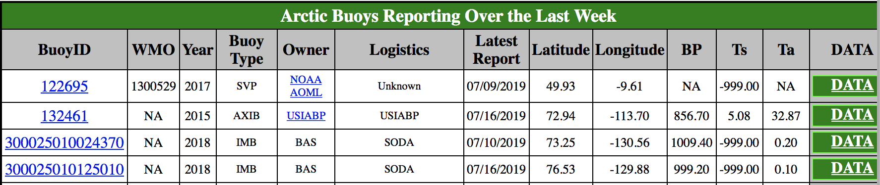

- To look at the buoy trajectory, click on the ID number.
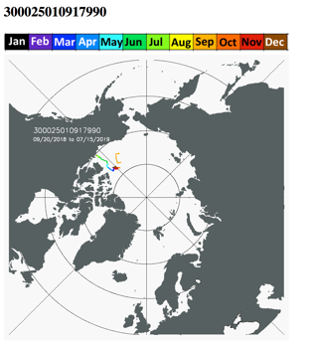
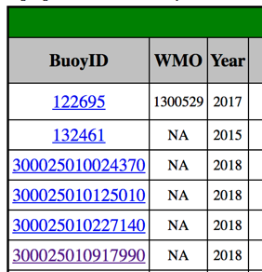

- Go back to the previous page.

- To download the data for this buoy, click on the ‘DATA’ link in the far column entry for the buoy. This will download a text file, which has a filename with the buoy ID number as the root of the filename and .dat as the suffix of the filename. You can open the text file in a text editor such as notepad on windows, TextEdit on mac.

- Change the suffix of the file by renaming it from ‘.dat’ to ‘.txt’. This will make it easier to import into excel later.

Importing Buoy Data into Excel:

Follow these instructions to import the .txt file into excel:

- Open a blank excel workbook.
- Choose Import (from the main menu item File -> Import)
- Choose the Text file option
- Navigate to find the ‘.txt’ file you downloaded, click on it, and then click Get Data. This opens the Text Import Wizard.
- Select Delimited as the import option.
- Change Start import row to 3, or 2 if you want headers to appear in the excel sheet.
- Click Next and then select Tab and Space under the delimiters column. Check that the columns are aligned as you expect them to be. If so, click Next. If not, go back and try a different import option.
- Click Finish, and OK to place this in the existing sheet at the top left-most cell (A1).
- Check the data has imported as you wish it to be. Are all fields in separate columns?
- You may wish to add a line to the top of the file with headers describing the column contents. To do this, right click on 1 the number that signifies row one. Choose Insert, then type in the column labels to the new cells that appear.

Looking at the progression of the latitude and longitude values in time, can you see if the buoy is drifting north, south, east or west?
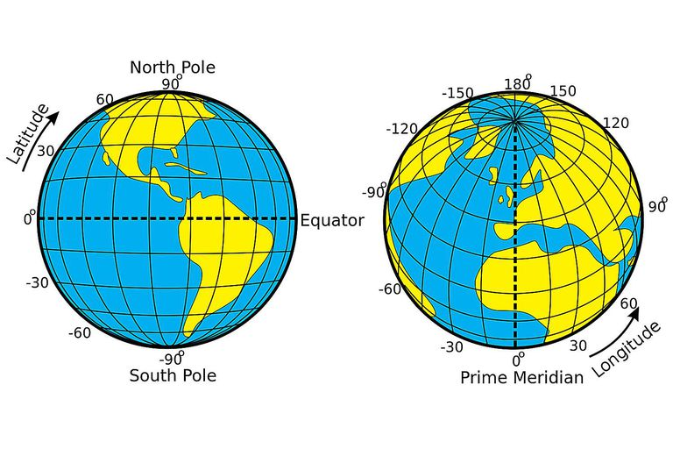
Djexplo/Wikimedia Commons/CC0 1.0

2.2 Notes: Calculating Velocity

- Velocity is the change in the position of an object over time. Velocity is a vector, meaning it has a magnitude and direction.

  - The magnitude of velocity is its speed.

  - The direction of velocity is whichever direction the object is traveling, and can be described using different coordinate systems.

Imagine a car driving in one direction along a street. The car is driving at 2 meters per second in the x-direction. The speed of the car is $v=2 \frac{m}{s}$, and we can call the direction that the car is moving “$\hat{x}$”. The velocity of the car must be written as a vector, containing both speed and direction:
$\overset{⃑}{v}=v \hat{x} =\left( 2 \frac{m}{s}\right) \hat{x}$
speed
direction
velocity

Now, we can imagine an object traveling along a more complicated path, as shown below. The object starts at (x, y) = (1, 1) and ends up at (5, 5) after traveling for ten seconds.

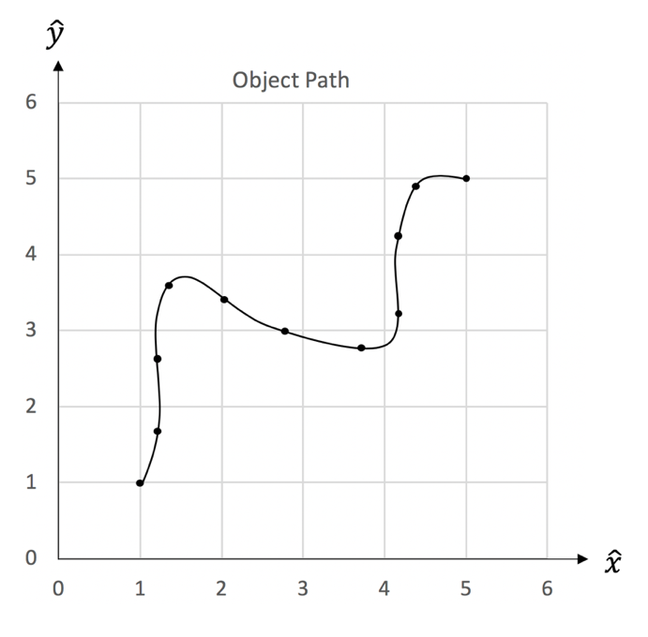

Let’s calculate the object’s velocity over the first second of its motion, shown as the first two black dots on the plot. We can describe the velocity of the object as its change in the position over time.
If we were to draw an arrow between the starting and ending position of the object over a given period of time, that would be the velocity vector of the object.
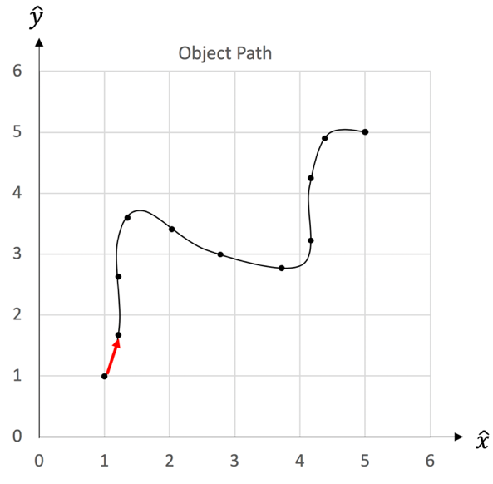

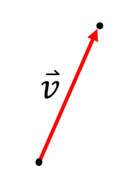

A velocity vector has both a magnitude (size) and direction.
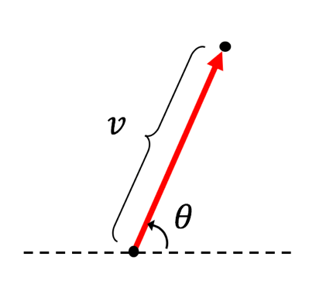
The magnitude of velocity is its speed, $v$, and that is shown as the length of the vector. The speed of the object is the distance it travels over a given period of time.

The direction of velocity is whichever direction the object is traveling. This object is traveling at an angle $θ$ from the horizontal.

An easy way to describe the direction the object is traveling is to break the object’s velocity vector up into components.

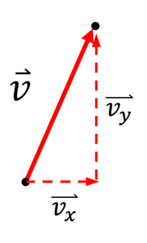
We can write the velocity vector as the sum of vectors that point horizontally and vertically:
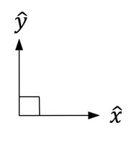
$$\overset{⃑}{v}= \overset{⃑}{v_{x}}+ \overset{⃑}{v_{y}}$$

The horizontal $(\hat{x})$ and vertical $(\hat{y})$ velocity vectors have their own directions and magnitudes (speeds) as well:
$\overset{⃑}{v_{x}}= v_{x} \hat{x}$ $\overset{⃑}{v_{y}}= v_{y} \hat{y}$

direction
speed
velocity

We could write the velocity vector in terms of components as:

This says that the object is traveling at speed $v_{x}$ in the horizontal $(\hat{x})$ direction and speed $v_{y}$ in the vertical $(\hat{y})$ direction.
$$\overset{⃑}{v}= v_{x} \hat{x}+ v_{y} \hat{y}$$

Because the horizontal and vertical directions are perpendicular to one another, the velocity components form a right triangle. This allows us to solve for certain components of the velocity in terms of other components:
$$v= \sqrt{{v_{x}}^{2}+{v_{y}}^{2}}$$

$$v_{x}= v\cos{θ}$$

$$v_{y}= v \sin{θ}$$

$$\tan{θ}=\frac{v_{y}}{v_{x}}$$

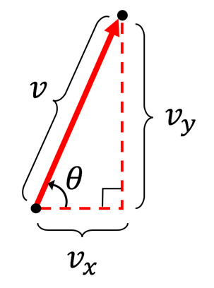

In order to calculate the velocity and speed of the object, we’ll want to calculate the components of the object’s velocity separately. The speed of an object is its change in position over time. Thus, the horizontal and vertical components of the object’s speed over time are given by:
$$v_{x}=\frac{∆x}{∆t}=\frac{(x_{final}-x_{initial})}{(t_{final}-t_{initial})}, v_{y}=\frac{∆y}{∆t}=\frac{(y_{final}-y_{initial})}{(t_{final}-t_{initial})}$$

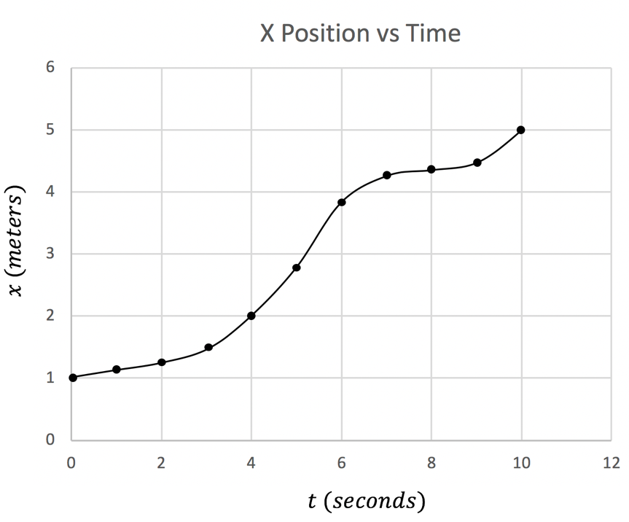
Let’s begin by calculating $v_{x}.$ It’s helpful to plot the x position of the object over time to make this calculation.

(1, 1.2)

(0, 1)

To calculate $v_{x}$ during the first second of the object’s motion, we need only use the x positions
$$v_{x}= \frac{∆x}{∆t}$$
$$v_{x}=\frac{(x_{final}-x_{initial})}{(t_{final}-t_{initial})}$$

$$∆x$$
$$v_{x}=\frac{(1.2 m-1 m)}{(1 s-0 s)}$$
$$∆t$$

$$v_{x}=0.2\frac{m}{s}$$

Thus, during the first second of the object’s motion, we see that the object is moving at 0.2 m/s in the x-direction. Let’s do the same for the y-direction of the motion.
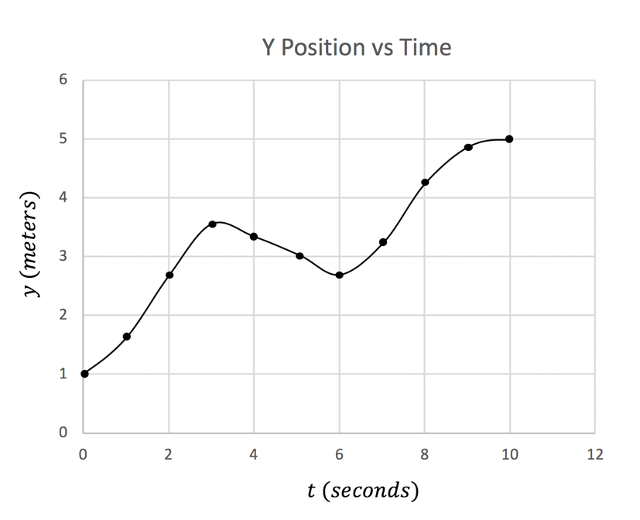

(1, 1.6)
(0, 1)

$$v_{y}= \frac{∆y}{∆t}$$
$$v_{y}=\frac{(y_{final}-y_{initial})}{(t_{final}-t_{initial})}$$

$$∆y$$
$$v_{y}=\frac{(1.6 m-1 m)}{(1 s-0 s)}$$

$$∆t$$
$$v_{y}=0.6\frac{m}{s}$$

We can then write the object’s velocity during the first second of its motion as:

$$\overset{⃑}{v}= \left(0.2 \frac{m}{s}\right) \hat{x}+ \left(0.6 \frac{m}{s}\right)\hat{y}$$

We can also notice from the equations for speed that the speed of the object is just the slope (the rise over the run) of the position vs. time plot. Thus, to more accurately estimate the velocity at a given point, one should estimate the slope using two points exactly beside the point in question to increase accuracy. Slop estimates at given points are indicated below.
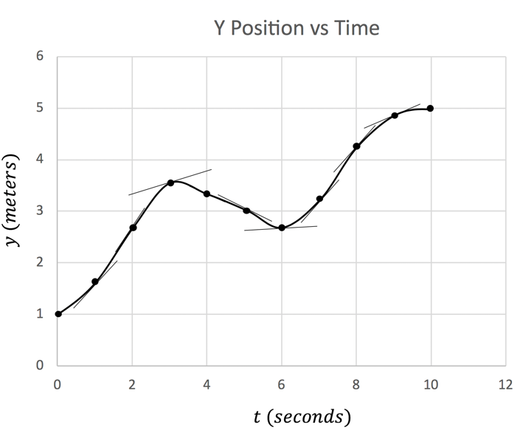
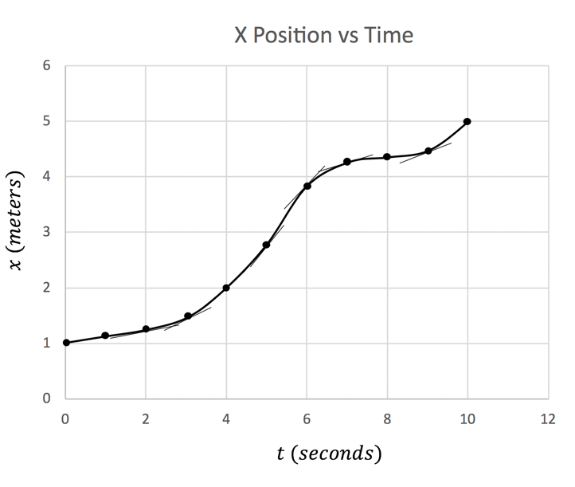

By determining the slopes of the position vs time plots above at each instant in time, the velocity of the object in the x and y directions can be plotted over time.
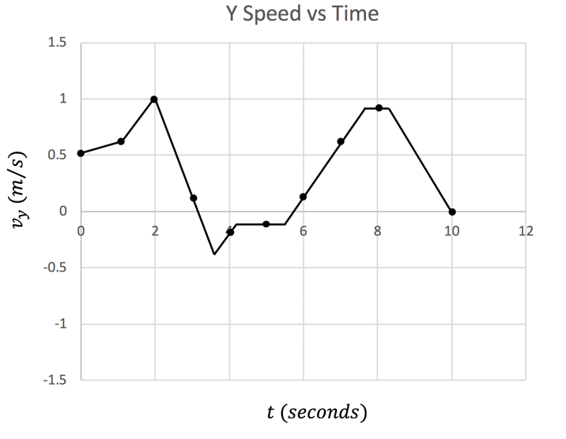
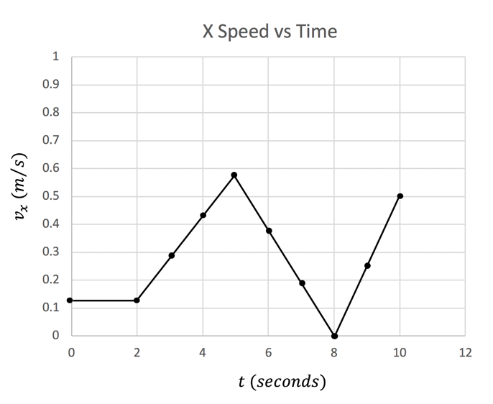

2.3 Notes: Finding speed and bearing along a trajectory

Section 1:

The following note sheet describes how to calculate the speed and bearing along the trajectory of an object’s motion.

- A grid bearing is the angle between a North-pointing ray and a ray pointing along a path of motion. Traditionally, the angle is measured clockwise from North to the ray of motion.
- Speed is the distance traveled over a given period of time.

In the example below, we’ll find the speed and bearing of an object moving between locations A and B, with known coordinates $({latitude}_{A}, {longitude}_{A})$ and $({latitude}_{B}, {longitude}_{B})$, respectively.

- Remember, latitude and longitude coordinates might be listed in the opposite order from how you are used to reading coordinates.

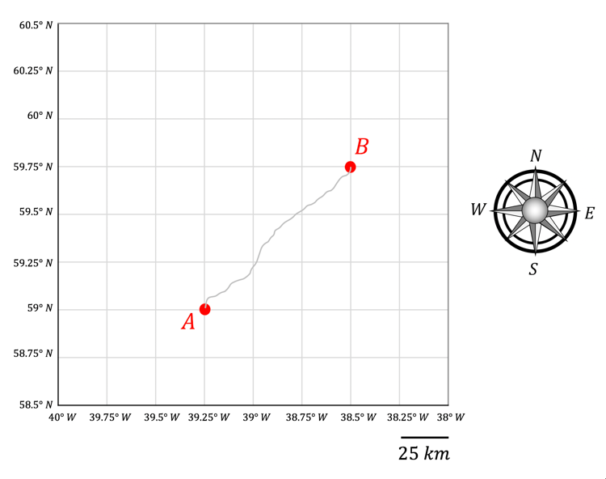
longitude
latitude

Let’s imagine that sea ice drifts from location A to location B over 15 days. We can describe the average motion of the ice with a ray $\overline{AB}$that points from point A to point B:
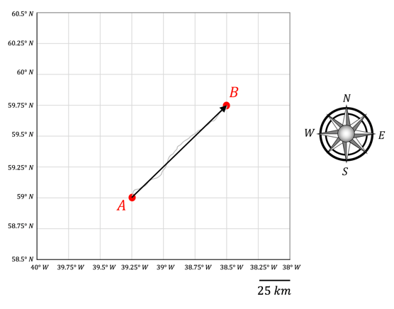
We’ll need to calculate the speed and bearing of the ice drift to properly describe its motion.

We will begin by drawing a line along a meridional (north-south) grid line that passes through point A. The grid bearing, $θ$, is the angle measured clockwise from the dashed meridional line to the ray $\overline{AB}$. The speed, $v$, is the distance,$d,$ traveled along $\overline{AB}$ over the amount of time,$∆t,$ it took to travel along $\overline{AB}$ ($v=d/{∆t}$).
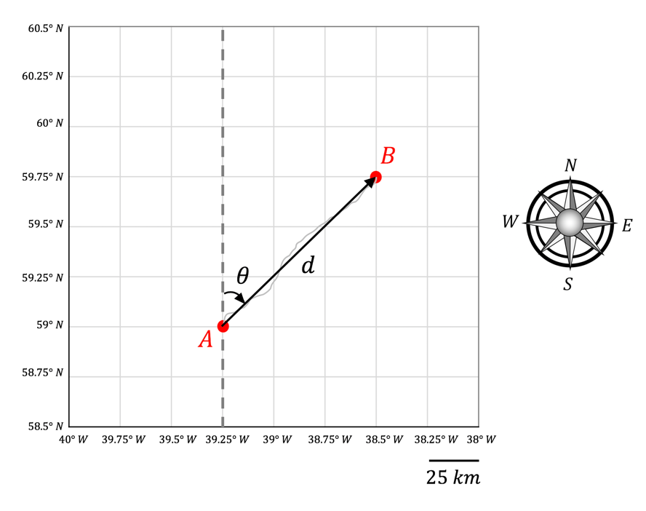

In order to calculate the bearing, $θ$, and the distance, $d$, traveled along $\overline{AB}$, we will need to use our knowledge of triangular geometry. Below, we will construct a right triangle with the meridional (north-south), $m$, and zonal (east-west), $z$, components of the ray $\overline{AB}$. If the coordinates of points A and B are known, the distances $m$ and $z$ can be calculated. In this case, each grid cell is 25 km in length, so the distances $m$ and $z$ can be calculated directly.
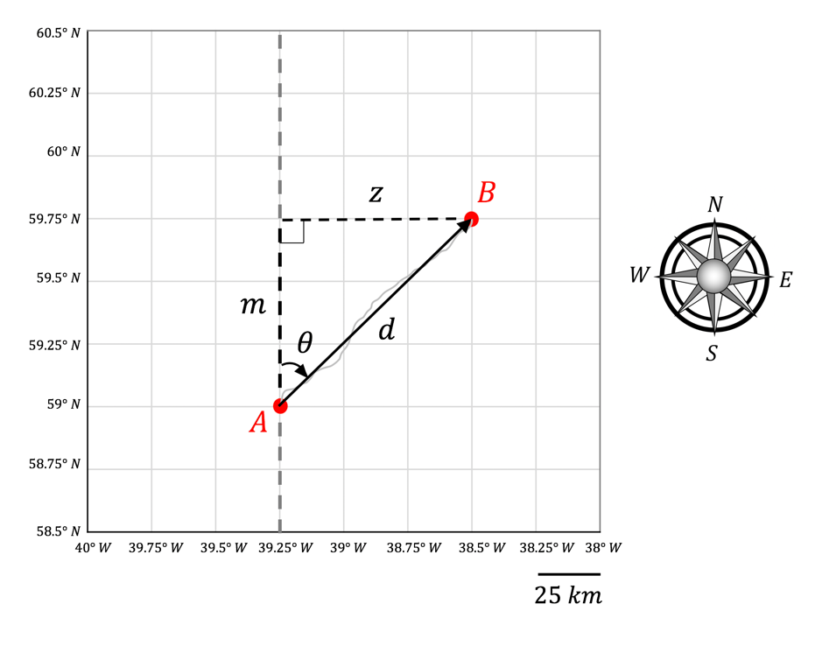
Using the values $m$ and $z$, both $θ$ and $d$ can be determined:

- Pythagorean’s theorem can be used to solve for $d$:

$$d= \sqrt{m^{2}+z^{2}}$$

- The bearing can be solved for using:

$$\tan\left(θ\right)=\frac{z}{m} → θ=arctan\left(\frac{z}{m}\right)$$

Calculating bearing and speed:

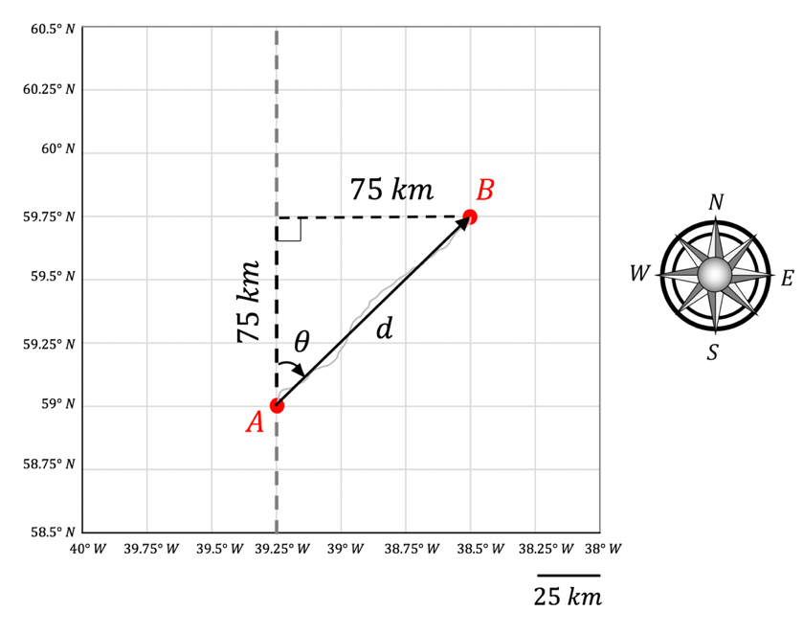
$$v=\frac{d}{∆t}$$

$$v=\frac{106.1 km}{15 days}$$

$$v=7.1 \frac{km}{day}$$

$$d= \sqrt{{(75 km)}^{2}+{(75 km)}^{2}}$$

$$d= 106.1 km$$

$$θ= arctan\left(\frac{75 km}{75 km}\right)$$

$$θ= arctan\left(1\right)$$

$$θ= 45°$$

Section 2:

Forecasting ice drift:

What can we do with the speed and bearing of the average ice drift? We can use it to try to forecast where the buoy will drift in the future.

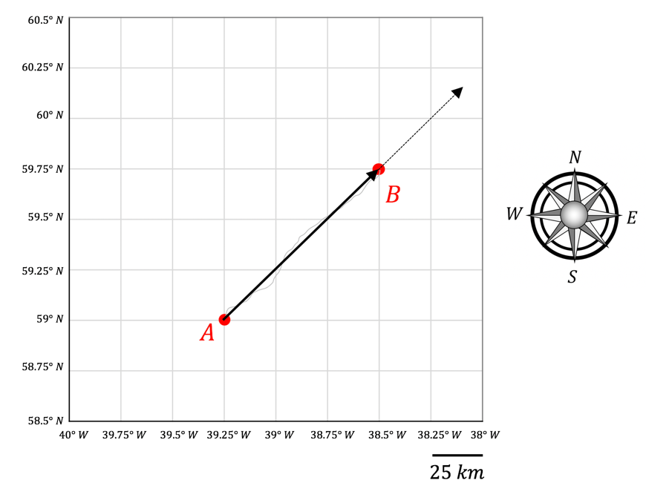

Let’s imagine the buoy continues to drift at the same speed and bearing at which it is currently drifting. Where will it be in 5 days?

We can calculate where it will be using the same math we used above – but in reverse. Now, by knowing the bearing and speed, we can find the distance it travels to see where it ends up.
$$v=7.1 \frac{km}{day}, θ= 45°$$

We know the current drift is described by:

From the known speed, the distance traveled in a given time can be calculated:

$$v= \frac{d}{∆t} → d= v ∆t$$

Over 5 days, the distance traveled by the buoy will be given by:

$$d=\left(7.1 \frac{km}{day}\right) (5 days)$$

$$d=35.5 km$$

Knowing the distance traveled and the direction along which it travels, the zonal and meridional components of the travel can be calculated:
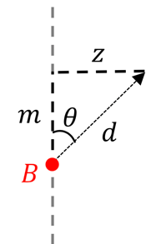

$$\sin\left(θ\right)=\frac{z}{d} → z=d\sin\left(θ\right)$$

$$\cos\left(θ\right)=\frac{m}{d} → m=d\cos\left(θ\right)$$

$$m=d\cos\left(θ\right)$$

$$m=(35.5 km)\cos\left(45°\right)$$

$$m=25.1 km$$

$$z=d\sin\left(θ\right)$$

$$z=(35.5 km)\sin\left(45°\right)$$

$$z=25.1 km$$

The distances traveled in either direction can be added onto the ice’s current location to find where it might end up after 5 more days of drift.

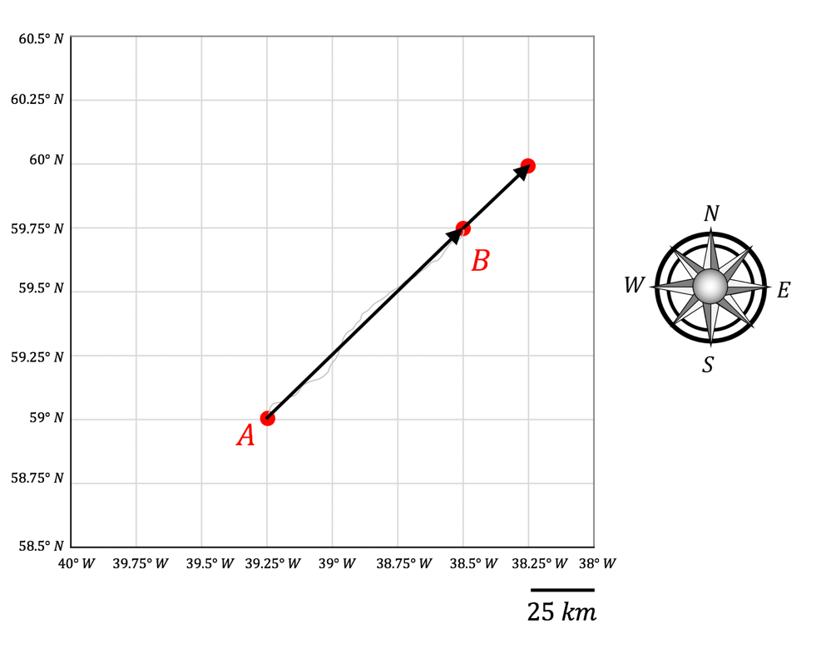

Section 3:

A note about the definition of bearing:

As mentioned before, bearing is traditionally measure clockwise from a North-pointing ray to the ray connecting two locations. So what happens if an objects moves West or South of its original location? We’ll demonstrate what this might look like by imagining the object in the example above moves from location B to location A.

Bearing and distance B to A:

When making a bearing estimate from B to A, the bearing angle must still be taken clockwise from North to the ray $\overline{BA}$.
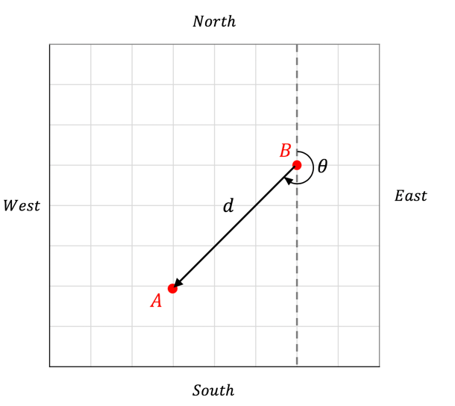

The distance traveled can be calculated again in terms of zonal and meridional components and will be the same distance as that traveled over ray $\overline{AB}$.
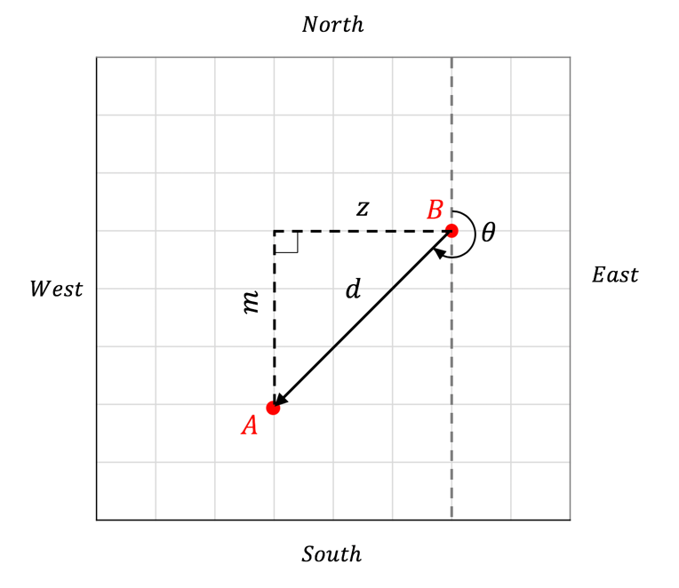

The bearing angle will be slightly more challenging to calculate, but we can do it using some well-known angles and angles within the triangle.

To calculate the bearing angle, we will use known angles. Right away, we can notice and label some right angles ($90°$). We can also label the angle we found in the previous calculation ($45°$).

- The angles in any triangle add up to $180°$:

$$90°+45°+b=180°$$

$$b=180°-90°-45°$$
Also, the angle made around one half and one fourth of a circle are 180 and 90 degrees, respectively.
$$b=45°$$

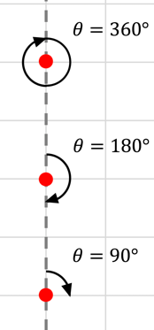
- The angle made around a full circle is $360°:$

$$90°+b+ θ=360°$$

$$θ=360°-90°-b$$

$$θ=360°-90°-45°$$

$$θ=25°$$

2.4: Working with Geographic Data

Latitude and longitude are geographic coordinates. These are different from cartesian coordinates (x,y). They represent angles rather than distances.

- Latitude describes the angle made from the equator to a location in the North/South direction. The term meridional describes a direction along a circle of latitude.

- Longitude describes the angle made from the prime meridian to a location in the East/West direction. The term zonal describes a direction along a circle of longitude.

- Latitude is defined to be $0°$ at the equator. Latitude reaches a maximum of $90°$ at the North Pole and a minimum of $-90°$ at the South Pole.
  - Latitude can be any value $-90°≤θ≤90°$.

- Longitude is defined to be $0°$ at the prime meridian. Longitude is measured as a positive value East of the prime meridian (reaching a maximum of $180°$ at the anti-meridian) and is measured as a negative value West of the prime meridian (ranging towards a minimum of $-180°$ at the anti-meridian).
  - Longitude can be any value $-180°<θ≤180°$.
The Western and Southern directions can either be indicated by negative signs, or simply by stating the longitude or latitude are measured W or N, respectively.

- Example: the coordinates of Oregon State University are: $44.5638° N, 123.2794° W$
- Alternatively, this could be written as $(44.5638° , -123.2794°)$

To use geographic coordinates to find distances between two locations we need to perform some trigonometry. We will assume the earth is a sphere (this is in fact an approximation of the actual shape of the Earth, which is better approximated as an oblate spheroid, being flatter at the poles than the equator).

To find the distance, $d$, between two locations A and B on the Earth, we need to find the distances $m$ and $z$ shown in the diagram below.

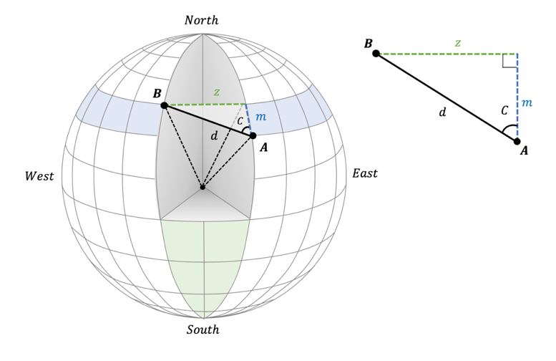

The meridional distance, $m,$ is represented by a change in latitude. We can calculate the angular change between locations A and B, $∆{lat}_{AB}$, to calculate $m.$

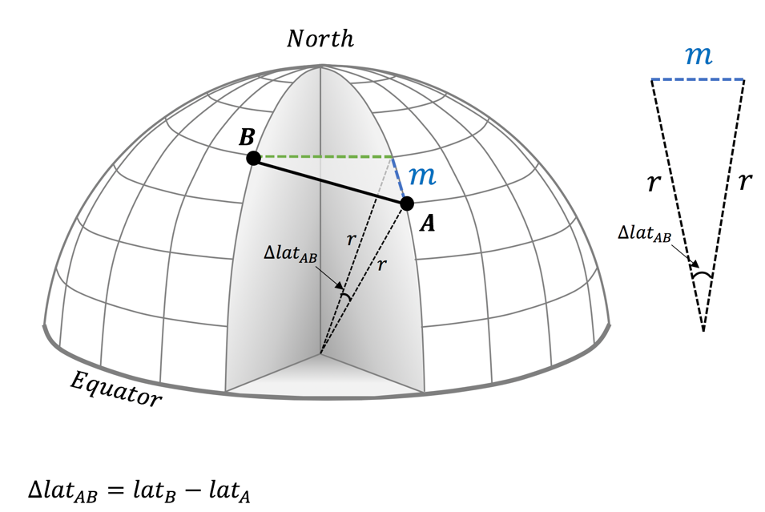
Look at the diagram above. Maybe you can see how we can calculate the meridional distance $m$. Is there a way to make right triangles from the isosceles triangle? Can you use trigonometry to find $m$ given you know $r$ (the radius of the Earth) and $∆{lat}_{AB}$?

To find $m$ we split the triangle made by $∆{lat}_{AB}$ in two, forming two right angle triangles. Each of these has hypotenuse $r$ and opposite length $\frac{m}{2}$. Hence we can find $m$ as
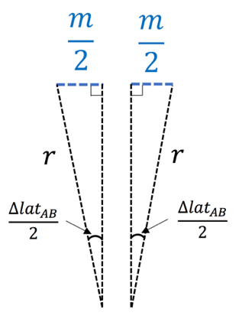
$$\frac{m}{2}= r\sin\left(\frac{∆{lat}_{AB}}{2}\right)$$

$$↓$$

$$m=2 r\sin\left(\frac{∆{lat}_{AB}}{2}\right)$$

Finding the zonal distance, z, is a little more involved because zonal bands decrease in radius as they approach the pole. The figure below illustrates this. A zonal band bounded by two fixed longitudes is outlined in black. The distance between the two longitudes bounding the zonal band decreases as latitude increases due to the shape of the Earth.
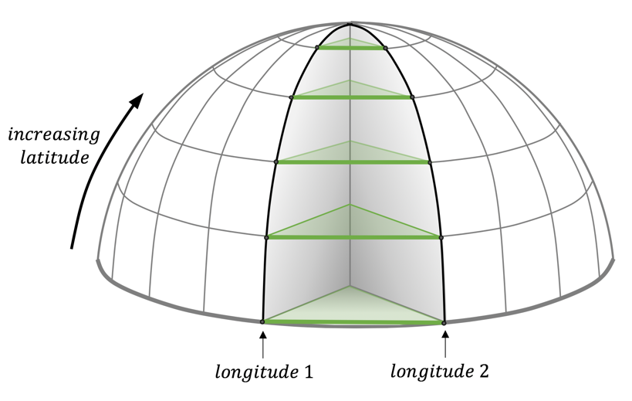
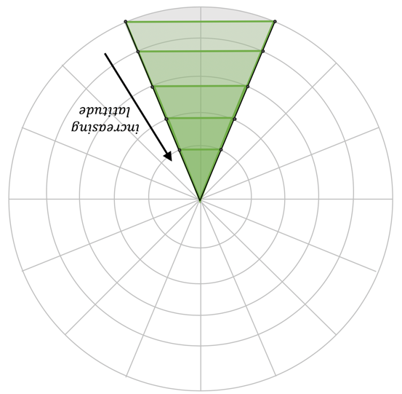
The zonal band as seen from looking down on the North Pole
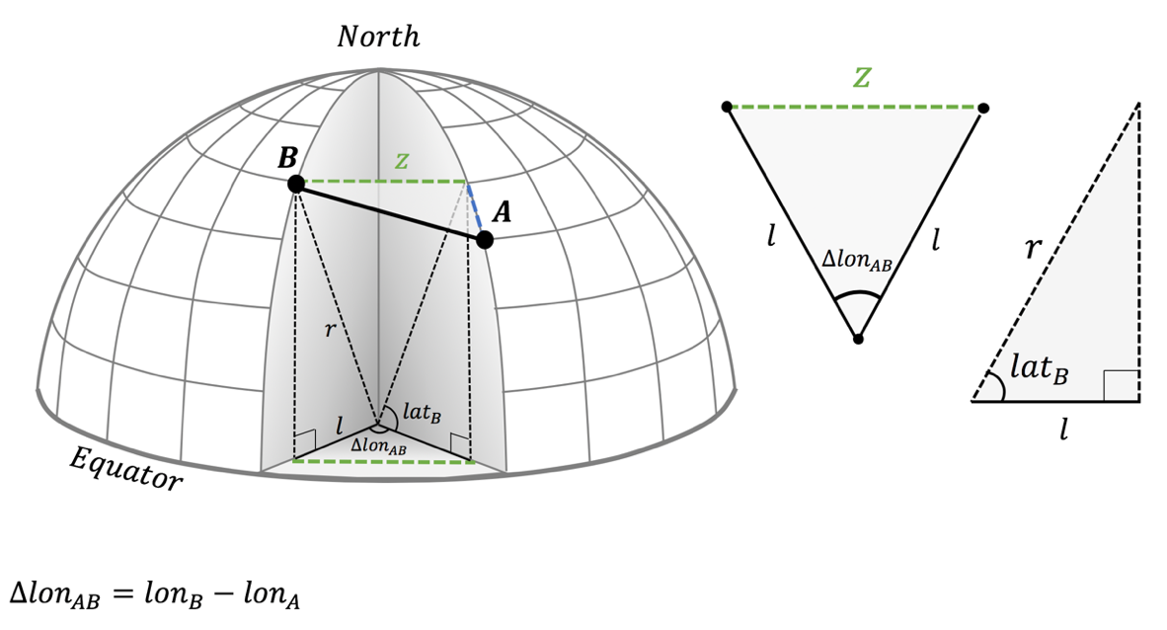

In the diagram above, see that we need to find the radius of the longitudinal band, $l,$ before calculating $z$. This radius, $l$, is the same as $r$ at the equator and decreases to 0 at the north pole. You can find $l$ if you know the latitude of the zonal band.

Using the right triangle in the above diagram, we can see that

$$l=r\cos{({lat}_{B})}$$

Splitting the isosceles triangle in two as we did on the previous page, we can solve for $z$ as
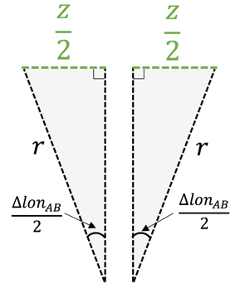

$$\frac{z}{2}=l\sin\left(\frac{∆{lon}_{AB}}{2}\right)$$

$$z= 2 l\sin\left(\frac{∆{lon}_{AB}}{2}\right)$$

Finally, combining the equations for $l$ and $z$, we can solve for $z$ as

$$z= 2 r\cos{({lat}_{B})}\sin\left(\frac{∆{lon}_{AB}}{2}\right)$$

Now we know $m$ and $z$ we can find distance $d$ and bearing $C$exactly as we did in cartesian coordinates.
(2.5) Worksheet Solution: Distance and bearing along a trajectory

Problem:

Find the distance ($km$) and direction ($°$) this buoy has traveled over the last day. Take the radius of the earth, $r$, to be $r=6356 km$. Assume the Earth is flat between the position the buoy was at yesterday and today. What is the distance and direction between these two points?

Worked Example Solution:

This example will use data from when Buoy ID: 300234060834110 travelled from ($80.0788°, -164.838°$) to ($80.1176°, -165.7632°$) from Oct. 27-28, 2016. Remember, the negative sign in front of longitude means West of the prime meridian. A negative sign in front of latitude would mean South of the equator.

We can use the following rule of isosceles triangular geometry to calculate $m:$
$$m= 2 r\sin\left(\frac{∆{lat}_{AB}}{2}\right)$$

$$m= 2 r\sin\left(\frac{latB-latA}{2}\right)$$

$$m= 2 (6356)\sin\left(\frac{80.1176°-80.0788°}{2}\right) km$$

$$m=4.3 km$$

- This means the buoy drifted $4.3 km$North as it drifted from location A to B.
We can use the same rule to calculate $z$ for the triangle containing $z$:

$$z= 2 l\sin\left(\frac{∆{lon}_{AB}}{2}\right)$$

Here, we will need to calculate $l$ using right triangle geometry:

$$l=r cos⁡({lat}_{B})$$
Thus, the zonal component becomes:
$$z= 2 \left(r cos⁡({lat}_{B})\right)\sin\left(\frac{∆{lon}_{AB}}{2}\right)$$

$$z= 2 r cos⁡({lat}_{B})\sin\left(\frac{lonB-lonA}{2}\right)$$

$$z= 2\left(6356\right)\cos\left(80.1176°\right)\sin\left(\frac{-165.7632°-(-164.838°)}{2}\right)km$$

$$z= -17.6 km$$

- The negative sign in front of the distance means the object drifted to the West.

The total distance traveled, $d,$ can be calculated from the zonal and meridional components of the buoy drift using Pythagorean’s Theorem.
$$d=\sqrt{z^{2}+m^{2}}$$

$$d=\sqrt{{(-17.6 km)}^{2}+{(4.3 km)}^{2}}$$

$$d=18.1 km$$

Using rules for a right triangle, we can calculate C:

$$\tan\left(C\right)= \frac{z}{m} → C=\tan^{-1}\left(\frac{z}{m}\right)$$

$$C=\tan^{-1}\left(\frac{-17.6 km}{4.3 km}\right)$$

$$C=-76.3°$$

- The negative sign means the object drifted at an angle West of North.

The total trajectory between points A and B can be visualized as the following:
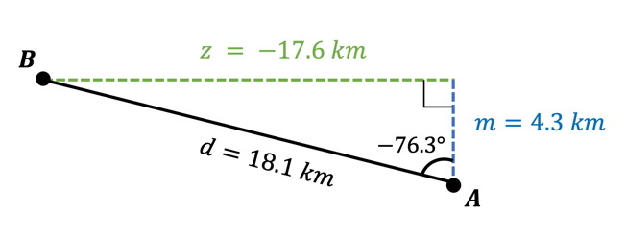

2.6 Worksheet Solution: Extrapolating position with distance and bearing

Problem:

Let us assume that the ice will keep moving at the same speed and in the same direction as it did over the last day. Where will the ice drift to in a day’s time?

Assume the ice will keep drifting with the same bearing and speed of the previous day. Calculate the meridional and zonal distance it will travel.

From these two distances find the number of degrees latitude and degrees longitude the ice moved.

Add these to the start position to estimate where the ice will be in one day.

Points for discussion

How accurate do you think your forecast is?
How will you test this?
Let’s see tomorrow where the buoy moved to.

Worked Example Solution:

- This is a reverse calculation to estimating bearing and direction in the previous exercise.

This example will again use data from Buoy ID: 300234060834110. We will consider the drift over a 2-day period:

- Point A: ($80.0788°, -164.838°$) on Oct 27, 2016
- Point B: ($80.1176°, -165.7632°$) on Oct 28, 2016
- Point D: ($80.2296°, -166.747°$) on Oct 29, 2016

From worksheet (2.5-solution), we found the drift distance and direction of the buoy from point A to point B as shown in the following figure:

$$d=18.1 km$$

$$C=-76.3°$$

We’ll assume the buoy will drift the same way it did that day over the following day. So, we’ll assume the buoy will again drift $18.1 km$ at an angle $76.3°$ West of North. Knowing the coordinates of the buoy at location B, we’ll use this information to calculate the coordinates of the buoy at location d.

Distances m and z will be the same as they previously were, so we can use this information to calculate the new latitude coordinate, $latD$.
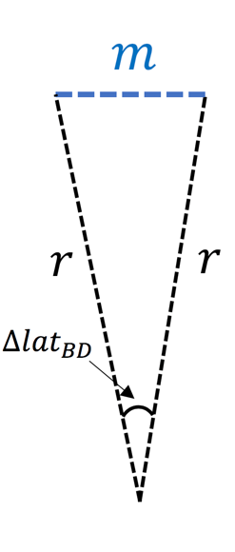
$$m= 2 r\sin\left(\frac{∆{lat}_{BD}}{2}\right)$$

$$\frac{m}{2 r}=\sin\left(\frac{latD-latB}{2}\right)$$

$$\sin^{-1}\left(\frac{m}{2 r}\right)=\frac{latD-latB}{2}$$

$$latD={2 sin}^{-1}\left(\frac{m}{2 r}\right)+latB$$

$$latD={2 sin}^{-1}\left(\frac{4.3 km}{2 (6356 km)}\right)+80.1176°$$

$$latD=0.0388°{+ 80.1176°}$$

$$latD=80.1564°$$

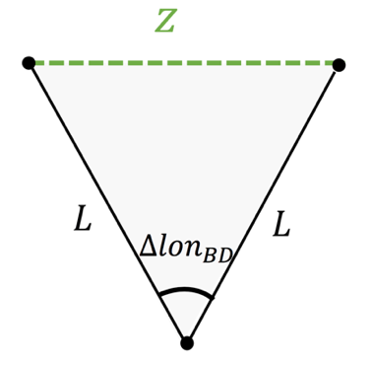
- Be careful that your calculation of$\sin^{-1}\left(\right)$ is returning a value in degrees and not in radians, otherwise this will give an incorrect answer.

We can use the same rule to calculate $z$ for the triangle containing $z$:

$$z= 2 L\sin\left(\frac{lonD-lonB}{2}\right)$$

$$lonD={2 sin}^{-1}\left(\frac{z}{2 L}\right)+lonB$$

We will need to calculate $L$ using right triangle geometry:

$$L=r cos⁡({lat}_{D})$$

Plugging this in, we find:

$$lonD={2 sin}^{-1}\left(\frac{z}{2 (r cos⁡(latD))}\right)+lonB$$

$$lonD={2 sin}^{-1}\left(\frac{-17.6 km}{2 ((6356 km) cos⁡(80.1564°))}\right)-165.7632°$$

$$lonD=-0.9282°{-165.7632° }$$

$$lonD=-166.6914°{ }$$

The forecasted coordinates of point D are: ($80.1564°, -166.6914°$).

Students can compare to the actual recorded position: ($80.2296°, -166.747°$)

A handy online tool to compare two geographic locations on a map is
http://dwtkns.com/pointplotter/

3.1 Worksheet: Hindcasting

In the following exercise, students will use their knowledge and resources from modules 1 and 2 of the lesson to forecast where a specified buoy (ID: 300234061872720) will drift over a day in the past (hence hindcasting) given two known locations of the buoy. Shown in the figure below, students will use their forecast to estimate location D based off of given locations A and B.
Day of Forecast | (Latitude, Longitude) | Student(s) Assigned
350 | A: ($85.6018°,150.0076°$)  B: ($85.6494°, 149.8064°$)
352 | A: ($85.7006°, 149.7012°$)  B: ($85.7438°, 149.5474°$)
354 | A: ($85.7864°,149.1562°$)  B: ($85.8016°, 148.6854°$)
356 | A: ($85.7318°, 147.4628°$)  B: ($85.6702°, 145.612°$)
358 | A: ($85.6472°, 145.2402°$)  B: ($85.7072°, 145.8052°$)
360 | A: ($85.822°, 146.2298°$)  B: ($85.9884°, 145.3776°$)
362 | A: ($86.169°, 146.396°$)  B: ($86.2272°, 147.1172°$)
364 | A: ($86.3678°, 147.2328°$)  B: ($86.4694°, 147.279°$)
1 | A: ($86.5726°, 146.525°$)  B: ($86.6518°, 146.1364°$)
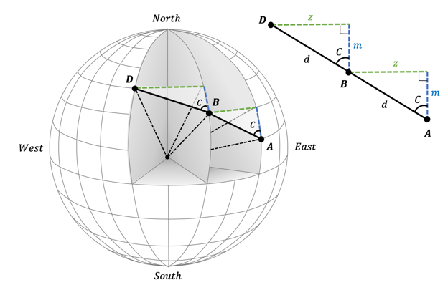
Assign at least one student to each forecast task below. Coordinates at locations A and B are provided. Each student will calculate the coordinates of location D, the location of the buoy on the listed day of forecast (locations A and B are reached two days and one day before location D, respectively.
3.2 Hindcasts Results Worksheet

Once students have forecasted location D, they should be plotted in the excel notebook for today’s lesson in order for students to visualize the buoy trajectory. For each day of forecast, the students will calculate the model error of their forecast by comparing forecast D coordinates to actual reported coordinates of D.

Below are forecasted location solutions using an excel worksheet. They may be slightly different from the values students have calculated by hand.

Day of Forecast | (Latitude, Longitude) | error (kilometers)
350 | Forecast D: ($85.697°, 149.6030°$)  Reported D: ($85.7006°, 149.7012°$)
352 | Forecast D: ($85.787°, 149.3920°$)  Reported D: ($85.7864°, 149.1562°$)
354 | Forecast D: ($85.8168°, 148.2129°$)  Reported D: ($85.7318°, 147.4628°$)
356 | Forecast D: ($85.6086°, 143.7871°$)  Reported D: ($85.6472°, 145.2402°$)
358 | Forecast D: ($85.7672°, 146.3782°$)  Reported D: ($85.822°, 146.2298°$)
360 | Forecast D: ($86.1548°, 144.4886°$)  Reported D: ($86.169°, 146.396°$)
362 | Forecast D: ($86.2854°, 147.8497°$)  Reported D: ($86.3678°, 147.2328°$)
364 | Forecast D: ($86.571°, 147.3266°$)  Reported D: ($86.5726°, 146.525°$)
1 | Forecast D: ($86.731°, 145.7384°$)  Reported D: ($86.7198°, 145.7782°$)

3.3 Worksheet Solution: Estimating Error

Error calculation:

In this lesson, error will be calculated as the difference in the distance your forecast predicted the buoy would travel, $d_{F}$, and the distance the buoy was actually reported to have traveled, $d_{R}$, in a given period of time:
$$error= d_{F}- d_{R}$$

Students must calculate the error of their forecasts using known relations and the reported and forecasted locations of the buoy.

Error calculation:

The meridional and zonal distances traveled by a buoy from location B to D are given by:

$$m= 2 r\sin\left(\frac{latD-latB}{2}\right)$$

$$z= 2 r cos⁡({lat}_{D})\sin\left(\frac{lonD-lonB}{2}\right)$$

And the total distance is given by:
$$d=\sqrt{z^{2}+m^{2}}$$

Combining, we can simplify to:

$$d=\sqrt{{\left(2 r cos⁡({lat}_{D})\sin\left(\frac{lonD-lonB}{2}\right)\right)}^{2}+{\left(2 r\sin\left(\frac{latD-latB}{2}\right)\right)}^{2}}$$

$$d=2 r\sqrt{{\left(cos⁡({lat}_{D})\sin\left(\frac{lonD-lonB}{2}\right)\right)}^{2}+{\left(\sin\left(\frac{latD-latB}{2}\right)\right)}^{2}}$$

The error is given by the difference in the forecasted and reported distances traveled from B to D:

$$error= d_{F}- d_{R}$$

where:

$$d_{F}=2 r\sqrt{{\left(cos⁡({lat}_{DF})\sin\left(\frac{lonDF-lonB}{2}\right)\right)}^{2}+{\left(\sin\left(\frac{latDF-latB}{2}\right)\right)}^{2}}$$

$$d_{R}=2 r\sqrt{{\left(cos⁡({lat}_{DR})\sin\left(\frac{lonDR-lonB}{2}\right)\right)}^{2}+{\left(\sin\left(\frac{latDR-latB}{2}\right)\right)}^{2}}$$

and “DF” and “DR” indicate the forecasted and reported buoy locations, respectively.

Example for Forecast Day 350:

B: ($85.6494°, 149.8064°$)
Reported D: ($85.7006°, 149.7012°$)
Forecast D: ($85.697°, 149.602979°$)

The forecasted distance would be given by:

$$d_{F}=2 r\sqrt{{\left(cos⁡({lat}_{DF})\sin\left(\frac{lonDF-lonB}{2}\right)\right)}^{2}+{\left(\sin\left(\frac{latDF-latB}{2}\right)\right)}^{2}}$$

$$d_{F}=2 (6356 km)\sqrt{{\left(cos⁡(85.697°)\sin\left(\frac{149.602979°-149.8064°}{2}\right)\right)}^{2}+{\left(\sin\left(\frac{85.697°-85.6494°}{2}\right)\right)}^{2}}$$

$$d_{F}=(12,712 km)\sqrt{{\left((0.0750309)(-0.00177518)\right)}^{2}+{\left(0.000415388\right)}^{2}}$$

$$d_{F}=(12,712 km)(0.00043622)$$

$$d_{F}=5.545 km$$

The reported distance would be given by:

$$d_{R}=2 r\sqrt{{\left(cos⁡({lat}_{DR})\sin\left(\frac{lonDR-lonB}{2}\right)\right)}^{2}+{\left(\sin\left(\frac{latDR-latB}{2}\right)\right)}^{2}}$$

$$d_{R}=2 (6356 km) \sqrt{{\left(cos⁡(85.7006° )\sin\left(\frac{ 149.7012°-149.8064°}{2}\right)\right)}^{2}+{\left(\sin\left(\frac{85.7006° -85.6494°}{2}\right)\right)}^{2}}$$

$$d_{R}=(12,712 km)\sqrt{{\left((0.0749683)(-0.000918043)\right)}^{2}+{\left(0.000446804\right)}^{2}}$$

$$d_{R}=5.747 km$$

The error for this forecast is thus given by:

$$error= d_{F}- d_{R}$$

$$error= 5.545 km- 5.747 km$$

$$error=- 0.202 km$$

Below are the errors for each forecast:

Day of Forecast | (Latitude, Longitude) | Error
350 | Forecast D: ($85.697°, 149.6030°$)  Reported D: ($85.7006°, 149.7012°$) | $$- 0.202 km$$
352 | Forecast D: ($85.787°, 149.3920°$)  Reported D: ($85.7864°, 149.1562°$) | $$- 0.744 km$$
354 | Forecast D: ($85.8168°, 148.2129°$)  Reported D: ($85.7318°, 147.4628°$) | $$- 8.543 km$$
356 | Forecast D: ($85.6086°, 143.7871°$)  Reported D: ($85.6472°, 145.2402°$) | $$12.901 km$$
358 | Forecast D: ($85.7672°, 146.3782°$)  Reported D: ($85.822°, 146.2298°$) | $$- 5.046 km$$
360 | Forecast D: ($86.1548°, 144.4886°$)  Reported D: ($86.169°, 146.396°$) | $$- 1.801 km$$
362 | Forecast D: ($86.2854°, 147.8497°$)  Reported D: ($86.3678°, 147.2328°$) | $$- 7.288 km$$
364 | Forecast D: ($86.571°, 147.3266°$)  Reported D: ($86.5726°, 146.525°$) | $$- 1.218 km$$
1 | Forecast D: ($86.731°, 145.7384°$)  Reported D: ($86.7198°, 145.7782°$) | $$1.261 km$$

The students have calculated the deviation of their forecast from reality (an observation). You can think of this as an error for the particular forecast time. It is more instructive to think of model error in such a way that the model error characterizes the spread in error of the forecast model.

The excel spreadsheet provides tools to investigate the distribution of d_{F} – d_{R}. We will use this to explore the concept of model error.

3.4 Notes: Filling out Excel Notebook

∗ The excel notebook for this assignment is locked so that only the cells that you will fill in with student calculations can be altered. In the case that you need to alter other cells, the password to unlock the notebook is “seaice”

- Enter the students’ forecasted locations for the buoy at locations D into the empty blue and green colored cells, columns J and K, in the excel notebook provided. This should make a plot showing the forecasts of the buoy calculated by the students.
- Look at the forecast plot, it should look similar to below:

- The blue curve indicates the recorded path of the buoy, with the blue dots indicating the buoy’s location at the beginning of each new day. The red lines indicate the forecast of the buoy beginning on a given day and continuing over an entire day.

- Compare this plot to the one below, where forecasts were taken by calculating the buoy’s trajectory over ¼ of a day and extending the drift out for ¼ of a day. Why might this plot look different? How is it different?
- Work through worksheet 3.3 with the students, allowing each of them to calculate the error for their forecast. Enter the error into the empty purple colored cells, column M, in the excelworkbook. The workbook will calculate the mean of the errors. Discuss with the class.

- Below shows the error for many forecasts carried out over the same overall time window but for ¼ day forecasts. Does this distribution look familiar?

As more data points are added this distribution would start to look like a Gaussian (normal) distribution. The mean of the model-observation differences is the average error. As the distribution is Gaussian with a peak at the mean value, the mean is the most frequently encountered error.

A Gaussian curve. The distribution is centered around the mean value. Frequency is the probability of a value occurring. One standard deviation either side of the mean encloses 68.2% of the values under the curve.

Mean deviation: $μ= \frac{\sum{(d_{F} – d_{R})}}{n} = -1.2 km$

If this mean is non-zero it indicates the forecast model is biased. In the case of a persistence forecast we might expect no bias, μ = 0. The reason we do not see this with our data is because we only have a small sample and the distribution of deviations is not well represented. With more data we expect the distribution to become more gaussian centered on zero.

As the forecast may be slow or fast, having positive or negative errors, it can be instructive to think about the mean of the absolute errors. This is the magnitude of $d_{F} – d_{R}$.

Sum of the magnitude of errors: $\sum{\left|d_{F} – d_{R}\right|=39 km}$

Mean deviation of forecast distance from reality: $\frac{\sum{\left|d_{F} – d_{R}\right|}}{n}=\frac{39 km}{9}=4.3 km$

This is still not an estimate of the model error, because it only tells us what the predominate distance error is.

The standard deviation of the distribution of the deviations or errors ($d_{F} – d_{R}$) represents the spread in the forecast ability (the spread in differences between forecast and observed distances travelled). For a gaussian distribution the spread about the mean is characterized as the standard deviation
$$σ= \sqrt{\frac{\sum{{\left[\left(d_{F} – d_{R}\right)-μ\right]}^{2}}}{n}}$$

The standard deviation provides an indication of the spread of the Gaussian curve. The larger σ is, the wider the curve is. More accurate forecasts would have smaller standard deviation for the error.

It is more instructive, however, to think about the spread of the observations about the forecast track. Let us look at the two examples considered in the excel spreadsheet, hindcasts for 1 day or for ¼ day.

Forecast tracks are in red. The actual trajectory of the buoy is in blue. Note how the 1 day forecast locations have a wider spread about the observed locations than the ¼ day forecast. We quantify this difference between model and observations as the root mean square error.

The Model Error, or root mean square error, is similar to the standard deviation of the errors, but is not identical to it.

Model Error is $\sqrt{\frac{\sum{{\left(d_{F} – d_{R}\right)}^{2}}}{n}}=6 km$
One hopes that the model error plus model bias is smaller than the required forecast accuracy. If not, we need to consider our model as not fit for its purpose. In the example of a search and rescue we are limited by the flight time of a helicopter and can only survey a region with radius 10km in one flight. Hence if $model error + model bias > 10km$, one might argue the model is not fit to be used to predict the search location for the flights.

$$Model Error = 6 km$$
$$Model Bias = -1.2 km$$

Search radius to find the drifter, with success 68 % of the time is $6 + 1.2 ≈ 7 km$

Note that we took the absolute value of the model bias, because this is an offset in the search pattern, so the distance must be added to the model error if we are not sure of the direction of the bias.

The one-day persistence forecast is fit for the purpose of the search and recovery of the dead buoy, with a search radius of 7 km if a 68% success rate is acceptable.

3.5: Discussing errors in forecast models

There are various ways that a model might not provide an accurate prediction. Ask the students to think about their model and what might explain the difference between the model forecast and where the buoy actually drifted.

Below are examples of particular types of errors in modeling. In considering each error it is important to consider if the model, with it’s known uncertainties is fit for the purpose it is designed for. In this case that purpose is estimating where a buoy will drift so it can be revisited in a day. We can quantify the ability of the model to predict ice drift, in terms of a model skill score. The art of modeling is to reduce errors to acceptable levels and/or to understand how model behavior responds to variance that is similar to the known error. In the case of a sea ice trajectory we have a tolerance of an acceptable search radius to find the buoy in a day, this might be as large as 10km (for example for a helicopter search and rescue operation).

Types of Error we encounter in these lessons

Calculation Error: Were your calculations accurate? Check yourself by comparing to others or redoing your calculation.

In a model which has equations solved by computation (numerical methods) there is an inherent error introduced by rounding because a computer can only hold numbers to limited precision. This introduces a roundoff error in calculations. It is typically small, but some systems of equations can amplify numerical error. We study variability in the climate system by allowing model runs to be initialized with numbers describing the atmospheric state that are within numerical tolerance of each other. The natural variability in the climate system these experiments show is commonly known as the butterfly effect. A small beat of wings here will change the weather elsewhere.

While we can not control the chaotic behavior of our model, we can work to ensure the sensitivity of the model to variability in forcing (sunlight for example) is realistic. Such a model will describe the long-term response of the system well.

Measurement Error: GPS is accurate to about 25m for typical handheld devices. This error propagates through your calculations, and so will introduce a minimum drift speed that is detectable. Essentially you cannot dissociate two points less than 50m apart, so the ice needs to drift more than 50m for a speed to be detectable.
Speed = distance travelled / time
If positions are recorded one hour apart, the buoy must drift at least 50m in that hour. So the minimum speed detectable is 50 m / 1 hr = 50 / 3600 sec = 0.01 m/s

Ice on average moves at about 2 m/s, so this error is not significant in our calculations.

Discretization Error: This is the error introduced by the assumptions you make to calculate a solution by approximating the function you are solving. In the case of finding the distance a buoy has drifted, the piecewise linear approximation will introduce a discretization error.

Representation Error: The earth is not perfectly spherical, it is an oblique ellipsoid, and radius varies with location on the planet. You estimate of drift speed is based on assuming the earth is locally flat, this introduces a representation error into your calculations. You can quantify this error. It is important to consider such representation errors when choosing a map projection to work in for calculations of distance, bearing or area on the Earth.

Model Error: The persistence model does not account for information related to the force balance on the ice, it does not obey Newton’s laws. Would a physically realistic model, that solves the momentum balance according to Newton’s laws do a better job?

