Name:______________________________

In this exercise we will track ice drift in the Arctic ocean with a buoy that is placed on the ice.

Here is your challenge

The buoy needs to be visited by helicopter a day from now to be repaired because it just stopped reporting its position and data. As you will not have a report of its position, because it is broken, you will need to forecast where the buoy will drift in a day’s time in order to attempt to locate the buoy.

Once you have a drift forecast it would be a good idea to estimate how accurate this forecast is likely to be. The helicopter may need to search around the predicted location of the buoy until the buoy is found. How large of a search radius would you recommend?

Good luck. May the accuracy of your forecast be in your favor.

The ID of the buoy you are tracking is ___________________________________ .

Downloading and Importing Arctic Buoy Data

Downloading Buoy Data:

Make note of the buoy id number you have been provided. You will need this number to find the buoy’s data.

- In a web browser navigate to <http://iabp.apl.washington.edu/maps_daily_table.html>.

- Scroll down, you will find a table with buoy ids listed in the first column. Find your buoy by its ID number.
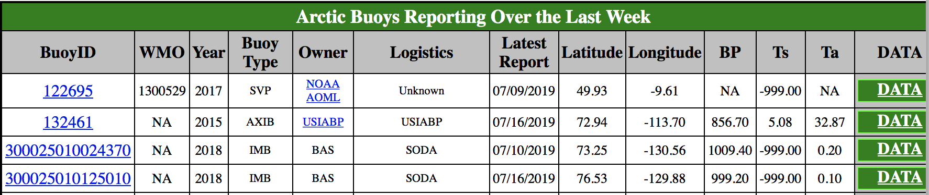

- To look at the buoy trajectory, click on the ID number.
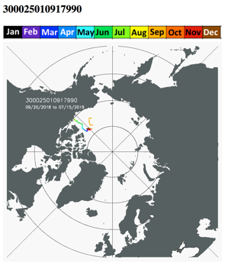
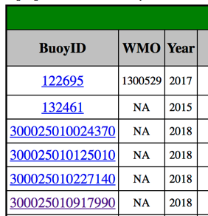

- Go back to the previous page.

- To download the data for this buoy, click on the ‘DATA’ link in the far column entry for the buoy. This will download a text file, which has a filename with the buoy ID number as the root of the filename and .dat as the suffix of the filename. You can open the text file in a text editor such as notepad on windows, TextEdit on mac.

- Change the suffix of the file by renaming it from ‘.dat’ to ‘.txt’. This will make it easier to import into excel later.

Importing Buoy Data into Excel:

Follow these instructions to import the .txt file into excel:

- Open a blank excel workbook.
- Choose Import (from the main menu item File -> Import)
- Choose the Text file option
- Navigate to find the ‘.txt’ file you downloaded, click on it, and then click Get Data. This opens the Text Import Wizard.
- Select Delimited as the import option.
- Change Start import row to 3, or 2 if you want headers to appear in the excel sheet.
- Click Next and then select Tab and Space under the delimiters column. Check that the columns are aligned as you expect them to be. If so, click Next. If not, go back and try a different import option.
- Click Finish, and OK to place this in the existing sheet at the top left-most cell (A1).
- Check the data has imported as you wish it to be. Are all fields in separate columns?
- You may wish to add a line to the top of the file with headers describing the column contents. To do this, right click on 1 the number that signifies row one. Choose Insert, then type in the column labels to the new cells that appear.

Looking at the progression of the latitude and longitude values in time, can you see if the buoy is drifting north, south, east or west?
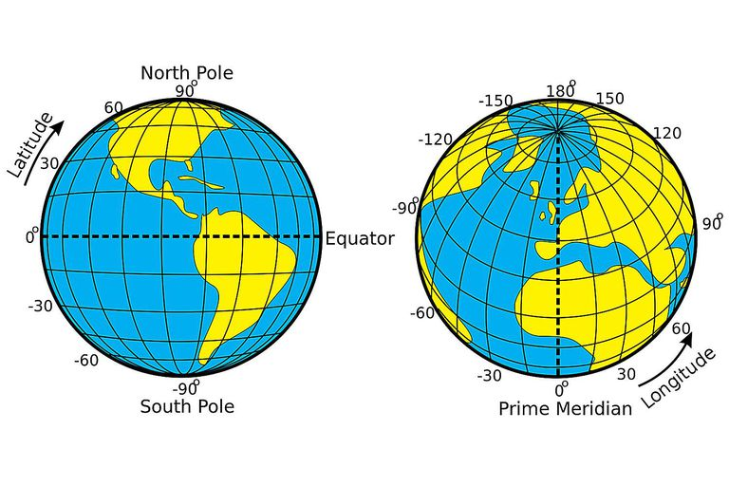
Djexplo/Wikimedia Commons/CC0 1.0

Calculating Speed and Bearing

The following note sheet describes how to calculate the speed and bearing along the trajectory of an object’s motion.

- A grid bearing is the angle between a North-pointing ray and a ray pointing along a path of motion. Traditionally, the angle is measured clockwise from North to the ray of motion.
- Speed is the distance traveled over a given period of time.

In the example below, we’ll find the speed and bearing of an object moving between locations A and B, with known coordinates $({latitude}_{A}, {longitude}_{A})$ and $({latitude}_{B}, {longitude}_{B})$, respectively.

- Remember, latitude and longitude coordinates might be listed in the opposite order from how you are used to reading coordinates.

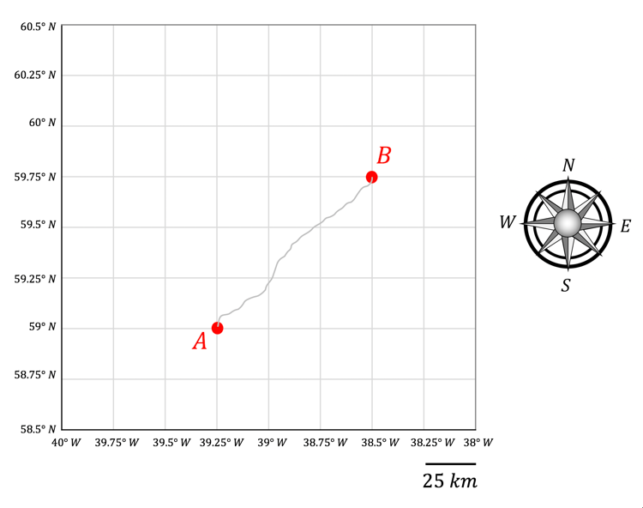
longitude
latitude

Let’s imagine that sea ice drifts from location A to location B over 15 days. We can describe the average motion of the ice with a ray $\overline{AB}$that points from point A to point B:

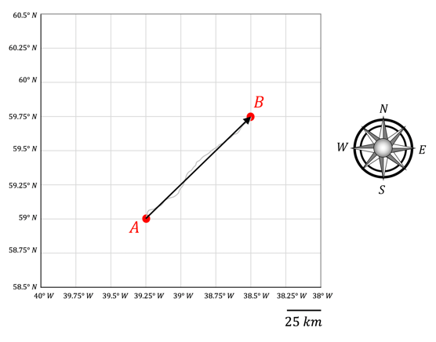
We’ll need to calculate the speed and bearing of the ice drift to properly describe its motion.

We will begin by drawing a line along a meridional (north-south) grid line that passes through point A. The grid bearing, $θ$, is the angle measured clockwise from the dashed meridional line to the ray $\overline{AB}$. The speed, $v$, is the distance,$d,$ traveled along $\overline{AB}$ over the amount of time,$∆t,$ it took to travel along $\overline{AB}$ ($v=d/{∆t}$).
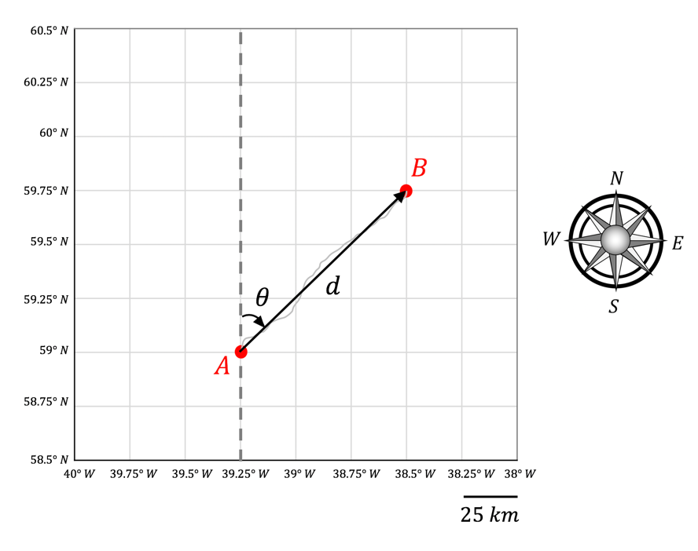

In order to calculate the bearing, $θ$, and the distance, $d$, traveled along $\overline{AB}$, we will need to use our knowledge of triangular geometry. Below, we will construct a right triangle with the meridional (north-south), $m$, and zonal (east-west), $z$, components of the ray $\overline{AB}$. If the coordinates of points A and B are known, the distances $m$ and $z$ can be calculated. In this case, each grid cell is 25 km in length, so the distances $m$ and $z$ can be calculated directly.
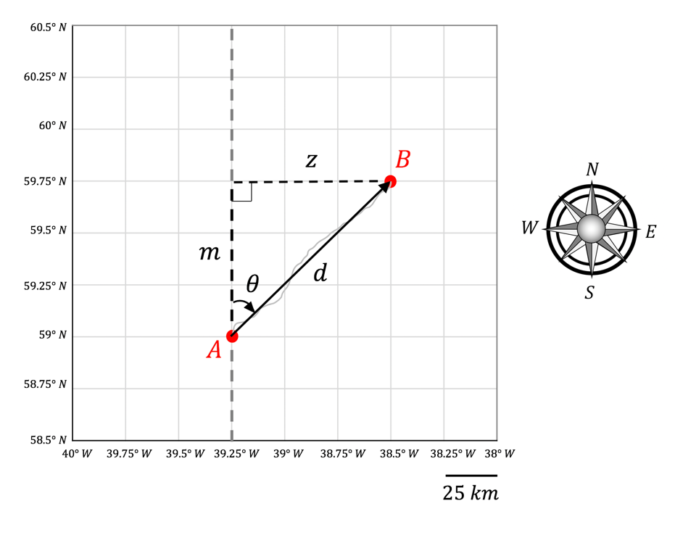
Using the values $m$ and $z$, both $θ$ and $d$ can be determined:

- Pythagorean’s theorem can be used to solve for $d$:

$$d= \sqrt{m^{2}+z^{2}}$$

- The bearing can be solved for using:

$$\tan\left(θ\right)=\frac{z}{m} → θ=arctan\left(\frac{z}{m}\right)$$

Calculating bearing and speed:

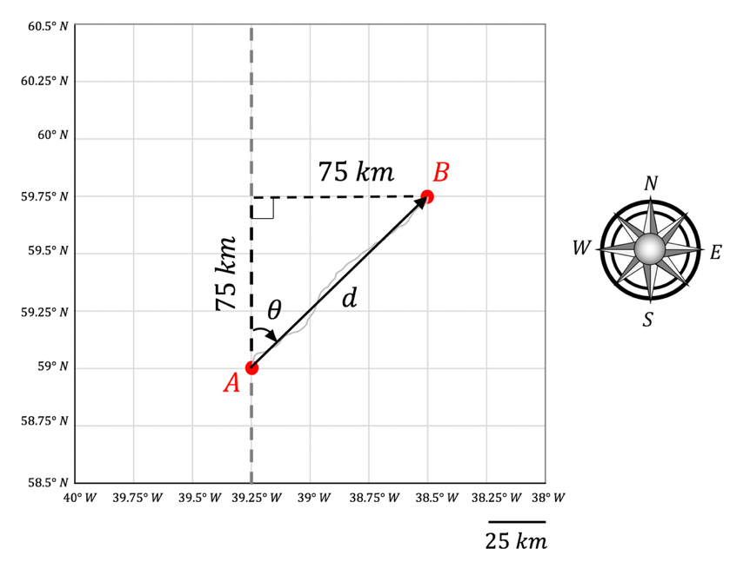
$$v=\frac{d}{∆t}$$

$$v=\frac{106.1 km}{15 days}$$

$$v=7.1 \frac{km}{day}$$

$$d= \sqrt{{(75 km)}^{2}+{(75 km)}^{2}}$$

$$d= 106.1 km$$

$$θ= arctan\left(\frac{75 km}{75 km}\right)$$

$$θ= arctan\left(1\right)$$

$$θ= 45°$$

Working with Geographic Data

Latitude and longitude are geographic coordinates. These are different from cartesian coordinates (x,y). They represent angles rather than distances.

- Latitude describes the angle made from the equator to a location in the North/South direction. The term meridional describes a direction along a circle of latitude.

- Longitude describes the angle made from the prime meridian to a location in the East/West direction. The term zonal describes a direction along a circle of longitude.

- Latitude is defined to be $0°$ at the equator. Latitude reaches a maximum of $90°$ at the North Pole and a minimum of $-90°$ at the South Pole.
  - Latitude can be any value $-90°≤θ≤90°$.

- Longitude is defined to be $0°$ at the prime meridian. Longitude is measured as a positive value East of the prime meridian (reaching a maximum of $180°$ at the anti-meridian) and is measured as a negative value West of the prime meridian (ranging towards a minimum of $-180°$ at the anti-meridian).
  - Longitude can be any value $-180°<θ≤180°$.
The Western and Southern directions can either be indicated by negative signs, or simply by stating the longitude or latitude are measured W or N, respectively.

- Example: the coordinates of Oregon State University are: $44.5638° N, 123.2794° W$
- Alternatively, this could be written as $(44.5638° , -123.2794°)$

To use geographic coordinates to find distances between two locations we need to perform some trigonometry. We will assume the earth is a sphere (this is in fact an approximation of the actual shape of the Earth, which is better approximated as an oblate spheroid, being flatter at the poles than the equator).

To find the distance, $d$, between two locations A and B on the Earth, we need to find the distances $m$ and $z$ shown in the diagram below.

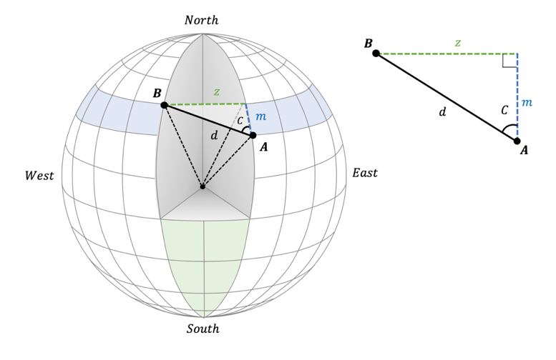

The meridional distance, $m,$ is represented by a change in latitude. We can calculate the angular change between locations A and B, $∆{lat}_{AB}$, to calculate $m.$

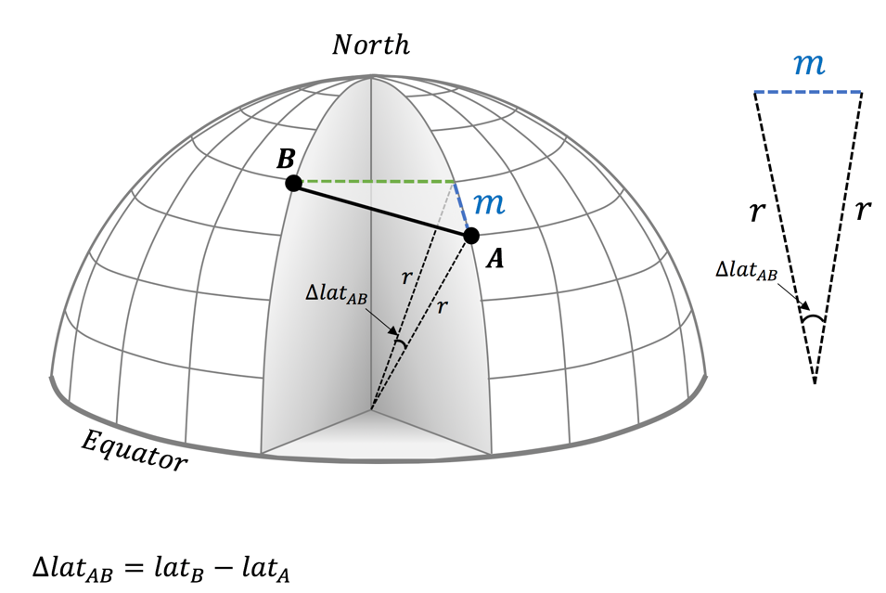
Look at the diagram above. Maybe you can see how we can calculate the meridional distance $m$. Is there a way to make right triangles from the isosceles triangle? Can you use trigonometry to find $m$ given you know $r$ (the radius of the Earth) and $∆{lat}_{AB}$?

To find $m$ we split the triangle made by $∆{lat}_{AB}$ in two, forming two right angle triangles. Each of these has hypotenuse $r$ and opposite length $\frac{m}{2}$. Hence we can find $m$ as
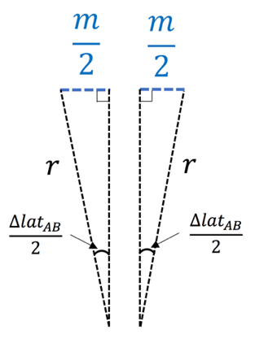
$$\frac{m}{2}= r\sin\left(\frac{∆{lat}_{AB}}{2}\right)$$

$$↓$$

$$m=2 r\sin\left(\frac{∆{lat}_{AB}}{2}\right)$$

Finding the zonal distance, z, is a little more involved because zonal bands decrease in radius as they approach the pole. The figure below illustrates this. A zonal band bounded by two fixed longitudes is outlined in black. The distance between the two longitudes bounding the zonal band decreases as latitude increases due to the shape of the Earth.
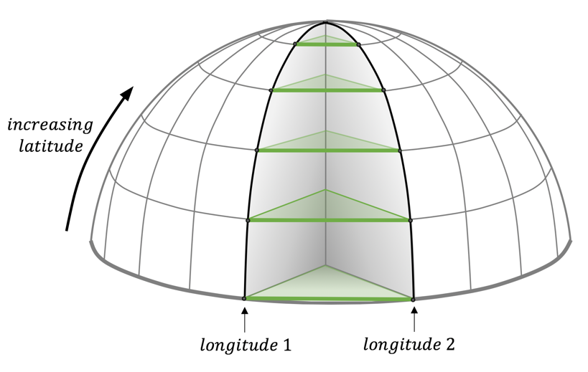
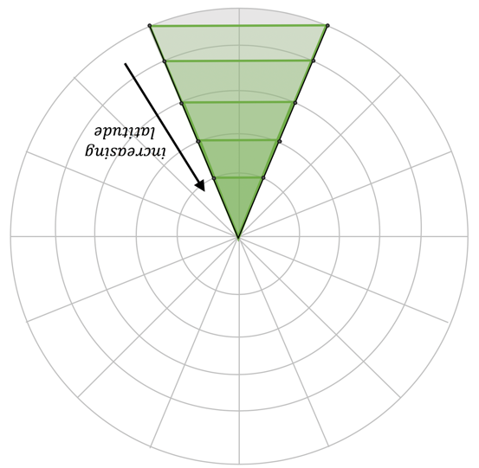
The zonal band as seen from looking down on the North Pole
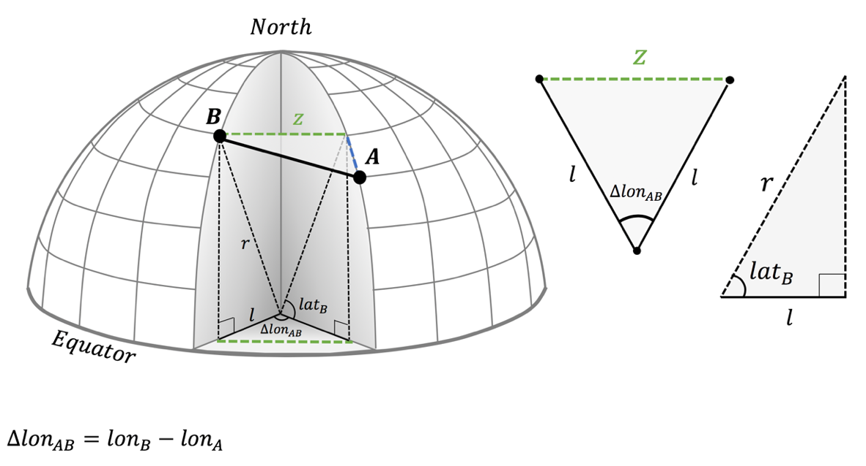

In the diagram above, see that we need to find the radius of the longitudinal band, $l,$ before calculating $z$. This radius, $l$, is the same as $r$ at the equator and decreases to 0 at the north pole. You can find $l$ if you know the latitude of the zonal band.

Using the right triangle in the above diagram, we can see that

$$l=r\cos{({lat}_{B})}$$

Splitting the isosceles triangle in two as we did on the previous page, we can solve for $z$ as
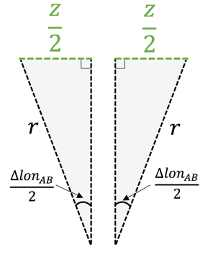

$$\frac{z}{2}=l\sin\left(\frac{∆{lon}_{AB}}{2}\right)$$

$$z= 2 l\sin\left(\frac{∆{lon}_{AB}}{2}\right)$$

Finally, combining the equations for $l$ and $z$, we can solve for $z$ as

$$z= 2 r\cos{({lat}_{B})}\sin\left(\frac{∆{lon}_{AB}}{2}\right)$$

Now we know $m$ and $z$ we can find distance $d$ and bearing $C$exactly as we did in cartesian coordinates.
Distance and bearing along a buoy trajectory

Accessing the Buoy Data:

Open your excel file with buoy data. If you wish, you can download the most recent data (it would have been updated since last lesson) and open this in an excel workbook as you did last lesson.

Identify the latitude and longitude data and identify the time data. Scroll to the end of the data. It might be a long data file. Write down the times and positions for the last day of drift or copy these to a separate excel sheet.

Linear approximation of the buoy trajectory:

Find the distance ($km$) and direction ($°$) this buoy has traveled over the last day.

Take the radius of the earth, $r$, to be $r=6356 km$. Assume the Earth is flat between the position the buoy was at yesterday and today. What is the distance and direction between these two points?

Finding the distance:
First consider the distance the buoy traveled latitudinally, then the distance it traveled longitudinally. You can find these distances with trigonometry (for example, $\frac{m}{2}= r\sin\left(\frac{θ}{2}\right)$).
You will need to construct a similar trigonometric identity for the zonal component of the drift. Combine the meridional and zonal distances, $m$ and $z$respectively, to find the distance, $d$, between the two points.

Finding the direction:
Direction can be found as the angle from the meridian bisecting the buoy’s initial position. This angle is labelled ‘C’ in figure 1. As you know the distances$m$and $z$, you can find this angle with trigonometry.
Useful triangle Identities:
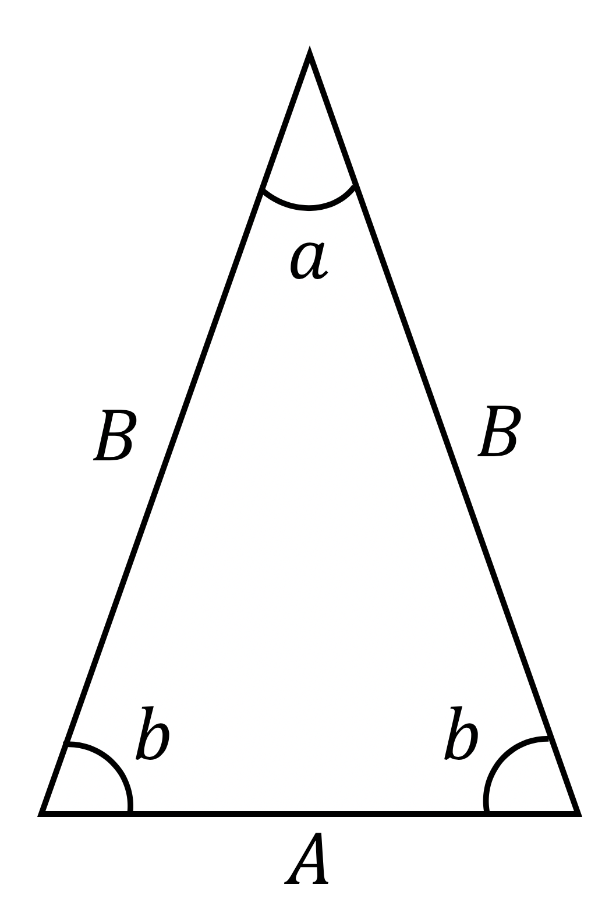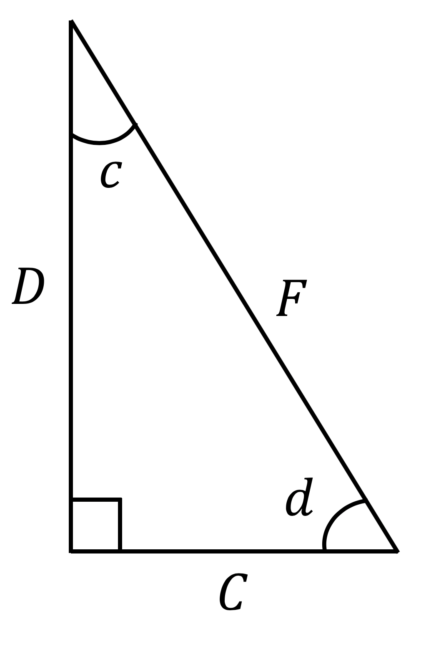

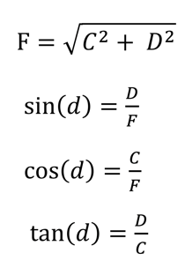
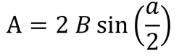

Figure 1: Depiction of the path traveled by the ice from point A (${latitude}_{A}, l{ongitude}_{A}$) to point B (${latitude}_{B}, l{ongitude}_{B}$). By knowing the latitude and longitude of the ice’s initial and ending locations, the distance,$d$, traveled and bearing, $C$, of the ice’s motion can be calculated.
Work Space
(Student handbook pages 1-3)

Solutions
(Student handbook pages 1-3)

distance: ______________________________ direction:_____________________________
Forecasting Drift from Speed and Bearing

Forecasting ice drift:

What can we do with the speed and bearing of the average ice drift? We can use it to try to forecast where the buoy will drift in the future.

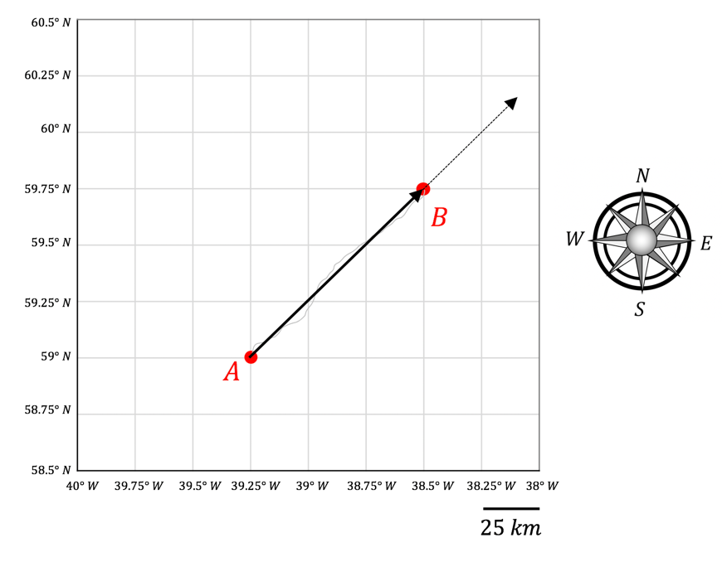

Let’s imagine the buoy continues to drift at the same speed and bearing at which it is currently drifting. Where will it be in 5 days?

We can calculate where it will be using the same math we used above – but in reverse. Now, by knowing the bearing and speed, we can find the distance it travels to see where it ends up.
$$v=7.1 \frac{km}{day}, θ= 45°$$

We know the current drift is described by:

From the known speed, the distance traveled in a given time can be calculated:

$$v= \frac{d}{∆t} → d= v ∆t$$

Over 5 days, the distance traveled by the buoy will be given by:

$$d=\left(7.1 \frac{km}{day}\right) (5 days)$$

$$d=35.5 km$$

Knowing the distance traveled and the direction along which it travels, the zonal and meridional components of the travel can be calculated:
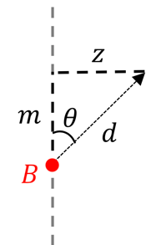

$$\sin\left(θ\right)=\frac{z}{d} → z=d\sin\left(θ\right)$$

$$\cos\left(θ\right)=\frac{m}{d} → m=d\cos\left(θ\right)$$

$$m=d\cos\left(θ\right)$$

$$m=(35.5 km)\cos\left(45°\right)$$

$$m=25.1 km$$

$$z=d\sin\left(θ\right)$$

$$z=(35.5 km)\sin\left(45°\right)$$

$$z=25.1 km$$

The distances traveled in either direction can be added onto the ice’s current location to find where it might end up after 5 more days of drift.

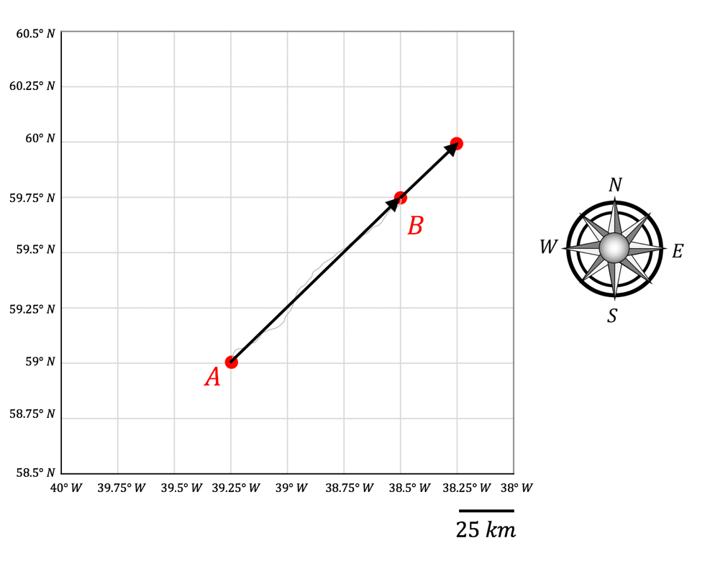
Extrapolating position with distance and bearing

Let us assume that the ice will keep moving at the same speed and in the same direction as it did over the last day. Where will the ice drift to in a day’s time?

Assume the ice will keep drifting with the same bearing and speed of the previous day. Calculate the meridional and zonal distance it will travel.

From these two distances find the number of degrees latitude and degrees longitude the ice moved. Add these to the start position to estimate where the ice will be in one day. Points for discussion.

How accurate do you think your forecast is?
How will you test this?
Let’s see tomorrow where the buoy moved to.

The figures below can be used to visualize the path of the ice.

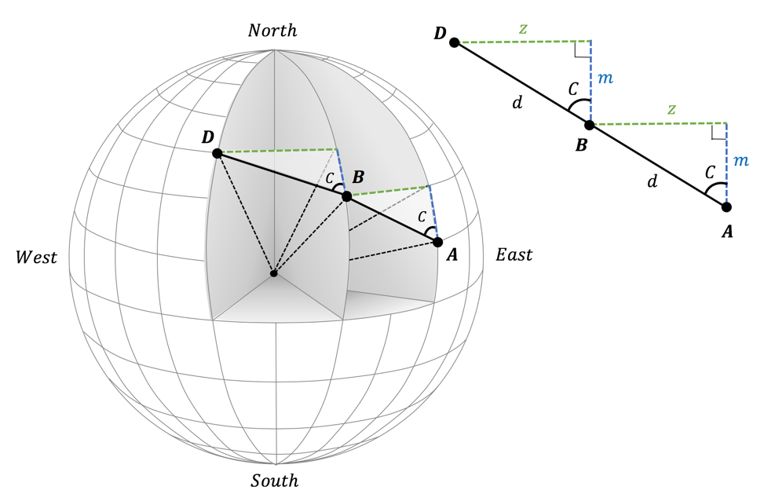

Figure 1: Depiction of the path traveled by the ice from point A ($latA, lonA$) to point B ($latB, lonB)$in one day and ultimately to point D ($latD, lonD$) the following day. By knowing the latitude and longitude of the ice at points A and B, as well as the distance,$d$, traveled and direction, $C$, of the ice motion between these points over the first day, the location of the ice the following day (D) can be estimated.

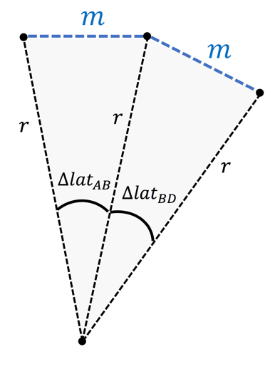
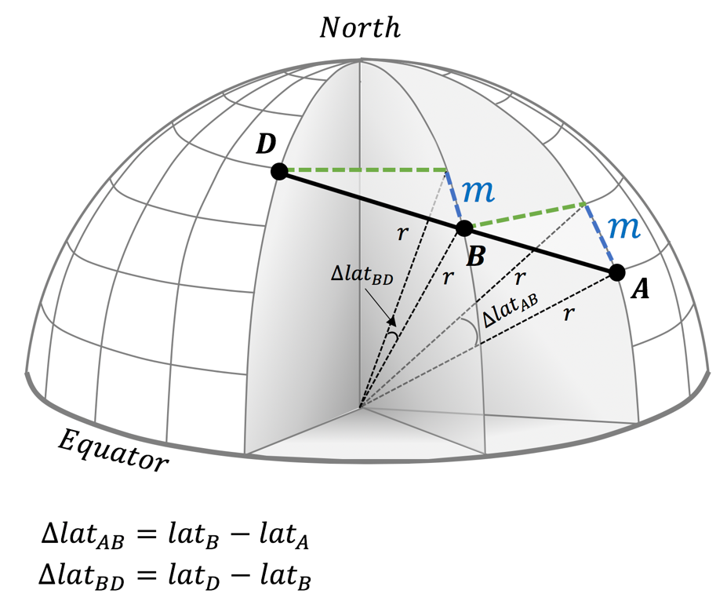

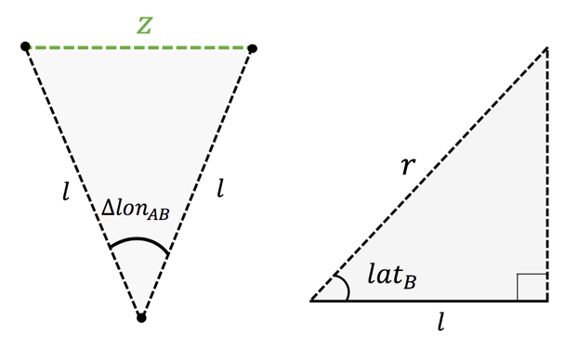
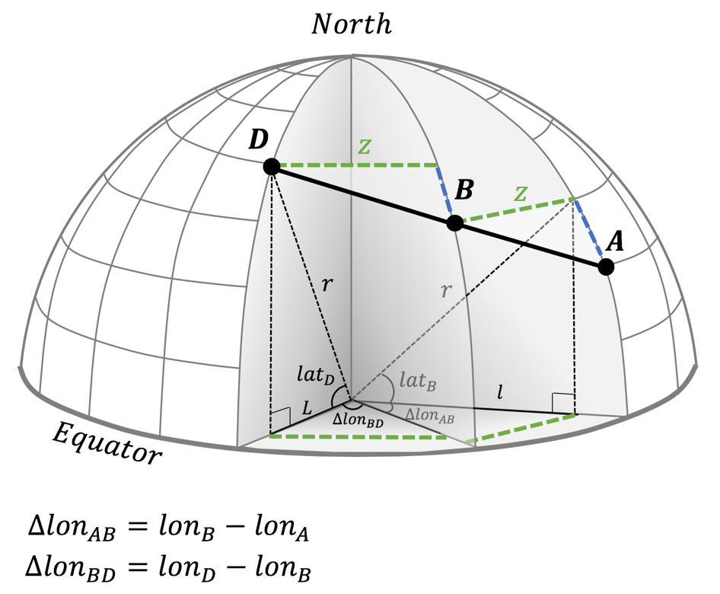

Figure 2: Path geometry that is useful for calculating distance and bearing of ice motion.

Work Space
(Student handbook pages 1-3)

Solutions
(Student handbook pages 1-3)

Beginning coordinates (locations A and B): ___________________________________________

Ending coordinates (location D): ___________________________________________________
Estimating forecast model error for buoy ID 300234061872720

Your forecast of buoy drift is a model. Assuming the buoy will continue to drift with the same speed and direction it has now into the future is called a persistence forecast.

We can perform hindcasts, which are the same as forecasts however performed for times in the past so we can compare forecast drift against the actual observed buoy trajectory. Model error is calculated by finding the difference between the hindcast position and the actual position of the buoy at for the time you hindcast. As your model works the same for any buoy in the Arctic, you can use any buoy (or set of buoys) to estimate the model error.

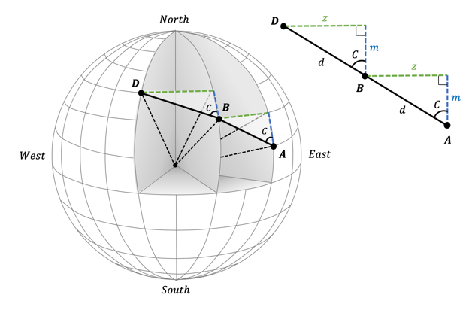
You will be given two past positions, A and B, of buoy ID 300234061872720. From these, hindcast position D (where the buoy will be in a day). Record positions A and B and their time here.

Location | Latitude | Longitude | Time (day of year)
A
B

Find the geographic location D, assuming the buoy will continue on the same trajectory at the same speed and bearing as between locations A and B. You will need to follow the same method you used previously and use the following page for your calculations.

Note your results here so you can share them. Time is the time you are forecasting to.
Location | Latitude | Longitude | Time (day of year)
D

Once everyone has calculated their hindcasts, you will want to collate all the data into one place so you can use it to estimate the persistence model error.

The hindcasted locations can be recorded in the table on page 21 for reference:
Work Space
(Student handbook pages 1-3)

Day of Forecast | (Latitude, Longitude) | Student(s) Assigned
350 | Forecast D: ( $°, °$)  Reported D: ($85.7006°, 149.7012°$)
352 | Forecast D: ( $°, °$)  Reported D: ($85.7864°, 149.1562°$)
354 | Forecast D: ( $°, °$)  Reported D: ($85.7318°, 147.4628°$)
356 | Forecast D: ( $°, °$)  Reported D: ($85.6472°, 145.2402°$)
358 | Forecast D: ( $°, °$)  Reported D: ($85.822°, 146.2298°$)
360 | Forecast D: ( $°, °$)  Reported D: ($86.169°, 146.396°$)
362 | Forecast D: ( $°, °$)  Reported D: ($86.3678°, 147.2328°$)
364 | Forecast D: ( $°, °$)  Reported D: ($86.5726°, 146.525°$)
1 | Forecast D: ( $°, °$)  Reported D: ($86.7198°, 145.7782°$)

Reported D is the position the buoy was actually at on the day of forecast.

Error calculation

Error will be calculated as the difference in the distance your forecast predicted the buoy would travel, $d_{F}$, and the distance the buoy was actually reported to have traveled, $d_{R}$, in a given period of time:
$$error= d_{F}- d_{R}$$

Calculate the error of your forecast using the reported and forecast locations of the buoy at D.

Hint: You will need to calculate distance d_{R} using reported locations D and B
Once everyone has estimated the error of their forecast, note these errors in the table below. The forecast positions are provided here so you can check your calculations.

Day of Forecast | (Latitude, Longitude) | error (kilometers)
350 | Forecast D: ($85.697°, 149.6030°$)  Reported D: ($85.7006°, 149.7012°$)
352 | Forecast D: ($85.787°, 149.3920°$)  Reported D: ($85.7864°, 149.1562°$)
354 | Forecast D: ($85.8168°, 148.2129°$)  Reported D: ($85.7318°, 147.4628°$)
356 | Forecast D: ($85.6086°, 143.7871°$)  Reported D: ($85.6472°, 145.2402°$)
358 | Forecast D: ($85.7672°, 146.3782°$)  Reported D: ($85.822°, 146.2298°$)
360 | Forecast D: ($86.1548°, 144.4886°$)  Reported D: ($86.169°, 146.396°$)
362 | Forecast D: ($86.2854°, 147.8497°$)  Reported D: ($86.3678°, 147.2328°$)
364 | Forecast D: ($86.571°, 147.3266°$)  Reported D: ($86.5726°, 146.525°$)
1 | Forecast D: ($86.731°, 145.7384°$)  Reported D: ($86.7198°, 145.7782°$)

Sum of ${\left(error\right)}^{2}$ _________________________

Model error is calculated as the root mean square error.

$$Model error= \frac{\sqrt{\sum{{\left(error\right)}^{2}}}}{n}$$

where error is the individual differences between forecast and observation that you entered in the table above.$n$ is the number of forecasts compared to observations. There are 9 entries in the table above, so $n=9$.

Model Error = __________________________________________________

If you wanted to find a buoy one day after it reports a position, how large a search radius would you recommend?

Search radius = __________________________________________________

