GOOGLE EARTH WEBSITE AND RESOURCES

Download Google Earth Pro

Websites and Resources

USGS Earthquake Catalog

USGS Google Earth/KML Files

SERC - Eyes in the Skies II: GoogleEarth Index

SERC - Teach the Earth: GoogleEarth and Geoscience Education

NOAA National Buoy Center
Use the links at the bottom right of the map to access GoogleEarth data.

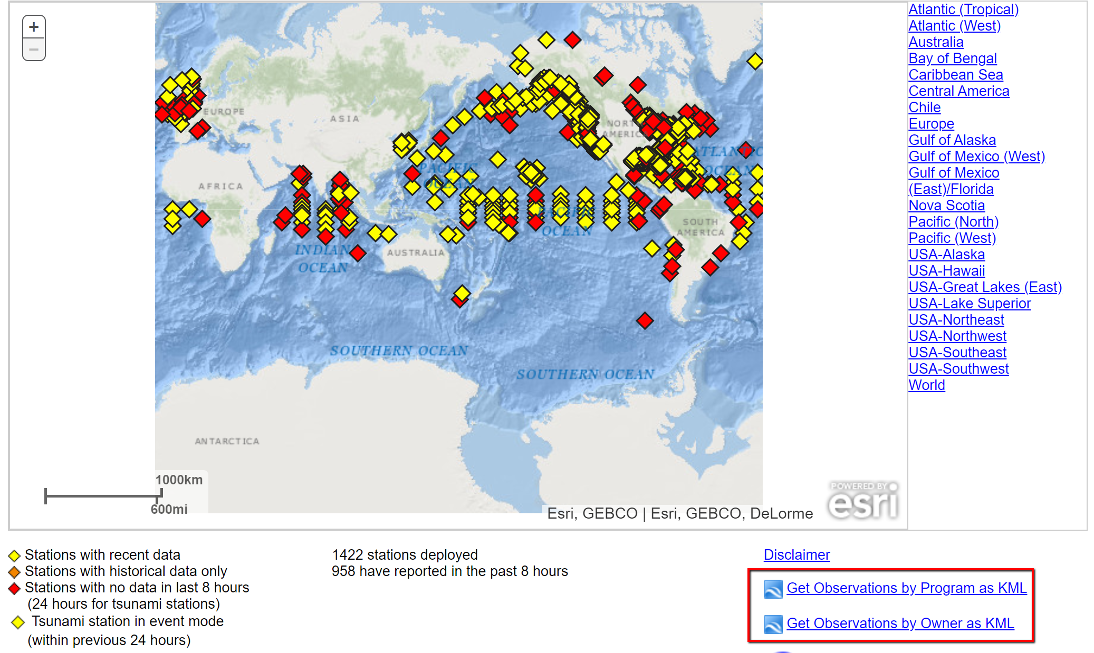

GoogleOcean - Google Maps & Google Earth as visualization tools for marine data

Earth Exploration Toolkit - use of data in teaching earth science with some Google Earth applications.

Climate.gov - good resource for climate information, data and teaching resources. There are some Google Earth applications at this site.

Smithsonian Global Volcanism Program - resources and media including Google Earth overlays of volcanoes.

Google Earth Tours of Glacial Change - this looks interesting and promising but does not seem to be very functional.

National Snow and Ice Data Center - NSIDC Data on Google Earth

Eruption video of Mexico's Popocatépetl

Taal Volcanic Eruption

OTHER VISUALIZATION TIPS & PROCESSES
JING AND POWERPOINT

Jing

- The screen capture application Jing is likely my favorite application and I use this all the time.
- Here is a link to the TechSmith website to download Jing

Some PowerPoint Tips That I Find Useful

- Setting backgrounds and fading backgrounds
- Doing overlays to emphasize parts of diagrams
- Showing a series with a fade

