Saving White City’s Air IV – Wood to Electricity
(Advanced)

Objectives
- Understand how important steam is for generating and transporting heat from biofuels
- Understand how air pressure exerts force
- Differentiate the states of matter for water
- Estimate the volume difference between steam and water
- Apply the energy required to turn water into steam (specific heat of water, heat of vaporization, and heat of condensation
- Apply scientific concepts of air pressure and states of water to engineering designs

Skill Level: High school | Prep time: Minimal  Activity time: 25 minutes demo, 25 minutes design activity (could be completed on different days)

Materials
- Saving White City’s Air IV – Activity sheet (one copy for each group)
- Scrap cardboard: Poster board, paper-towel tubes, cereal boxes, etc
- Tape
- Scissors

Next Generation Science Standards
Disciplinary Core Idea:
HS-ETS1.B: Developing Possible Solutions
HS-ETS1.C: Optimizing the Design Solution

Performance Expectations:
HS-PS3-3. Design, build, and refine a device that works within given constraints to convert one form of energy into another form of energy.
Practices  Asking questions / defining problems  Developing / using models  Planning / carrying out investigations  Analyzing / interpreting data  Math / computational thinking  Constructing explanations / design solutions  Engaging in argument from evidence  Obtaining / evaluate / communicate | Practices  Asking questions / defining problems  Developing / using models  Planning / carrying out investigations  Analyzing / interpreting data  Math / computational thinking  Constructing explanations / design solutions  Engaging in argument from evidence  Obtaining / evaluate / communicate

Background Information
Wood is a bioenergy source that has been use by humans since the dawn of civilization. We have relied upon wood to heat our homes and cook our food in almost every culture. However, it is sometimes more useful to convert wood into a different form of biofuel for a specific purpose. Wood can be converted into a solid (char or charcoal), liquid (bio-oil) or gas (synthesis gas). Without conversion, wood can have a low energy density and can be difficult to transport.
Wood can be converted into other biofuels using four thermal conversion methods (Carbonization, Pyrolysis, Gasification, and combustion). When wood is burned for fuel, it goes through a multi-step process of breakdown and then combustion. None of this can happen without adding heat to the wood. As we all know, we can’t light a piece of paper without first adding a small amount of heat from a match or lighter.
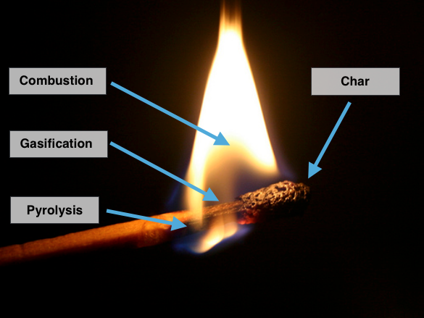
Figure 1. Thermal conversion in a simple match Photo Ref
The earliest method to modify wood into a higher density fuel was to make charcoal. Charcoal is made when wood is heated to a low temperature without oxygen. Charcoal burns very cleanly and produces more heat energy per mass than wood. Char (similar to charcoal) is the black material left after a match burns.
Another way to convert wood into a more-useful energy source is to make bio-oil out of it through a process called pyrolysis. Heating wood without oxygen creates pyrolysis vapors that condense into a liquid. The resulting alternative fuel is easy to burn and the bio-oil can be transported efficiently, although it can’t be directly burned in cars. It can be burned for electricity generation and heat. You can sometimes see a sticky, black oil at the base of a match flame. This is bio-oil and it can be captured for processing into an upgraded cleaner substance.
Another way to convert wood is to heat it with a small amount of oxygen in a process called gasification. This generates a burnable gas (also called synthetic gas or syngas) that can be burned in a generator for electricity. In a match, it is primarily gasification that creates the gasses that are burned in the flame.
Finally, wood can be burned directly – through combustion. During combustion, gases are burned to generate heat and smoke. If wood is used to generate steam, it can be burned in a boiler without any conversion. The steam can be used for heat in homes or factory processes or to turn a turbine.
In situations where steam is not needed, one of the other forms of biofuel might be more appropriate. Charcoal can be transported more easily than wood and was used to power cars in World War II. Bio-oil and syngas can be piped to generator engines, where solid wood cannot. It can also be more efficient to convert the wood into another product before burning it. While thermal conversion processes were invented for over 100 years ago (the first gas lamps were fueled by wood gas) they still have their place in a comprehensive energy strategy today. No one biofuel is lkely to solve our energy challenges on its own.
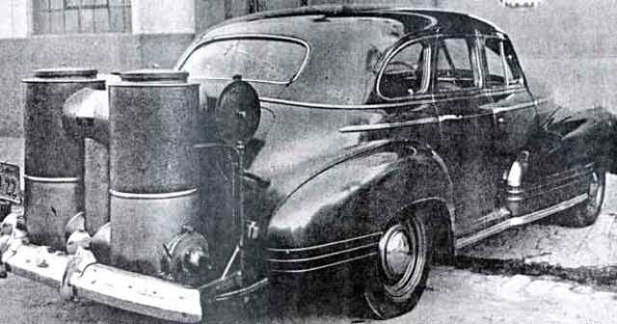
Figure 2. Gasifier installed on a vehicle during the 1940’s Ref
New technologies are making these processes even more efficient and producing fewer waste products. It is even possible that we might drive cars powered by a derivative of bio-oil or syngas in the future.
Biofuel Thermal Conversion Summary
- Carbonization (Low heat, no oxygen) – Produces charcoal
- Pyrolysis (Medium heat, no oxygen) – Produces bio-oil
- Gasification (Medium heat, low oxygen) – Produces synthesis gas, syngas
- Combustion (High heat, high oxygen) – Produces heat, soot, and smoke

Steam has been used for thousands of years to power devices. Hero of Alexander, an early Greek scientist and philosopher, described the first steam engine in the first century AD. Although his steam engine was more of a novelty than a device to perform serious work, it demonstrated that steam could be harnessed for human purposes.
In the 1700’s and 1800’s steam became the workhorse behind many engines of the industrial revolution. Engines using steam powered mine pumps, locomotives and factories. Steam engines were popular because they could operate on just about any fuel source then available such as coal and firewood. As new fuels became available in the early 1900’s (gasoline and diesel) the steam engine lost popularity as a driver of technology. That does not mean that steam is no longer used today, however. Steam is used today to generate power in nuclear reactors, natural gas, and coal plants. Because steam can be generated from many heat sources, steam turbine systems are common in the alternative energy field where they generate electricity from solar, geothermal, and biofuel sources. In the bioenergy field, fuel sources include bio-gas, sawdust, wood pellets, hog fuel and even municipal solid waste are used to create steam.
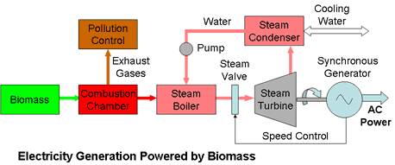
Figure 2. Typical schematic of a biomass power generation system. Ref
This activity explores using combustion to turn biomass, like the White City wood chips, into electricity. In a typical power generation system (see Figure 2) biomass is carried on a conveyor into a boiler that burns the fuel and turns water into steam. The large expansion of steam (as shown in the demo below) is sent at high pressure into a steam turbine. The spinning blades power an AC generator that delivers electricity to the power grid. After exiting the steam turbine, the steam is sent to a condenser where it turns back into water. It is important to recycle the water because it is very pure and difficult to get, and this process uses large quantities of water that would be wasted into the environment. Students will design a simple model of a biomass steam turbine plant that includes all these components. Figure 3 below shows a diagram of a 20 megawatt biomass boiler, similar to what could be installed in White City.
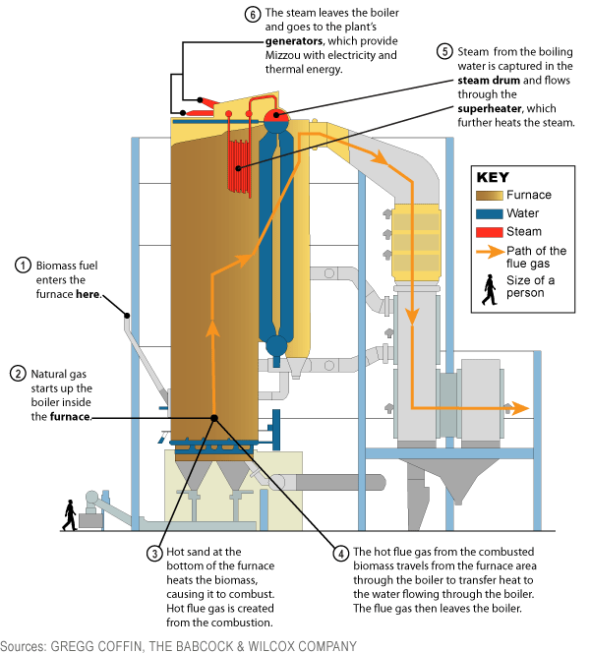
Figure 3. Biomass Boiler that turns wood into steam. Ref

Engineer (Elaborate)
Problem to Solve: How could you build a power generation plant that could burn wood chips to make steam, which powers a turbine generator?

Background: Sawmills use boilers to convert sawdust into steam. Rather than converting the wood biomass into another biofuel, it is burned by combustion for heat. The steam is then run through a turbine to generate electricity and to also provide heat.
Time options:
This design activity can be used in multiple ways, depending on the time available:
- Students complete a drawing of their design during the PLAN phase, but don’t build a model
- Students complete the drawing (PLAN) and model (BUILD) but don’t test it
- Students complete a drawing (PLAN), model (BUILD), and testing (IMPROVE)

Activity
- Begin the activity with a discussion of the difference between engineering and science. Emphasize that science tries to understand nature and engineering attempts to solve problems.

- ASK
  - Help the students understand that engineers begin with a detailed description (requirements) of the problem they need to solve. Without requirements, engineers would not know what the finished product should be able to do.
  - Divide the class into design teams.
  - Give each team one of the articles included in Saving White City’s Air III-- Activity Sheet (separate file). Ask them to read the article and be prepared to share how their article could help their power station design.
  - After each team has shared their article, write the following requirements on the board for each team to use:
    - A way to get wood chips into the boiler from the chip pile (Enter the boiler half-way up)
    - A place to hold the water until it turns into steam
    - The model is able to hold 2 liters of chips
    - A turbine generator
    - A way to convert the steam back into water for reuse
- IMAGINE
  - Each team needs to take the requirements and come up with ways they can solve the problem.
  - Assign project manager, artist, builder, and calculator roles. This will ensure each student is given the opportunity to participate in the design.
  - Ask the project manager to have the team vote on the ideas to decide which one is going to work best.
- PLAN
  - Design questions. These can be answered by having the students complete the Saving White City’s Air IV – Activity Sheet
    - How long does the conveyor need to be?
    - How large does the boiler need to be?
    - How large does the condenser need to be?
    - How much fuel will the plant burn in a year? Is the White City pile large enough?
    - How much water will the plant use per hour?
  - Have the teams figure out the sizing of the components necessary to deliver 20 megawatts.
  - Ask the artist to draw their design
  - Ask the calculator to estimate how much wood the boiler will need to burn
  - Approve the plan before the team starts to build.
- CREATE

  - Ask the builder to guide the team in building the design out of the supplied cardboard materials. A scale of 1 inch = 3 feet provides a nice scale.
  - Ask the calculator to provide feedback on the estimated cost of the project
  - Ask the artist to ensure the design from the is followed
- IMPROVE
  - Have each team test their design to ensure it will hold 2 liters (foam peanuts are easier to manage in a classroom than actual sawdust)
  - Have each team weigh their design
  - Ask the calculator to determine the final cost of their design
  - Have each team present their design and ask the other teams to give a rating on each requirement.
  - Using this feedback, students can improve their designs.

Resources
Additional Resources:

- Proper heating of test tubes – CRS Scientific
- Heat of vaporization – Kent Chemistry
- Energy content in various biofuel feedstocks
- Biomass Boilers
- How does a condenser work? -- GEA

Resources Used:
- How to get steam into a balloon – eHow
- The magic of steam – Boys and Girls Science and Tech Club

Saving White City’s Air IV: Worksheet Answers

1. What is the size of the generator? 20 megawatts for the White City plant.
2. How many wood chips are needed?
- How much electricity is generated per ton of wood? .54 megawatts
(Article 2)
- How much wood is needed per hour? 37 tons
(1 ÷ 2a)
- How much wood (tons) is in the White City pile? 130,000 tons
(Article 1)
- How long (hr) can the plant be run on the White City pile? 3513 hours
(2c ÷ 2b)
e) How long (days) can the plant be run on the White City pile? 146 days

3. How much steam is required (per hour)?

- How much steam to generate 1 megawatt? 5 tons
(Article 2)
- How much steam to generate 20 megawatts? 100 tons
(20 ×3a)

4. How much water is required (per hour)?
- How many gallons of water are required for 1 megawatt? 1204 gallons
(Article 2)
- How much water is required per hour for 20 mw? 24,096 gallons / hr
(20 ÷4a)
5. How tall does the boiler need to be (per hour)?
- Tons of steam per foot of boiler height? 3.53 tons / hr
(Article 3)
- How high does the boiler need to be? 28.3 ft
(3b ÷ 4a)

6. How large is the condenser?
- How much area is required for 1 ton/hr steam? 50 sq ft
(Article 4)
- What is the area needed for the condenser? 5,000 sq ft
(3b × 6a)
- What would the lengths of a side if installed in a square? 70.7 ft
(Square root of 6b)
7) How long is the conveyor?
- Where does the conveyor need to go on the boiler? Half way up
(Article 1)
- How high does the conveyor need to go? 14.2 ft
(Use 3b & 7a)
- How much rise is there for every 10 feet of conveyor? 2.6 ft
(Article 1)
- How long does the conveyor need to be? 54.6 ft
(7b ÷ 7c x 10)

