Saving White City’s Air II: Wood to Electricity

Objectives
- Differentiate thermal conversions of wood (pyrolysis, gasification, combustion)
- Understand the uses for each thermal conversion product.
- Create a basic model of a gasifier

Skill Level: Middle school | Prep time: Minimal  Activity time: 30 minutes

Materials
- Saving White City’s Air II – Activity sheet (one copy for each group)
- Scrap cardboard: Poster board, paper-towel tubes, cereal boxes, etc
- Tape
- Scissors

Next Generation Science Standards
Disciplinary Core Idea:
MS-ETS1.B: Developing Possible Solutions
MS-ETS1.C: Optimizing the Design Solution
Performance Expectations:
MS-PS1-6. Undertake a design project to construct, test, and modify a device that either releases or absorbs thermal energy by chemical processes.
Practices  Asking questions / defining problems  Developing / using models  Planning / carrying out investigations  Analyzing / interpreting data  Math / computational thinking  Constructing explanations / design solutions  Engaging in argument from evidence  Obtaining / evaluate / communicate | Practices  Asking questions / defining problems  Developing / using models  Planning / carrying out investigations  Analyzing / interpreting data  Math / computational thinking  Constructing explanations / design solutions  Engaging in argument from evidence  Obtaining / evaluate / communicate

Background Information
Wood is a bioenergy source that has been use by humans since the dawn of civilization. We have relied upon wood to heat our homes and cook our food in almost every culture. However, it is sometimes more useful to convert wood into a different form of biofuel for a specific purpose. Wood can be converted into a solid (char or charcoal), liquid (bio-oil) or gas (synthesis gas). Without conversion, wood can have a low energy density and can be difficult to transport.
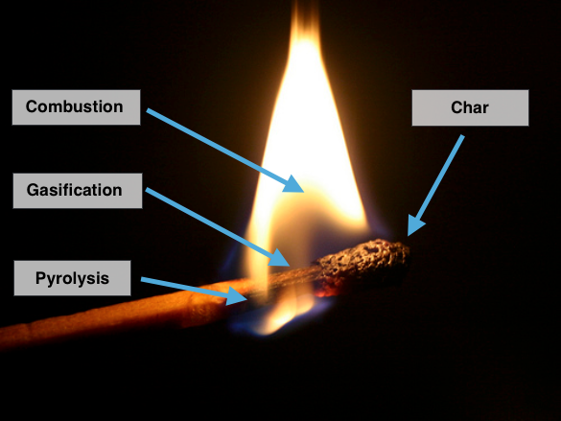
Figure 1. Thermal conversion in a simple match Photo Ref
Wood can be converted into other biofuels using four thermal conversion methods (Carbonization, pyrolysis, gasification, and combustion). When wood is burned for fuel, it goes through a multi-step process of breakdown and then combustion. None of this can happen without adding heat to the wood. As we all know, we cannot light a piece of paper without first adding a small amount of heat from a match or lighter.
The earliest method to modify wood into a higher density fuel was to make charcoal. Charcoal is made when wood is heated to a low temperature without oxygen. Charcoal burns very cleanly and produces more heat energy per mass than wood. Char (similar to charcoal) is the black material left after a match burns.
Another way to convert wood into a more-useful energy source is to make bio-oil out of it through a process called pyrolysis. Heating wood without oxygen creates pyrolysis vapors that condense into a liquid. The resulting alternative fuel is easy to burn and the bio-oil can be transported efficiently, although it cannot be directly burned in cars. It can be burned for electricity generation and heat. You can sometimes see a sticky, black oil at the base of a match flame. This is bio-oil and it can be captured for processing into an upgraded cleaner substance.
Another way to convert wood is to heat it with a small amount of oxygen in a process called gasification. This generates a burnable gas (also called synthetic gas or syngas) that can be burned in a generator for electricity. Syngas is primarily comprised of hydrogen and carbon-monoxide gases that burn readily. In a match, it is primarily gasification that creates the gasses that are burned in the flame.
Finally, wood can be burned directly – through combustion. During combustion, gases are burned to generate heat and smoke. If wood is used to generate steam, it can be burned in a boiler without any conversion. The steam can be used for heat in homes or factory processes or to turn a turbine.
In situations where steam is not needed, one of the other forms of biofuel might be more appropriate. Charcoal can be transported more easily than wood and was used to power cars in World War II. Bio-oil and syngas can be piped to generator engines, where solid wood cannot. It can also be more efficient to convert the wood into another product before burning it. While thermal conversion processes were invented for over 100 years ago (the first gas lamps were fueled by wood gas) they still have their place in a comprehensive energy strategy today. No one biofuel is likely to solve our energy challenges on its own.
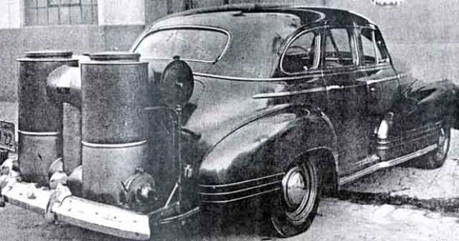
Figure 2. Gasifier installed on a vehicle during the 1940’s Ref
New technologies are making these processes even more efficient and producing fewer waste products. It is even possible that we might drive cars powered by a derivative of bio-oil or syngas in the future.
Biofuel Thermal Conversion Summary
- Carbonization (Low heat, no oxygen) – Produces charcoal
- Pyrolysis (Medium heat, no oxygen) – Produces bio-oil
- Gasification (Medium heat, low oxygen) – Produces synthesis gas, syngas
- Combustion (High heat, high oxygen) – Produces heat, soot, and smoke

In this activity, students have an opportunity to understand how a gasifier works. The wood chips from the White City pile (see Saving White City’s Air I activity) are turned into syngas in the gasifier. The syngas is then sent to a piston engine that can burn this type of fuel. The engine turns an electrical generator that can be used to power the town.

Engineer (Elaborate)
Problem to Solve: Build a simple model of a gasifier plant that could burn the White City wood chip pile and generate power for the town?

Background: Sawmills use gasifiers to convert sawdust into bio-gas. The syngas can then be used as fuel in a motor that generates electricity. A basic gasifier is comprised of a wood conveyor and a large tank for burning the wood without oxygen. Wood chips are added to the top of the tank and they are turned into gas through heat. Through this activity, students will have an opportunity to understand how these components work together.

Time options:
This design activity can be used in multiple ways, depending on the time available:
- Students complete a drawing of their design during the PLAN phase, but don’t build a model
- Students complete the drawing (PLAN) and model (BUILD) but don’t test it
- Students complete a drawing (PLAN), model (BUILD), and testing (IMPROVE)

Activity
- Begin the activity with a discussion of the difference between engineering and science. Emphasize that science tries to understand nature and engineering attempts to solve problems.

- ASK
  - Help the students understand that engineers begin with a detailed description (requirements) of the problem they need to solve. Without requirements, engineers would not know what the finished product should be able to do.
  - Divide the class into design teams.
  - Give each team one of the articles included in the Appendix. Ask them to read the article and be prepared to share how their article could help their gasifier design.
  - After each team has shared their article, write the following requirements on the board for each team to use:
    - A way to get wood chips into the gasifier from the chip pile
    - A way to keep air away from the wood chips while they are gasified
    - The model is able to hold 2 liters of chips
    - A way to get ash out of the gasifier after it has been processed
    - Lowest cost while meeting the requirements (cost is based on weight of materials used)
- IMAGINE
  - Each team needs to take the requirements and come up with ways they can solve the problem.
  - Assign project manager, artist, builder, and calculator roles. This will ensure each student is given the opportunity to participate in the design.
  - Ask the project manager to have the team vote on the ideas to decide which one is going to work best.
- PLAN
  - Have the teams figure out how the components will fit together
  - Following are some design questions the students will need to answer:
    - Is the belt conveyor or chain conveyer best for this design? The chain conveyor is more expensive, so it is needed? (Belt conveyor typically works best)
    - Where does the conveyor need to deliver wood chips on the gasifier? Top, middle, or bottom? (Top)
    - What are the major components of the gasifier? (Inner tank, outer tank, insulation, and gas out tube)
  - Ask the artist draw their design
  - Ask the calculator to estimate the cost of the design (each gram of material costs $100,000.00)
  - Approve the plan before the team starts to build.
- CREATE
  - Ask the builder to guide the team in building the design out of the supplied cardboard materials. A scale of 1 inch = 3 feet works well. This will give a 12-inch tall and 4-inch diameter gasifier tank. A tank of this size will hold two liters.
  - Ask the calculator to provide feedback on the estimated cost of the project
  - Ask the artist to ensure the design plan is followed
- IMPROVE
  - Have each team test their design to ensure it will hold 2 liters (foam peanuts are easier to manage in a classroom than actual sawdust)
  - Have each team weigh their design
  - Ask the calculator to determine the final cost of their design
  - Have each team present their design and ask the other teams to give a rating on each requirement.
  - Using this feedback, students can improve their designs.

Resources
Additional Resources:

- Bioenergy conversion technologies
- Bioenergy conversion technologies list
- Bioenergy conversion types
- Pyrolysis processes
- Gasification
- Sawdust combustion boiler / water heater
- Biomass One catches fire in White City -- YouTube
- Biomass bark pile ignites again – Mail Tribune
- Build a bio-gas stove

Resources Used:
- Elementary Engineering Design Process – Boston Museum of Science

