Human Population Density Practice Work Activity
In this activity, your group will be responsible for determining the population density of the 5-8 states assigned to you. After determining population and population density, you will be reporting your results to the class via an interpretative map. After completion of the map, you will answer several questions regarding populations and limiting factors.
Part 1: Population Research
- Use the website http://www.census.gov/2010census/ to find the population of the states you were assigned and record your findings in the table below.
- Find the square mileage of each state by using the website http://en.wikipedia.org/wiki/List_of_U.S._states_and_territories_by_area and record into the data table.
- Find the population density, which is how many people there are in your state per square mile. You can do this by dividing the population by the square mileage for each state. Record this in your data table.

Population Density for Selected US states
State | Population (2010) | Square mileage | Population Density  (population/sq. mileage)

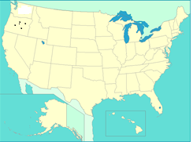
Part 2: Classroom Map
- Use the map on the smart board to record the population for each state that you looked up onto the classroom map. One dot on the smart board represents one million people. Round to the nearest million.

- Example: Oregon’s population is 3,831,074. We can round this to about 4,000,000. This would be 4 dots for the state of Oregon.
- After all groups have put dots on the map, you may take a picture on your phone (or ask a friend to take a picture) and use your picture and your notes from class to answer the questions on the back of this sheet.

Part 3: Discussion Questions

- Which states had the highest population density? Lowest?

- Why do you think that some states are more populated than others?

- Our classroom map shows the population for each state. In actuality, population density will be different depending on which part of a state you are in. Would you expect the human population density to be higher or lower than the state average in….
  - A large city?
  - A farming area of the state?
  - A national forest area?

- Give 3 examples of density-independent factors that might effect a state’s human population.

- Give 3 examples of density-dependent factors that might effect a state’s human population.

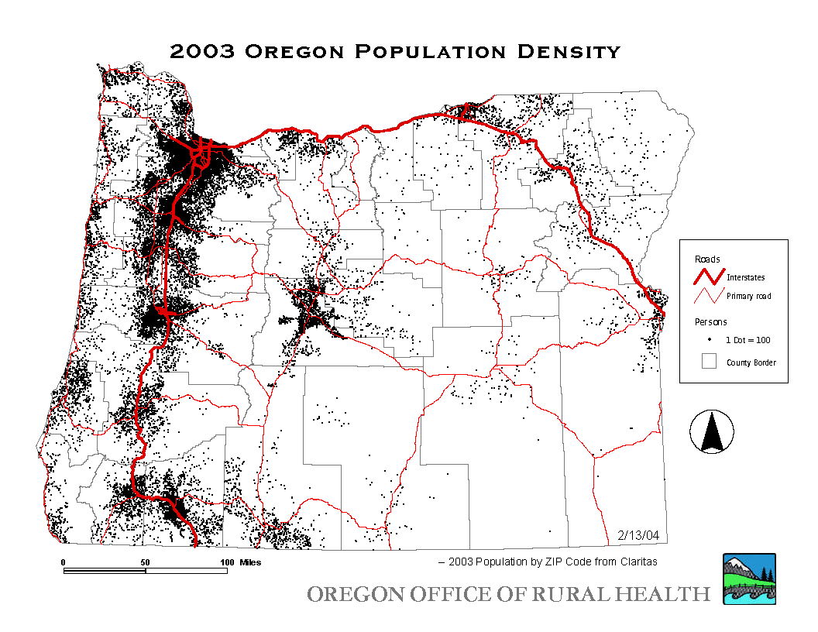
- Look at the map of Oregon on the right. How would you describe the dispersion (in general) of the human population? (clumped, uniform or random)

- Based on your answer to number 4, explain why you think that the population density looks the way that it does. What factors are influencing where people live?

