Murder Mystery Teacher’s Guide
Background
DNA Fingerprinting https://www.yourgenome.org/facts/what-is-a-dna-fingerprint
Videos: https://www.youtube.com/watch?time_continue=33&v=ZxWXCT9wVoI; https://www.youtube.com/watch?v=AkBUriMK9u8
Materials
Procedure Guide https://www.scienceinschool.org/sites/default/files/teaserPdf/issue19_detective.pdf
(All of the following to be downloaded here: http://www.genejury.biology.ed.ac.uk/databaseDNAdetectives.html)
Worksheets
All materials below to be printed preferably in color but not mandatory
DNA Evidence Cards
Suspects’ Statements (green) and Pathologist’s Report (purple)
Suspect DNA Profile Cards (blue) and Victim DNA Profile Card (purple) (the number should match the number of groups/investigators; 1 additional copy of Victim DNA Profile for PATHOLOGIST)
Lab Results (light yellow) (the number should match the number of groups/investigators)
Learning Objectives
- Understand the process of DNA Fingerprinting.
- Understand some of the real-world applications of DNA Fingerprinting.
Procedure
Setup
- Stage the crime scene.
  - Place the victim (e.g. outline, fake body)
  - Place the DNA Evidence cards in their respective locations
- Assign the student roles (6 Suspects and 1 Pathologist).
  - Each suspect gets their Info/Statement card and their DNA Profile card
    - They should be given enough DNA Profiles cards to match the number of instigator groups. (this will be made clear later)
    - They should keep their cards hidden from other students until they are told otherwise.
  - The pathologist gets the Victim’s DNA Profile card and the Pathologist’s Report card
- As the teacher, you will play the roles of Chief Inspector and Forensics Lab
  - Retain the DNA Database, Lab Results, and remaining Victim DNA sheets.
- The remaining students will be investigators (in groups or as individuals).
  - Each group or individual should receive a worksheet.
(OPTIONAL) PLAY SHORT VIDEO: https://www.youtube.com/watch?v=AkBUriMK9u8
Game Play (flow diagram on next page)
- CHIEF INSPECTOR: Read the introduction out loud.
- INVESTIGATORS: Search the crime scene for evidence. Take notes on worksheet.
- INVESTIGATORS: Take evidence to the Forensics Lab. Results will be delivered later.
- PATHOLOGIST: Read your report. INVESTIGATORS: Take notes on worksheet.
- SUSPECTS: Read your statement. INVESTIGATORS: Take noted on worksheet. Decide which 3 suspects you would like to take DNA samples from.
- INVESTIGATORS: request DNA sample from your 2 chosen suspects. SUSPECTS: Give a DNA profile card to the requesting investigator.
- FORENSICS LAB: Give evidence analysis results to investigators (Lab Results and Victim’s DNA). INVESTIGATORS: Compare your 3 suspect DNA samples to the lab results. Take notes on worksheet. Can you identify the murderer?
- CHIEF INSPECTOR: Ask if any group identified the murderer.
  - If yes, ask for explanation and verify correct answer (Eric is the murderer).
    - Read Eric’s confession.
  - If no (or if group identified wrong suspect):
    - Let them have access to the entire DNA Database to compare their DNA Evidence.
OR
    - Give them the answer.
- Debrief.
  - Questions
    - Included at the end of the Procedure Guide.
  - Comparison to real life
  - Additional uses of DNA Fingerprinting
    - Paternity Testing
      - Infographic: https://infograph.venngage.com/p/219962/dna-fingerprinting-to-determine-paternity-infographic
      - Video (2:52 – 4:57): https://www.youtube.com/watch?v=Y8ozUlO9D9Y
    - Rare disease Treatment and Identification
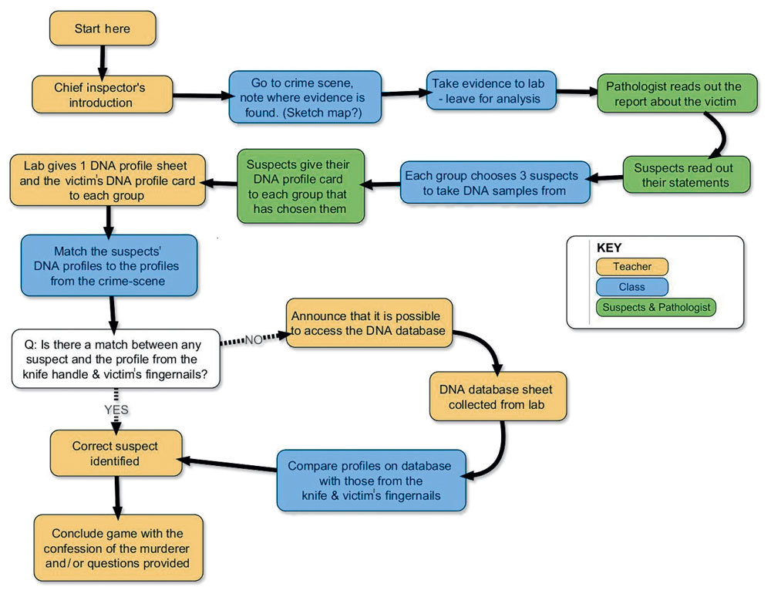
PROCEDURE FLOW DIAGRAM

