**Module - Unit Discharge**

By Catalina Segura and Dana Warren

The goal of this exercise is to help students explore how we answer a fundamental question in the study of streams: How much water is moving through the stream? The amount of water passing a given point in a stream over time is called the stream discharge or flow rate. We provide below a module that describes how scientists measure stream flow and how we estimate stream flow when it is impossible to make precise measurements. In conducting this module, students will learn about unit conversion, ratios, reading graphs, and basic algebra.

The amount of water in a stream is measured in terms of flow rate. That is volume per time (discharge). Typical units are cubic feet per second (cfs) or cubic meters per second (cms). Although we also think in terms of liters per second in smaller streams. It is important to have an idea of what the discharge or flow is for rivers because the amount of water in a stream over time, during low-flow periods and during storm events controls nearly every other aspect of the geology and ecology of a stream. Knowing discharge values of rivers that the students are familiar with, (for example, in the Siletz River – see figure below), will allow students to contextualize discharge, or flow, values.

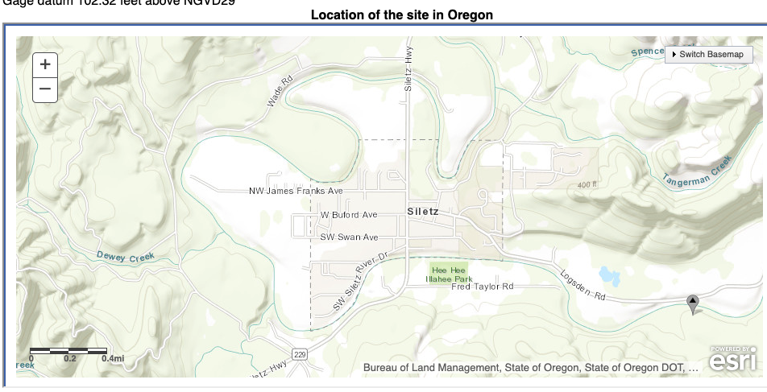

Siletz Valley Early College Academy

USGS Gauge No. 14305500

In the figure above, the red circle is the location of the school, and the blue triangle is the location of the USGS gauge on the Siletz River. This gauge provides real-time and historic data on stream flow rates at this point in the river.

Resources:

|  |  |
| --- | --- |
| Past data for Siletz | <https://waterdata.usgs.gov/or/nwis/uv?cb_00060=on&cb_00065=on&format=gif_default&site_no=14305500&period=6&begin_date=2014-11-19&end_date=2014-11-25> |
| Forecast | <https://water.weather.gov/ahps2/hydrograph.php?wfo=pqr&gage=silo3>  This website can be used to make predictions of the future |

The US Geological Survey (USGS) provides some of the best data nationwide on stream flows. The watershed size at the USGS gauge (blue triangle in map) is **202 square miles**. Knowing the watershed area upstream of a USGS gauge is important as it can help you to estimated discharge in some other sections of that basin or nearby basins where there are no gauges (we will go over how to do this below).

A hydrograph is a graph of stream flow over time. Time (x-axis), can be minutes to decades to centuries (although very few sites have discharge data for more 50 years). In the figure below the x-axis encompasses two full years. The data presented here represent the daily discharge (y-axis) at the Siletz River. So there is a discharge value for each day. Note the log-scale on the y-axis. We use a log scale to be able to see large and small values of discharge in the same graph.

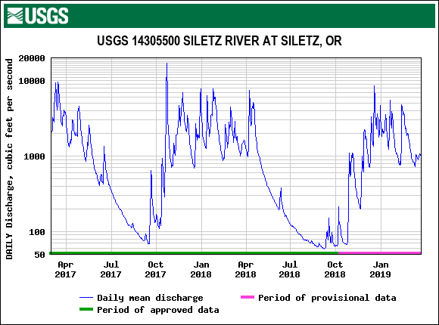

This is the USGS generated graph (note the log-scale in y-axis)

It might be easier to look at it out of log-scale:



The maximum discharge between March 2017 and March 2019 occurred on October 22, 2017 with a discharge of 17,200 cfs. This corresponds to 487 cubic meters per second (there are 0.02832 m3 in one cubic foot). This is a lot of water! For example, the volume of a washing machine is about 1 m3. Thus 487 m3/s is like 487 washing machines worth of water going by every second!

The discharge in the Siletz River at this USGS gauge represents the sum total of all the water collected in the catchment upstream from it and ultimately delivered down to this site. This location collects the water from 202 square miles of watershed, which encompassed many sub-watersheds and over one hundred miles of smaller tributary streams rivers that feed into it. The stream where our class measured discharge (Cerine Creek) drains 1.93 square miles and does not have a gauge. There is another watershed inside the Siletz River watershed called Sunshine Creek that also has a gauge, and has a drainage area of 7 square miles (see map). The gauge in Sunshine is administered by the Oregon Water Resources Department (<https://apps.wrd.state.or.us/apps/sw/hydro_near_real_time/display_hydro_graph.aspx?station_nbr=14304350>).

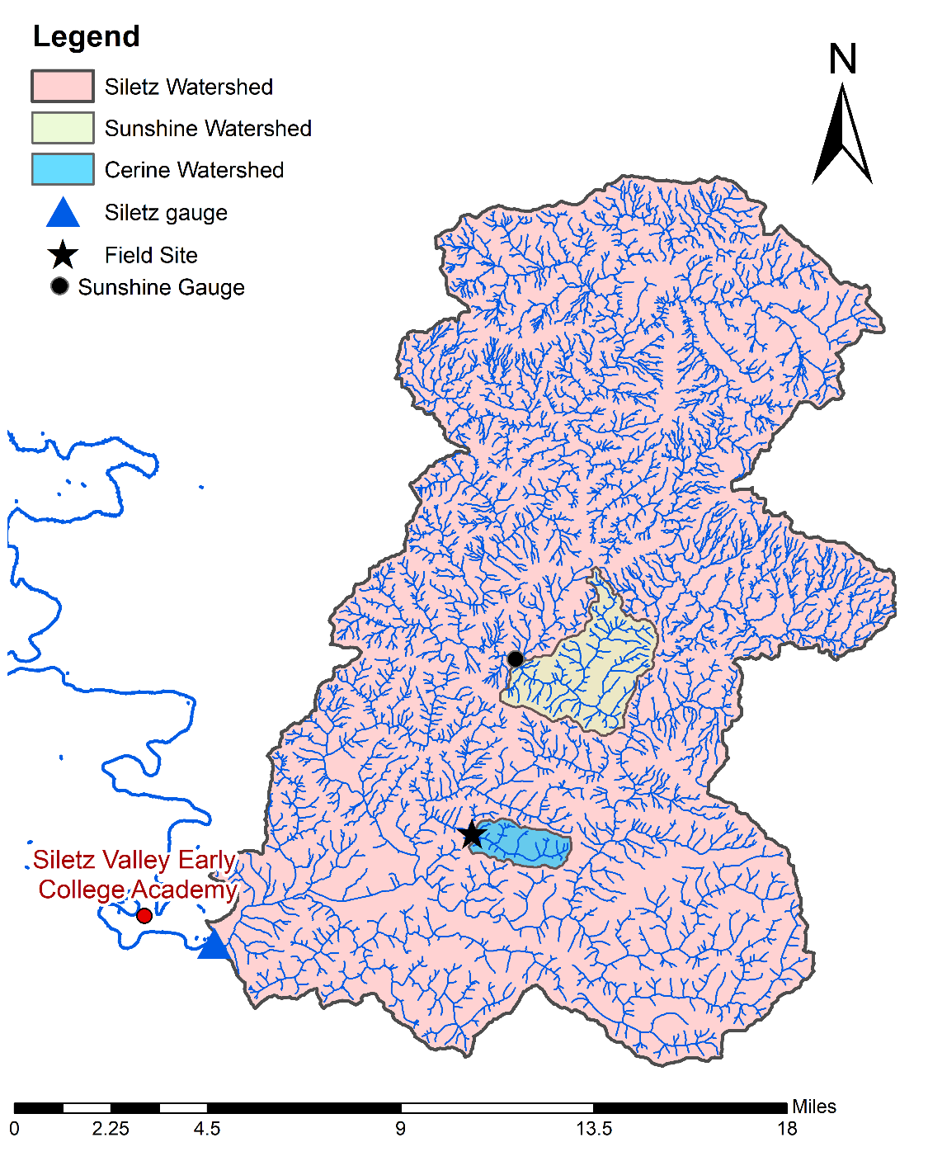

**How can we use the information from Siletz and Sunshine to estimate the flow in Cerine?**

Let’s consider the information for the day we had the field visit in March 5, 2019. That day we estimated a discharge of 270 liters/second (L/s) in Cerine Creek. We want to convert this value into the same units as Siletz and Sunshine ft3/s (cfs):

According to the USGS the discharge that day in Siletz was 895 cfs

According to OWRD the discharge in Sunshine was 29.1 cfs

So how do we put these three sites into the same set of units? Unit discharge is the discharge over the area, which allows us to compare across sites. It is the amount of flow per unit area produced by a watershed.

$$Qu=Q/DA$$

where Q is discharge in volume per time and DA is drainage area.

The unit discharge on March 5 in Cerine = $Qu=\frac{9.53 cfs}{1.93 {mi}^{2}}=4.81\frac{cfs}{{mi}^{2}}$

The unit discharge on March 5 in Siletz = $Qu=\frac{Q}{DA}= \frac{895 cfs}{202{mi}^{2}}=4.43\frac{cfs}{{mi}^{2}}$

The unit discharge on March 5 in Sunshine = $Qu=\frac{29.1 cfs}{7 {mi}^{2}}=4.15\frac{cfs}{{mi}^{2}}$

These numbers are all similar!!!!! Which means the discharge is proportional to drainage area! But wait, why is the unit discharge in Cerine bigger?

Think about how we measured stream velocity. We had a pingpong ball running through the middle of the stream. But not all of the water in the stream moves that fast. There are pools, backwaters, eddys, etc. that slow the water down in some places. With our basic ping-pong ball method we likely missed those.

*In addition to the areas of slower water at the stream edges, overestimation of the discharge often occurs using this method because the velocity on the surface is higher than the velocity near the bottom of the stream. This is because there is more friction on the bottom. Yet we still see a close value – so our method seems pretty good*

*If we had been sampling in the middle of a rain event, we might also expect to see differences in unit discharge because smaller streams are generally more responsive to rain events, meaning that their discharge comes up faster (but also goes down faster), so during a rain event, we may see higher unit discharge in the small tributaries like Cerine Creek early on but then lower discharge in Cerine creek relative to the mainstem Siletz later as the pulse of rain from the storm events moves downstream and builds in the larger system.*

Given how close these are, now take an average of the 3 estimates:

$$\overline{Qu}=4.46 \frac{cfs}{{mi}^{2}}$$

Based on this relation, we now have a unit discharge number that can be used to estimate the flow in Cerine Creek by looking at the flow in Siletz! For example, let’s say that you want to estimate the flow in Cerine on October 22, 2017 based on the measured flow in Siletz.

We can find the answer, using the average unit discharge:

Using some algebra. . . If $\overline{Qu}= \frac{Q}{DA}$ then $Q=DA*\overline{Qu}$

And from this we can then determine that the discharge in Cerine in October 22 2017 was:

$Q=1.93{mi}^{2}×4.46\frac{cfs}{{mi}^{2}}=$**8.6 cfs**

And If we assume that the rest of the areas upstream of the mainstem gauge have a similar relationship (which is reasonable here but may not be in other places – so be careful), we can use the unit discharge value to estimate discharge at ANY point in the entire upstream network as long as we have the watershed area above that given point.

It is important to note that this is not an arbitrary exercise. Scientists and managers working in streams regularly use this very unit discharge process to estimate stream flow a different points in a watershed.