Isle Royale, not Battel Royale: Then, Now, and Future

Isle Royale is the largest island in Lake Superior. The island is approximately 45 miles in length and 9 miles wide. It is located about 12 miles south of the Canadian border, 20 miles southeast of Minnesota, and 53 miles north of Michigan. The only way to access the island is by seaplane or boat. Moose arrived at Isle Royale around 1900. Wolves first arrived at the island on an ice bridge from Canada in 1940. The Isle Royale moose and wolves have been studied since 1958. It is the longest continuous study of any predator-prey population. The ecosystem of the island is unique because it only contains one top predator, the wolf.

This activity has three parts:
Part 1 – THEN – explore graphs, videos, and presentations to understand the relationship
between the wolves, moose, and how they survive on the island as wolves feed on moose over time.

Part 2 – NOW – Use the online simulation to understand the relationship between
the wolves, moose, and how people could intervene if they decide to. Why might
a someone want to introduce or take an animal from an ecosystem?

Part 3 – FUTURE – after using the online simulation to understand the relationship
between the wolves, moose, consider why/how a researcher, farmer, or U.S. Fish and Wildlife could intervene if they decide to? Why might force someone to introduce or take an animal from an ecosystem? Watch what happened recently on Isle Royale and discuss as a class.

Part 1 - THEN

1. Based on the background text in the box above, and the video answer the questions below:
- Why are the scientists studying the wolves on Island Royale? (1 sentence)

- What makes the ecosystem on Island Royale unique to scientists? (2 sentences)

- Why do you think scientists have chosen to study the predator-prey relationships of wolves in particular? What is so interesting or important about wolves? (2 sentences)

- Based on what you know about predator-prey relationships, what do you think would happen to the WOLVES if……
  - All the moose were removed from the island?

  - Only 1 wolf was left on the island?

  - No new wolves came to the island?

- Explore the online graph and look at the graph below.
  - As the wolf population increases, what is happening to the moose population?

  - As the wolf population decreases, what is happening to the moose population?

  - Write down when the most wolves on the island as shown in the graph:

Population Size: __________ Year: ___________

  - Write down when the least wolves were on the island as shown in the graph:

Population Size: __________ Year: ___________

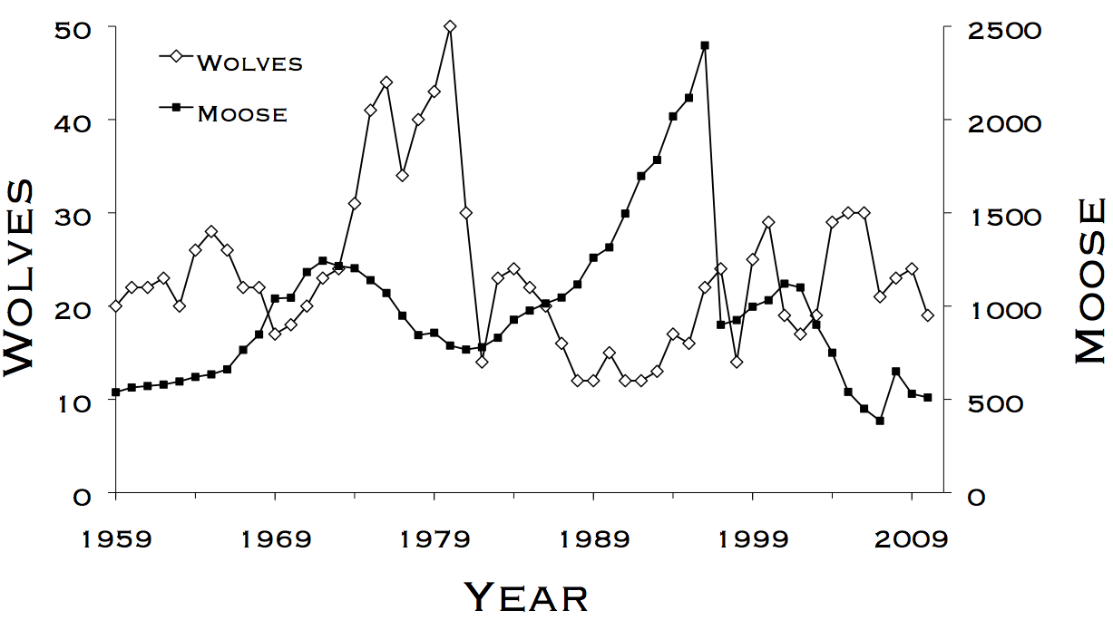
- See the graph below, why do you think caused the drop in wolves starting at 1979 in? (3 possible reasons for the decline)

What happened here to the wolves? How does it relate to the moose here?

- What other factors on the island might effect the wolves or moose that are not included in the graph? (e.g. food, disease, humans etc.)

4. on page 4, read the box called Objective of the Research Project and answer these questions:
- Why would scientists expect predator-prey relationships to follow the pattern shown on the graph?
Because wolves starve if there is not enough food. Moose die when the wolves eat them. After too many moose die, there is not enough food for the wolves. So the wolves die. This causes less predation and the moose population can then grow.

- Compare the graph on page 2 of this handout with the graph in the box on page 4 of the reading. Why do you think the wolf-moose population dynamic on Isle Royale looks different from this typical pattern?

There are other factors other than predation! Disease, weather, etc. can all affect populations.

5. Read the section on Methods (p. 5) and answer these questions:
- What types of data do scientists use to estimate the population of wolves and moose to help them develop their hypotheses?
Skeletal remains, scat (feces), etc. For example scat can tell the scientist what the diet consists of. Skeletal remains can give clues about nutrition, age, disease, etc.

- Why is it important for others to know their methods in detail?
It is important to communicate the methods so that others know the limitations of the research and can ask questions.

6. Read the section called Applications of the Data (p. 6) and answer these questions:
- What is the management philosophy of the National Park System?

A hands-off approach – let nature take its cou rse
- How have previous data from Isle Royale influenced worldwide policies on wolf conservation?

It brought attention to the issue of wolf conservation. This caused a decrease in wolf bounties and hunting, thus helping the populations recover

- Why do you think the author thinks it is important to continue the study of wolf- moose relationships on Isle Royale?
Because there is still much we do not know.

- What is the largest moose population measured? __~2500___ In what year did that occur? __1996__What was the wolf population in that same year? ___~20_____
- What was the largest wolf population measured?__~50___In what year did that occur?__1980___What was the moose population in that same year? __~750______

- What generally happens to the moose population when the wolf population decreases?
The moose population generally increases.

- What do you think would happen to the moose population if wolves were removed from Isle Royale? Why?
Moose populations might increase initially until other factors begin to increase competition and thus limit the population growth rate. Those factors might include availability of food, disease transmission, and availability of other resources such as space.

- Identify TWO factors, other than the moose population, that have impacted the wolf population.
- Canine parvovirus, an introduced disease, contributed to the crash in the wolf population, killing off wolves as it spread throughout the population.
- Low reproductive success, which may have been due to inbreeding.

- Identify TWO factors, other than the wolf population, that have impacted the moose population.
- Winter ticks may have spread disease that reduced the moose population.
- Severe winters led to decreased availability of forage, and the deeper snow made it more difficult for the moose to reach the remaining forage, which led to moose starvations.

- How are the population dynamics of wolves and moose different from or similar to the population growth rates of humans and bacteria? Why?
The moose and wolf population are in a typical predator/prey relationship, meaning that their populations are highly dependent on one another in addition to other density-dependent and density-independent factors such as weather, introduced species, etc.
Some species, like bacteria & even humans in certain areas, can grow exponentially temporarily while resources allow. Eventually, limited resources in a community limit the growth of a population. Not enough food, water, shelter or medicine will hold down the population growth.

- Ecologists, biologists, and population demographers often use the following terms to discuss their ideas and their data. Define these terms in your own words based on the reading. Refer to the pages in parentheses if you need to reread sections of the text where these words are used to help you understand these important concepts. Note: do NOT use the words to define themselves (i.e. “density-dependent means it depends on the density”) That DOES NOT tell you anything! What does each part of the phrase MEAN?
- Predation (pg. 1, pg. 3, pg. 4, pg. 6)
Killing another organism to eat it
- Population dynamics (pg. 1, pg. 4
Changes in population age, structure, number, etc. over time

- Emigration (pg. 1)
Animals leaving an area
- Immigration (pg. 1)

Animals entering an area
- Top-down population dynamics (pg. 3, pg. 4)
The predators on the top of a food chain control the number of individuals at lower trophic levels through predation. This in turn affects the levels of even lower trophic levels.

- Bottom-up population dynamics (pg. 3, pg. 4)
Organisms on lower trophic levels control the population of those on higher tropic levels.
For example, fewer moose might mean fewer wolves in the future due to starvation while an increase in moose population might lead to an increase in the survival of wolf pups and hence more wolves in the future.
- Density-dependent (pg. 3)
A factor whose effect is felt differently with different population numbers. Example: the spread of disease increases with a higher density of individuals and decreases when there are not many organisms around to infect.

- Density-independent (this is not used, but can you make an inference about its meaning based on the definition of “density-dependent” above?)
A factor whose effect does NOT depend on the population density. Example: a tidal wave. This could kill organisms and the lethality of it would not depend on how many individuals drown, etc.

Population reconstruction (pg. 3, pg. 5)
Using data from dead organisms to determine how large the population was historically.

