If I were a Tree Concept Mapping Activity
In the last part of this activity, you will work with a partner to create a concept map to show your understanding of the following topic: How are humans and trees similar and different?
Step 1—Partner discussion. Start by discussing the following questions with your partner:
● What are the main ideas we should include in our concept map about How humans and trees are similar and different? List your main ideas below. The list already has a few concepts you may want to include. What other ones should you add?
● What are the relationships between these main ideas? How are they connected?

List of main ideas for our concept map | Notes on how these ideas are connected
● Protection  ● Support  ● Absorption of nutrients  ● Transport of materials  - Gas exchange | - humans organs and trees parts have some of the same functions  - human skeleton has protection function like tree bark·

Step 2—Create your own individual concept map. After your partner discussion, use a blank sheet of paper to create your own concept map about how humans and trees are similar and different. Be sure to include the main ideas you listed and how these ideas are connected to each other.
Feeling stuck? These questions might help you get started.
- What is the most important idea that should go in the middle of your concept map?
- Do humans and trees protect themselves in the same way? Why or why not?
- How do humans and trees get the nutrition they need to survive?
- Below is an example of what a concept map can look like. This one is about the parts of a plant but it can give you ideas about how to draw your concept map.
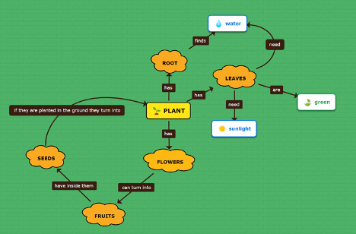
Step 3— Share and discuss your concept maps with a partner. After you finish your individual concept map, share and discuss your map with your partner or small group. Look for similarities and differences between your concept map and theirs. Why do you think your maps are not exactly the same? If you want to, you can use a second color to make changes or additions to your concept map.
Step 4— Put your name on your concept map and turn it in to your teacher.

