SMILE Teacher Workshop 2013

Activity – Fuel Comparison
Time needed: 50 min  Goal: Students will understand where fossil and biofuels come from and the benefits and disadvantages of both. Students will also gain an understanding of where their energy comes from. | Materials needed:  - Computer with internet access  - Pieces of coal

Introduction: The sun is the primary energy source of our planet; all other sources of energy originate from the sun in one way or another way. For example, plants convert sunlight into chemical energy, which drives the synthesis of leaves, flowers, and other parts of the flower for consumption by animals for energy. When animals eat these plants, it helps them generate body mass. When plants and animals die, their energy is broken down and becomes stored as oil, natural gas, or coal over a long period of time. Another example is wind power, which is fueled by a pressure gradient in the atmosphere caused by the sun heating one place more than another. All of these sources of energy are used in our lives to do work that make our lives easier and bring a certain standard of comfort we have come to expect. Each source of energy has its advantages and disadvantages, and this activity will focus on the pros and cons of fossil fuels and biofuels. From this activity, students will be able understand the positive and negative effects of using fossil fuels and biofuels, why fossil fuels are so prevalent, what are some alternatives to fossil fuels, and what can be done to push these alternatives into market. They will also learn where the energy they use comes from and what kind of energy sources Oregon uses to produce energy.

Background: Fossil fuels are carbon-based energy sources like coal, oil, and natural gas. Coal takes around 400 million years to produce to its final state. Today’s coal started out as biological material such as plants or animals. Once the biological material died and settled in the bottom of swamps, it started to decay. However, due to a change in climate and surface in the area, layers of dirt and rock trapped the decaying material, stopping the decaying process. As more layers of dirt and rock formed on top, more pressure built on the decaying material. This pressure, along with the natural heat of the earth, caused chemical and physical changes that extracted the oxygen in the biological material. This left hydrogen-rich deposits that have slowly turned into coal over millions of years. The diagram below shows the formation of coal.

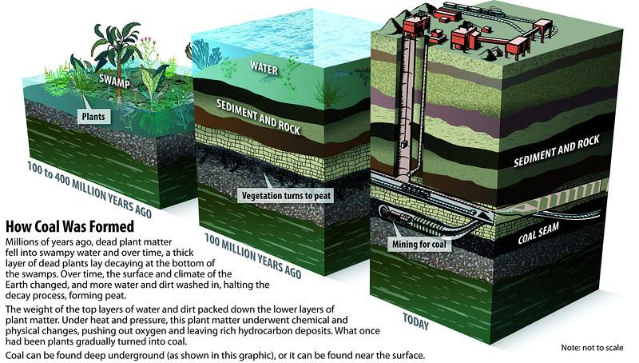

Petroleum, along with natural gas, is created in a similar fashion when organic material is trapped and buried in sedimentary rock where it decomposes. The decomposition process is a consequence of immense heat and pressure environments that exist in the earth's subsurface. The organic material forms either petroleum or natural gas, depending on the type of biomass and the surrounding temperature and pressure during the decomposition process. More heat produced lighter oil and even higher heat or biomass made predominantly of plant material produced natural gas. The following diagram shows the formation of petroleum and natural gas.

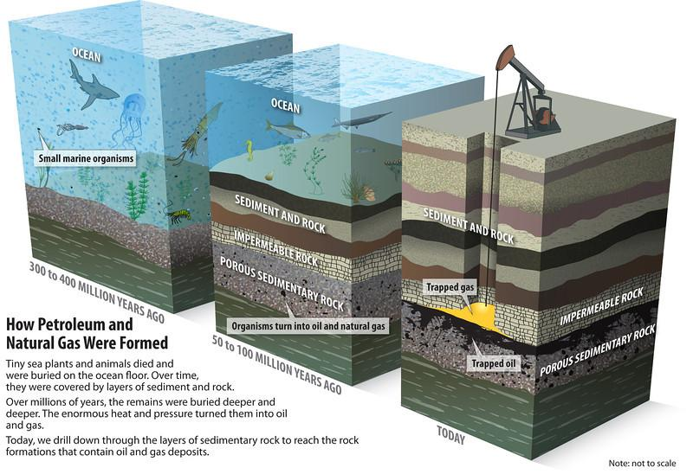

Fossil fuels have become a prevalent energy source in the past few centuries. They are relatively cheap to extract, are abundant throughout the earth, and are very energy-dense. These factors have pushed the use of fossil fuels instead of biofuels. The current electrical power grid that is responsible for delivering electricity from power plants to consumers is built around fossil fuels. The grid presents an advantage and disadvantage for fossil fuels. Even though this is a well-defined system for transporting electricity, it is extremely inefficient. Between 0.5 to 4.2% of the energy that the grid carries is lost daily, which is a significant amount considering that there are close to 40,000 miles of power lines in the US alone.

Our high demand for cheap, accessible energy has made fossil fuels our primary energy source. However, as we continue to extract fossil fuels from the earth, fossil fuel reserves are dwindling away. This is the main concern with fossil fuels as they are a nonrenewable source of energy. Due to the long time and special circumstances it takes to form them, geologists believe that little to no new fossil fuels are being produced. All of the fossil fuels we will ever see lie underneath our feet. Scientists believe that our coal supply will end in 130 years, oil in 42, and natural gas in 60. Students will be in their mid-50s when oil runs out and mid-70s for natural gas. As global energy demands increase due to improved quality of life in many nations, current and future generations face an energy crisis. The United States alone consumes fossil fuels at a remarkable rate: 380 million gallons of gasoline every day and 1.12 billion tons of coal every year. Fossil fuels will not be around for very much longer, so we must seek alternatives. Fossil fuels also present many environmental hazards, such as high greenhouse gas emissions, acid rain, and oil spillages. Extractions will become more dangerous as mines will get deeper and oil-rigs have to go further out to sea. All of these pose grave danger for not only humans but also all of the wildlife we share the planet with. Fossil fuels will inevitably become more expensive as reserves are depleted, which could cause great economic chaos. We are highly dependent on these fuels to accomplish even the minutest tasks, such as power our cars to get to work or keep our lights on.

On the other hand, biofuels are made from recently grown biological matter. There are several processes used to produce biofuels (see generations of biofuels activity). Biofuels resolve many of the concern with fossil fuels. They are a renewable source of energy, which means that they can be grown when they are needed. Domestically grown and produced energy is also an advantage because we can support our own economy and lessen our dependence on unstable foreign sources of fossil fuels. Biofuels can also help third world nations’ economies, many of which are located in warm climates where biomass can easily be grown. Biofuels are also more environmentally friendly as they produce fewer GHG emissions and burn cleaner than fossil fuels. They also close their carbon cycle faster because they remove CO₂ from the atmosphere within a relatively short amount of time compared to when it was released. Fossil fuels took million of years to harvest that energy, and we are releasing CO₂ faster than nature can reabsorb it. Accidental biofuel spills would not pose such a threat to the environment like the Deepwater Horizon or Exxon Valdez oil spills. These spills took millions of dollars to clean up and had destructive effects on the local environments. Biofuels are easily integrable into current technology. Most gasoline fueled cars can substitute in ethanol to certain degrees (E85 cars, E15 cars and E10 cars). Many diesel engines can be updated to run on peanut oil and current models can run on pure biodiesel (B100) with little to no changes to the engine. In Oregon, gasoline is required to be sold with 10% ethanol (E10). Bioenergy would also be more beneficial in power line loss since ideally bioenergy power plants would use local sources of biomass so it would not have to be transported over large distances. However, this would mean that there would need to be bioenergy producing plants relative close to populated areas.

While biofuels have many positive attributes, they still present numerous challenges. Biofuel technology is still not advanced enough to compete economically with fossil fuels, and further research needs to be done to make production and distribution economically viable. Ethanol and biodiesel are also less energy dense than their counterparts, gasoline and petrodiesel. Ethanol has 66% of the energy content of gasoline per liquid volume, which means less travel with the same amount of fuel. Another concern is the vast amount of arable land that would be needed to grow biomass. Farmers would need to use 71% of US cropland exclusively to grow corn to produce ethanol for gasoline. Land is still needed to grow our food. Second and third generation biofuels seem to capable of addressing this challenge, but similarly, the technology still needs advancements.

Problem: Fossil fuels are a finite source of energy, meaning they will eventually run out. We need large amounts of energy in many areas of our lives. Fossil fuels have been able to deliver this for a long time, but they will not be a reliable source of energy for much longer. We need to explore alternative, sustainable ideas for energy today to prepare for a day when we may not be able rely on fossil fuels anymore. Even though bioenergy sources have many challenges, they play an important part in our move toward energy independence from fossil fuels.

Procedure:
1. Hand out the pieces of coal and explain to the students the process that it took to get that coal there. You might want to use the Fig. 1 in this document as a visual. Stress the fact that it took millions of years under special circumstances to condense energy into coal. Explain the formation of petroleum and natural gas as well and highlight the difference in the process to coal.
2. Have a discussion with the class about the advantages and disadvantages of using fossil fuels. Discuss how biofuels would address some of these challenges and what still needs to be done to make biofuels commercially available.
3. Have students come up with a list of the energy sources where they believe their energy comes from (i.e. coal, petroleum, biomass, hydro, solar etc). Have them rank it accordingly to what they believe is the biggest contributor to the smallest. Have them make another list of what they think the energy sources Oregon uses to produce energy and have them rank that one as well.
4. Have students go to http://www.oregon.gov/ENERGY/Pages/Oregons_Electric_Power_Mix.aspx and find Oregon consumption sources. How do the values in the table compared to their predictions?
5. Have them go to http://www.npr.org/templates/story/story.php?storyId=110997398 and then under power plants, find Oregon’s energy production sources. How do these values compare to their predictions?
6. Have students hover around the US map and find extreme values such as most productions come from coal (West Virginia, Utah, and Indiana). Have students come up with ideas why this is.
7. Have student play around with the interactive map and see if they find anything else interesting or unexpected.

Ponder this:
1. What are the disadvantages of having most of our energy come from fossil fuels? How do biofuels address these disadvantages? What challenges might we experience with biofuels?
2. Do you see any problems with the current electric grid in the US? Think about the energy lost in the power lines over the thousands of miles it is transported.
3. Why do you think most of the coal power plants are in the Eastern US? How might this present a problem to western states such as Oregon? How would bioenergy solve this problem?
4. What specific bioenergy industries could Oregon create (cellulosic ethanol or biodiesel in particular)? Are these reasonable and/or feasible?
5. How would biofuels help out third world nations’ economies? Are biofuels more equally available to all countries than fossil fuels? How so?
6. Most of the US arable land is in the Midwest, however not that much biomass is used for energy there compared to fossil fuels. Why do you think that is?
7. Do you think price should determine what type of energy source that will be used or should we promote a better, more expensive option that is renewable and sustainable?

Extensions:

1. Have students find the closest power plant to them. Have them do some research on it and present a short presentation highlighting the location, the type of energy produced, the amount of energy produced and whether it is a renewable source of energy.

Next Generation Science Standards-http://www.nextgenscience.org/next-generation-science-standards:
- MS-ESS1-4
- MS-LS2-3
- MS-LS2-4
- MS-ESS2-1
- MS-ESS3-1
- MS-ESS3-3
- MS-ESS3-4
- MS-ESS3-5

Resources:

- http://www.eia.gov/state/?sid=OR- Another map of energy production by state
- http://www.seai.ie/Schools/Post_Primary/Subjects/Geography_JC/Pros_Cons/- Pros and Cons arguments for fossil and biofuels
- http://www.eia.gov/state/seds/seds-data-complete.cfm?sid=US
- http://www.npr.org/templates/story/story.php?storyId=110997398
- http://www.iu29.org/resources/Documents/CoalSecondary.pdf
- http://www.aep.com/about/transmission/docs/transmission-facts.pdf

