Rainbow Papaya Fact Sheet
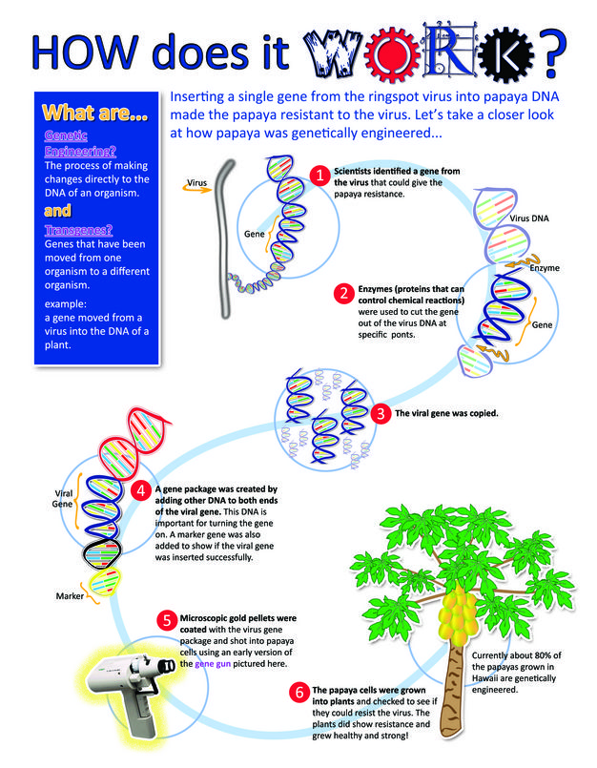

- Genetically modified version of papaya
- Resistant to the Ringspot Virus, which was killing many papaya trees in Hawaii
- Helped save the Hawaiian papaya from extinction and protected an important farming industry
- This product has been approved by the U.S. Food and Drug Administration and is currently available in U.S. markets.

Source: 2012 Nature Education.
For more information:
- YouTube Video: GMO Answers, How are GMOs Created? The Hawaiian Rainbow Papaya Story: https://www.youtube.com/watch?v=2G-yUuiqIZ0
- Business Insider: This Cornell scientist saved an $11-million industry — and ignited the GMO wars: https://www.businessinsider.com/gmo-controversy-beginning-fruit-2017-6?jwsource=cl

