Flavr Savr Tomato Fact Sheet

- First genetically modified plant commercially available to consumers in the U.S. (1994).
- It was genetically modified to remain ripe longer without getting soft.
- Its longer shelf life made it easier to ship and store than traditional tomatoes.
- Additionally, this modification allowed the tomatoes to ripen on the vine before being picked, as opposed to being picked green and being artificially ripened using spray chemicals.
- These tomatoes weren’t successful in U.S. markets for a variety of reasons, including because they were more expensive and didn’t taste as good as non-modified tomatoes and other competing varieties.
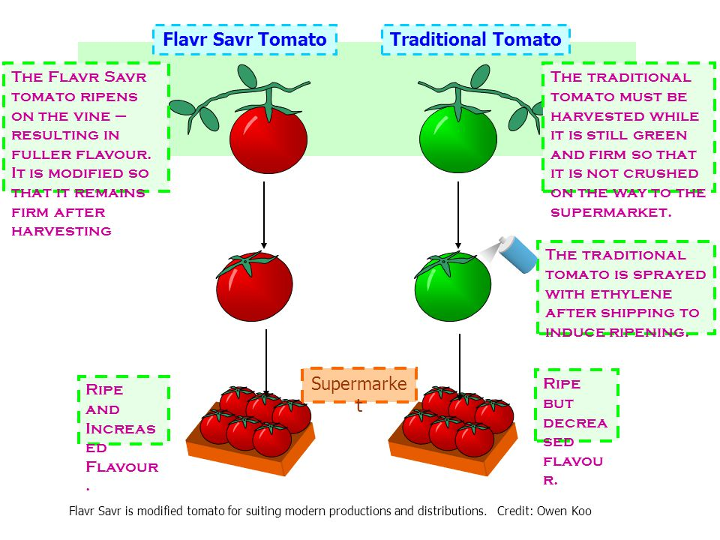
Flavr Savr Tomato is a genetically modified tomato that ripens differently than non-modified tomatoes. Source: Owen Koo.
For more information:
- Radio Broadcast: BBC, The ‘Flavr Savr’ Tomato – The World’s First Genetically Engineered food: https://www.bbc.co.uk/sounds/play/p04xj4d1
- Video: New York Times, You Call That a Tomato? https://www.nytimes.com/2013/06/24/booming/you-call-that-a-tomato.html
- Articles: Whatever Happened to the Flavr Savr genetically Engineered Tomato? http://www.tomatocasual.com/2008/02/28/what-ever-happened-to-the-flavr-savr-genetically-engineered-tomato/ ; Flavr Savr Tomato https://biotechnologysociety.wordpress.com/2015/02/16/flavr-savr-tomato/

