AquAdvantage Salmon Fact Sheet

- First genetically modified animal to be approved (2015) by the U.S. Food and Drug Administration.
- Had a gene inserted that produces a growth hormone protein that is continuously expressed year-round, as opposed to non-modified salmon which only express this gene for half of the year.
- Grows to adult salmon size in half the time as non-modified salmon.
- This product is not available commercially in the U.S. but is for sale in Canada and Norway.
- Salmon is an increasingly popular food product with substantial health benefits.
- The FDA requires that the modified salmon be grown in land pens to reduce potential for the modified salmon to breed with non-modified salmon, which would potentially allow the modified genetic material to flow into non-modified salmon populations.
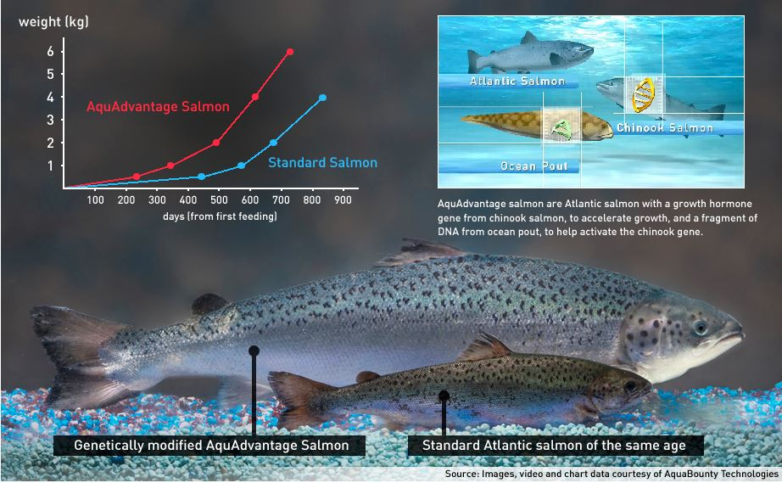
For more information:
- Youtube Video: CBC News, Genetically-modified Salmon Approved by FDA: https://www.youtube.com/watch?v=PQSArjT8j9o
- Articles: Food Safety fact Sheet: Genetically Engineered Fish: https://www.centerforfoodsafety.org/files/ge-salmon-fact-sheet_56203.pdf ; Nine Things You Need to Know About GMO Salmon: https://gmoanswers.com/nine-9-things-you-need-know-about-gmo-salmon

