Dropper Popper Inquiry Lab

Instructions: Your job is to try dropping several items from a height of exactly 1 meter to come to some conclusions about energy. Drop each item three times, and using a meter stick, record how high the item bounces back up. Get an average value for each item.

Part A: Dropping Objects

Ping-pong ball-

Trial 1: ______________ meters

Trial 2: ______________ meters Average: ______________ meters

Trial 3: ______________ meters

Dropper Popper (looking like this)

Trial 1: ______________ meters

Trial 2: ______________ meters Average: ______________ meters

Trial 3: ______________ meters

Dropper Popper (looking like this)

Trial 1: ______________ meters

Trial 2: ______________ meters Average: ______________ meters

Trial 3: ______________ meters

(1) First, rate the order of how high the objects bounced from least to greatest. Next, discuss possible reasons for the differences in the heights you observed. Mention all three items in your explanation.

Highest to Lowest:

Explanation:

(2) Why do you think turning the Dropper Popper inside out changed its bounce height? Try to use the word energy in your answer.

(3) Did you hear any noise when the objects bounced? Where do you think the noise came from?

(4) Try to make some conclusions about what you’ve learned about energy so far. Use evidence to support your explanation. A) Do you think there are different types of energy? B) Can energy change from one type to another? C) Can energy be stored?

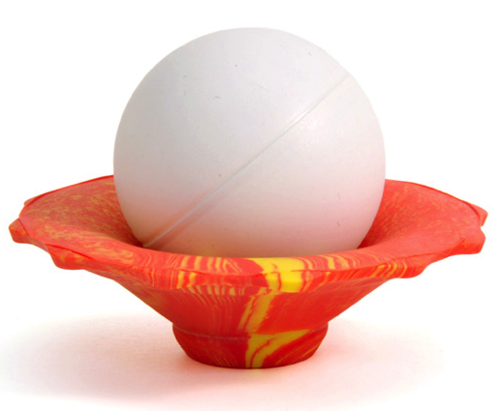
Part B:
Now try one more thing. Carefully place the ping-pong ball into the Dropper Popper like this, and then drop them together from exactly 1 meter. There’s no need to take height measurements here.

What did you notice?

Does this tell you anything else about energy? Explain.

