Corn
Non-Domesticated Corn Domesticated Corn

Wild Potato

Potato
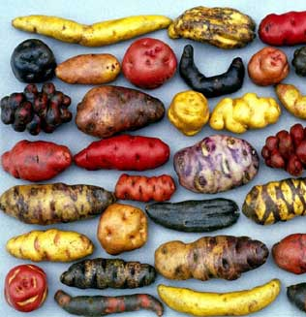
Domesticated Potato Non-Domesticated Potato

Rice
Non-Domesticated Rice Domesticated Rice
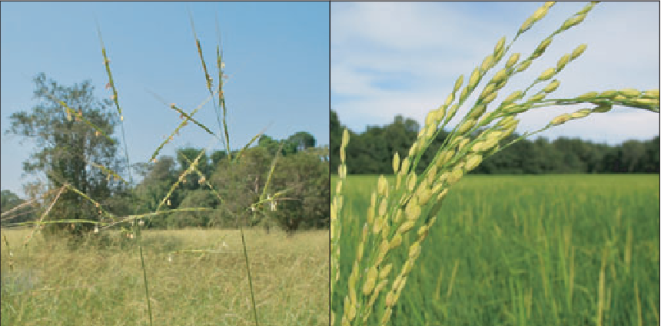

Banana
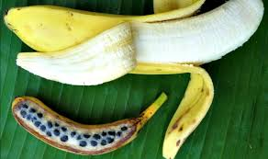
Domesticated
Banana

Non-Domesticated
Banana

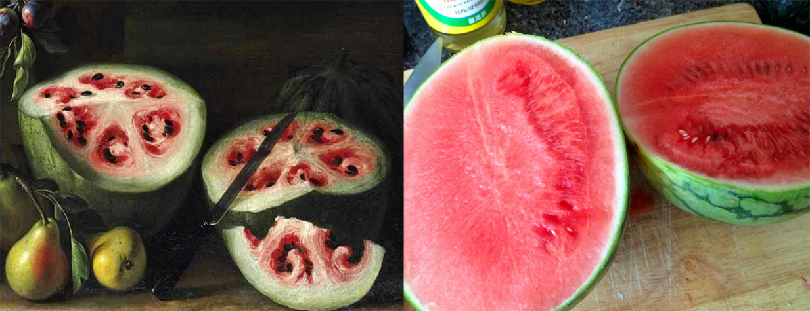
Watermelon

EGGPLANT

Non-Domesticated Watermelon Domesticated Watermelon

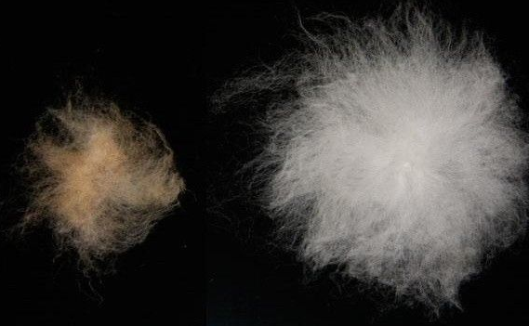
Cotton
Non-Domesticated Cotton Domesticated Cotton
Carrot
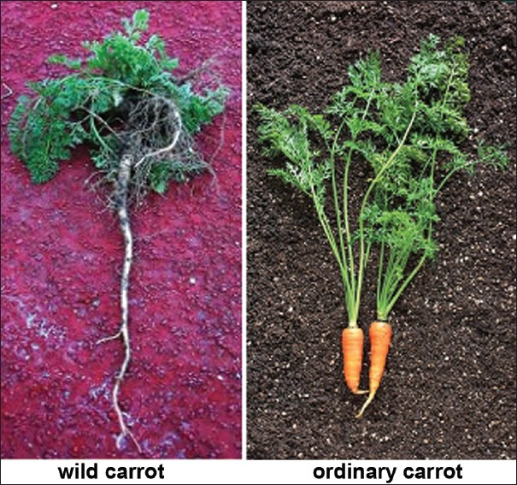
Non-Domesticated Domesticated
