Natural Selection

Two compatible species reproducing to create an offspring, which may or may not have the desired traits.
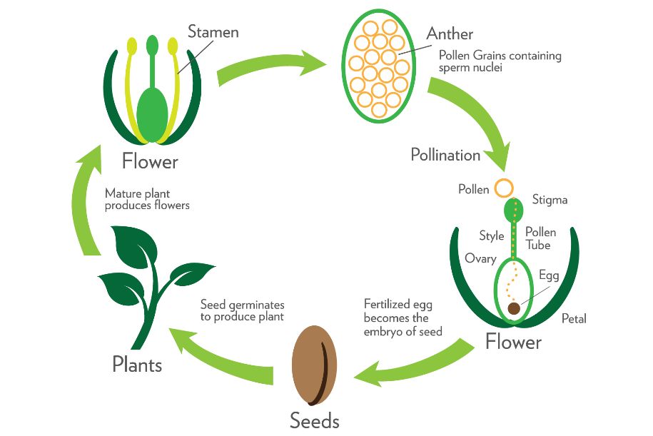

Induced Mutations

A process of exposing seeds to physical, chemicals or biological mutagens (e.g. UV light, X rays) to promote genetic mutation in hopes that the mutation will produce a desirable trait.
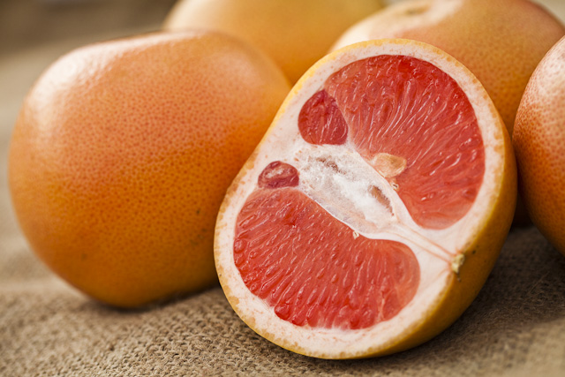
After exposing a grapefruit tree to radiation, a random genetic mutation produced fruit with a darker color.
Photo Credit: www.tradingatoms.com
Genome Duplications

Breeding two plants of the same species to create an offspring with multiple sets of chromosomes, affecting its’ traits.
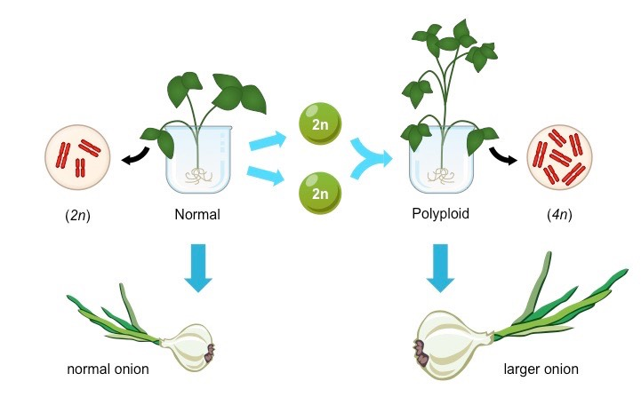

Selective Breeding
Photo Credit: BioNinja

Selective Breeding
The multi-generational process of breeding same-species organisms with desirable characteristics to produce an offspring that exhibits the desirable trait.
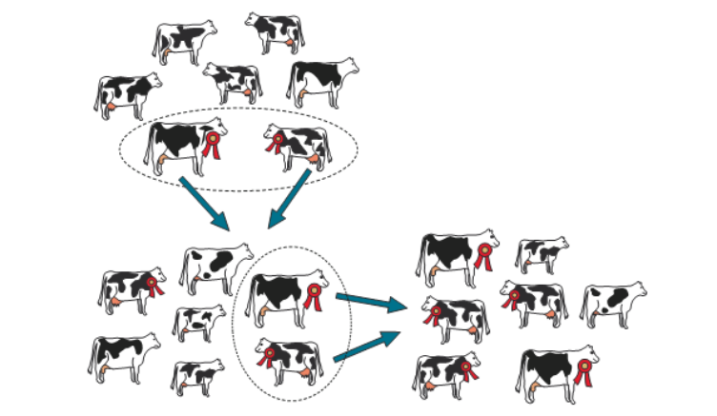

Photo Credit: Expert Guidance
Gene Editing

The process of using enzymes to cut, replace, or insert genes within a plant’s DNA to affect its traits.
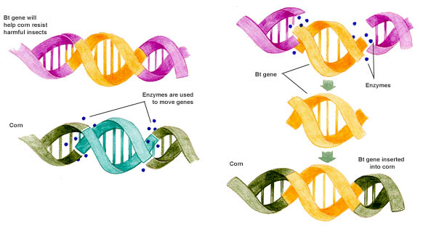
Photo Credit: Vox Media

