Bloom in a Bottle
Science & Math Investigative Learning Experiences (SMILE)

Introduction

Bloom in a bottle is a simple but versatile experiment which can be performed by students from different grade levels with a teacher’s supervision. The main objective of the experiment is to highlight the pivotal role of microorganisms in the carbon cycle, specifically:
- Microbes in the ocean, while small, have a large impact on the biological carbon cycle because of their tremendous numbers.
- Microbes convert atmospheric carbon into biomass through photosynthesis.
- The sinking of photosynthetically fixed carbon (microbial biomass) removes carbon from contact with the atmosphere, reducing atmospheric carbon dioxide concentrations. This process is called the biological carbon pump.

Phytoplankton are aquatic microorganisms capable of producing their own food and energy from sunlight and carbon dioxide through the same mechanism as land plants, photosynthesis.
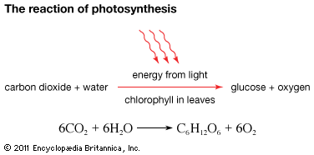

In ocean and freshwater basins, certain conditions cause phytoplankton to grow faster. When they reach such high densities that they begin to become visible, the color of the water becomes green because of the chlorophyll pigment found within their cells. This phenomenon is referred to as a Phytoplankton Bloom and has profound implications on the fate of carbon on earth, such as: the amount of carbon input to the marine food web, the capacity of the ocean to act as a carbon sink, and the amount of carbon released back to the atmosphere.

An important prerequisite that allows a bloom to form is the availability of macronutrients such as phosphorus and nitrogen. Additionally, micronutrients such as iron limit phytoplankton bloom formation. Other conditions that can influence a bloom are light intensity, temperature, salinity, number of grazers, and availability of different nutrients such as silica.

What are nutrients? Why are they so important?
Nutrients are chemical compounds that are required by life
Nitrogen is an essential component in nucleic acids (RNA and DNA) and in amino acids.
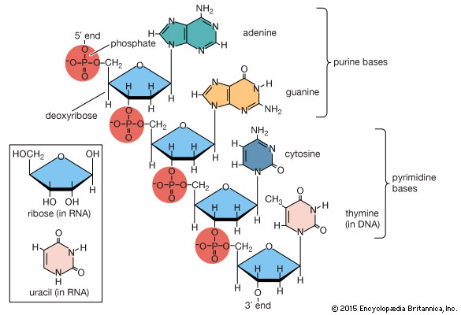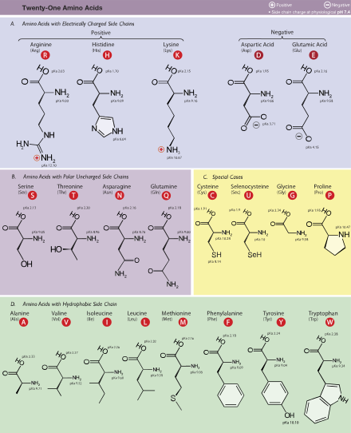

Phosphorus is also a component of DNA but is also a component of important energy molecules like ATP and make up the hydrophilic heads in the phospholipid bilayer that makes up all cells.
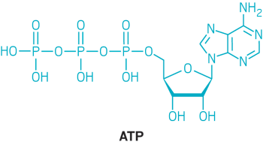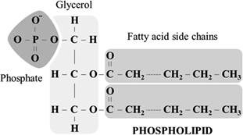
ACS.org Chegg.com

Iron is necessary to power certain enzymes. While proteins are primarily amino acids, many also contain metals. Especially important for photosynthesis are the proteins in the electron transport chain: Photosystem 1 (PS 1), photosystem 2 (PS 2), ferredoxin (Fd), and cytochrome (Cyt). All of them contain iron!
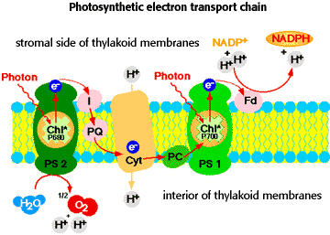
University of Arizona

To study phytoplankton blooms in the classroom, the Bloom in a Bottle experiment was designed. This experiment consists of collecting water from different sources (these can be any water sources; the ocean, ponds, lakes, creeks, rivers, etc). For each water sample you can perform different experiments by testing what happens with the addition of the biologically important elements nitrogen, phosphorus, and iron. Students should be encouraged to think about where these elements might come from, i.e. nitrogen from agricultural runoff. Some examples of potential experiments are listed below, but will be detailed more later:

- What happens if you add Nitrogen?
- What happens if you add Phosphorus?
- What if both Nitrogen and Phosphorus are added?
- What about Iron?

The above experiment can show the idea that an element can be limiting for growth. Food is usually an excellent way to explain the concept:
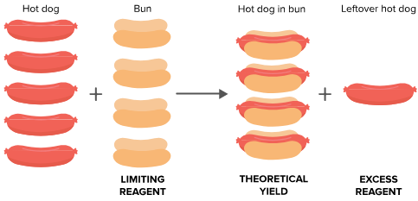
Khan Academy

You can add different ratios of both and compare the results, which allows students to make predictions about which elements are limiting.

We will recommend various potential experiments in the following section that can illustrate actual phenomena that influence algal growth in nature. This will give students a chance to learn the impacts of certain natural and human activities on the carbon cycle.

Activity

Purpose: This is an inquiry-based learning exercise where students will learn and implement the steps of the scientific method to investigate processes in microbial community ecology.

Scientific Method
STEP 1: Make an observation
STEP 2: Define a question based on the observation
STEP 3: Form a testable hypothesis
STEP 4: Design an experiment to test the hypothesis
STEP 5: Set up Experiment
STEP 6: Run experiment/Gather Data
STEP 7: Analyze Data
STEP 8: Use data to determine conclusions. Does the data support the initial hypothesis?
STEP 9: Use Data to refine hypothesis, then repeat process.

STEP 1: Make an observation
Observation is a key element in all scientific investigation. It is initial observations of natural systems that stimulate the curiosity that drives scientific research. Big picture observations become progressively more refined with continued observation. For example, one might observe that the color of the ocean differs from place to place. Pictures of tropical beaches look much different than the Oregon coast. Similarly, the colors of streams are different high in the mountains than downstream.

STEP 2: Define a question based on the observation
After making an observation, the next step is to ask “why?” Is this observation repeatable across space (e.g., are all rivers clearer at their source than downstream?) and time (e.g., is the ocean always more green in the Spring?). What factors could be creating this observation? What are the underlying causes? These questions should be broad and should seek to explain the observation. They can and should be open ended. At this point in the method, students should begin to investigate these questions to see what is already known, and then use this knowledge to further refine their questions. A list of potential questions that the students could use, along with potential experimental designs, are given in Appendix 1.

STEP 3: Form a testable hypothesis
A testable hypothesis is a very specific and focused question that has a yes/no answer. The hypothesis is the basis of the research to follow; the research is designed to provide a ‘yes’ or ‘no’ to the hypothesis. While the questions in step 2 are purposefully broad, the hypothesis must be very narrow and focused. The hypothesis takes the form of a statement, the results of the experiment will then be able to be used to prove if the statement is correct, or not.

For Example:
The students observed that the ocean is greener in the springtime. The initial question stemming from this observation could simply be: why is the ocean greener in the spring than in the fall? After conducting some internet research, the students determine that the availability of nutrients in the ocean is greater in the spring than the fall, caused by a process called upwelling. The increased availability of nutrients causes microbial plants called phytoplankton to grow which cause the water to appear green. A refined question would then be: what nutrients are required to stimulate this growth? From there a focused, testable hypothesis would be: Increased concentrations of nitrogen cause phytoplankton to grow. OR: A nitrogen to phosphorus ratio of 16:1 is ideal for causing a phytoplankton bloom.

STEP 4: Design an experiment to test the hypothesis
With a focused testable hypothesis in hand, an experiment can be designed to directly test the hypothesis. During steps 3 and 4 it is important to keep in mind the time and resources that are available. It's completely acceptable and normal to refine or change the hypothesis based on discoveries during the experimental design phase. However, it is important that the experiment that is ultimately designed does in fact test the hypothesis!

Some important things to consider:
- Only change one variable at a time. If you are going to be able to determine the impact of a condition (e.g., nitrogen concentration), that can be the only thing that changes, all other factors must be held constant
- Negative Control. In order to determine if your treatment had an impact, you must include a treatment where nothing was changed. This is called a negative control. The extent of the observed change is the difference between the negative control and the treatment. For example, if you’re studying the impact of different nitrogen concentrations on phytoplankton growth in seawater, your negative control would be normal seawater. If your unamended seawater grows as many phytoplankton as your amended seawater, your treatment with nitrogen added, then it didn’t have an impact.
- Positive Control. In some cases, you know that a certain set of conditions will give the desired result. Including a treatment with these conditions provides the ability to assess if the experiment would work if everything was perfect. Sometimes there is an unknown part of the experimental design that could cause unintended negative results. This is important because the appearance of a failed experiment could cause the hypothesis to be mistakenly thrown out. For example: You know that adding 100µM of nitrogen will cause a phytoplankton bloom. You’re interested in determining the minimum concentration of nitrogen required for bloom formation, so your experimental treatments are much lower concentrations of nitrogen (1-10µM). You could use the a 100µM concentration treatment as positive control as you know that a bloom should occur in that treatment. If a bloom doesn’t occur in any treatment (including the positive control) it would indicate that some other factor caused the experiment to fail. Some potential factors could be that there were no living phytoplankton in the sample, or there was a toxic chemical leaching from the experimental bottles.
- Replicates. It is important to have multiple bottles (three or more) where the treatment is the same. This allows for the assessment of the consistency of the response. Additionally, replicates allow for the application of robust statistical techniques.

Designing Your Experiment
Appendix 1 provides many possible experimental designs to be used as starting points. A major learning goal of this activity is the application of the scientific method, therefore we strongly encourage each group of students to develop their own experiment based off their own observations, questions, and hypotheses. The Giovannoni Lab at Oregon State University will be available via email, phone, or skype to work with each club at this stage of their activity to answer all experimental design questions. Please contact Dr. Chris Suffridge to set up a virtual meeting with a scientist (suffridc@oregonstate.edu).

STEP 5: Set up Experiment

This example uses the hypothesis:
The phytoplankton community found in the seawater in Newport Oregon is nitrogen limited.

This means that all nutrients except nitrogen are present in sufficient quantities for phytoplankton growth, and the only thing preventing more growth is a lack of nitrogen. In the figure in the introduction, nitrogen would be the hotdog bun. Therefore, if more nitrogen is added, more growth will occur, but if additional concentration of another nutrient (phosphorus) is added, nothing will occur.

In order to confirm this hypothesis, the following conditions need to be met:
- The nitrogen treatment had more growth than the phosphorus treatment
- The nitrogen treatment had more growth than the negative control.

This protocol can be adapted to other hypotheses by changing the experimental design in the table below.

Materials Provided by SMILE
See Appendix 2 for details about stock concentrations and dilutions.
- Nitrogen
- Phosphorus
- Iron
- Miracle-Gro All Purpose Liquid Feed (12%N, 4%P, 8%Potash, 0.05%Mn, 0.05%Zn)
- Mini-Phone microscopes

Materials Self-obtained
- Experimental containers. We suggest 500ml water bottles.
- Aluminum foil covers
- Source water
- Transfer pipettes
- Slides and coverslips
- Coffee filters
- Analytical balance

Procedure

- Collect water from a creek, river, lake, or ocean.
- Determine experimental treatments based off scientific method steps discussed above. For this example:
  - Our question is: Is nitrogen or phosphorus the limiting nutrient in seawater collected off the Oregon coast?
  - The testable hypothesis is: Nitrogen is the limiting nutrient in seawater collected off the Oregon coast.
    - Additions of nitrogen will stimulate a bloom, but additions of phosphorus will not because there is already sufficient phosphorus in the water, but there is insufficient nitrogen.
  - Our negative control is a no-addition control
  - Our positive control uses Miracle-Gro, which contains all necessary nutrients, and should stimulate a bloom.
  - We have three replicates per treatment
- Create a table outlining your experiment (see example below). You can add a column with your expectation (hypothesis) and other column with initial observations of the water (time 0) this can include some features you think are important for the experiment. For example, is water murky or clear? Did you collect the water in a hot day in summer or in winter?

Bottle # | Label | Replicate | Water Type | Water Volume | Treatment
1 | Negative Control | A | Seawater | 500ml | None
2 | Negative Control | B | Seawater | 500ml | None
3 | Negative Control | C | Seawater | 500ml | None
4 | Positive Control | A | Seawater | 500ml | Miracle-Gro 0.5ml
5 | Positive Control | B | Seawater | 500ml | Miracle-Gro 0.5ml
6 | Positive Control | C | Seawater | 500ml | Miracle-Gro 0.5ml
7 | Nitrogen | A | Seawater | 500ml | 1ml NH₄Cl
8 | Nitrogen | B | Seawater | 500ml | 1ml NH₄Cl
9 | Nitrogen | C | Seawater | 500ml | 1ml NH₄Cl
10 | Phosphorus | A | Seawater | 500ml | 1ml NaH₂PO₄
11 | Phosphorus | B | Seawater | 500ml | 1ml NaH₂PO₄
12 | Phosphorus | C | Seawater | 500ml | 1ml NaH₂PO₄

- Add 500ml of water into each container
- Label each bottle with the Number, Label, and Replicate from the table.
- Add the treatments to each container based on the table above. E.g., add 1ml of NH₄Cl to bottle 7. See Appendix 2 for details about stock concentrations and making dilutions.
- After adding the treatment, loosely cap the container (to allow air exchange), and place near a window where each bottle will recieve natural light

STEP 6: Weekly Observations and Data Collection
Depending on the initial concentration of cells in the water, it will take between 3 to 5 weeks to see growth. Growth will be between brown and green depending on the organisms that are blooming. Keep track of your measurements and observations as described below.

1. Microscopy using the Echo wooden scope
- Build the wooden microscope. Follow the steps in the video at https://discover-echo.com/productdemo
- With a dropper or disposable Pasteur pipette take a drop of water. Place the drop in a glass slide and cover it (wet mount).
- Place the slide below the magnification glass and the camera of your cellphone above it.
- Focus with the knob and your camera settings
- Take pictures and keep a record of your observations of the coloration, density, and type of growth (filamentous, smooth, etc.) of the cultures through time and across treatments.
- To quantify the color of the growth you see, you can use an app like Color Grab for Android or Pixel Picker for iPhone to measure and record the RGB values in your sample; this can be used as a way to measure if there are different types of algae growing in different treatments
  - Make sure you place a white piece of paper beneath your microscope to standardize the background color in all samples, and try to do them in roughly similar lighting on different weeks
  - As there will likely be splotches of different color on your sample, it would be best practice to select around 5 different spots on each sample and average the RGB values to come to one RGB value for each sample that can be compared to the other samples
  - Here is a link with a more detailed instruction on how to use a phone as a spectrophotometer, if you want to go more in-depth: https://bit.ly/2vbvA4r

2. Filtering: at the end of the experiment, when you have a good amount of growth in your cultures, use coffee filters and a funnel to filter each culture and weigh the amount of biomass present.
- Once the cultures have finished filtering through, dry the filters by squeezing them between paper towels to get most of the moisture out
- Weigh each filter separately on a tared balance
  - Technically, it would be more accurate to let the filters completely dry out before weighing them, but the weight differences between dried samples are quite small, on the order of 0.05 grams, so you’re more likely to see better results if you squish them dry to remove excess moisture before weighing the same day as filtering.
- Record weights for all samples across all treatments and subtract the weight of the averaged negative control from the weight of the treatment samples to get a final measure of biomass.

STEP 7: Analyze Data
Keep careful notes about the growth observed in each container. As the experiment progresses, plot your data. Averaging replicates accounts for natural variability between bottles of the same treatment.

STEP 8: Use data to determine conclusions. Does the data support the initial hypothesis?
Look back on the course of the experiment and determine if your hypothesis was supported. Did the positive control have more growth than the negative control? Did the experimental treatments have more growth that the negative control? How much more?
Did nitrogen or phosphorus produce more growth? We hypothesized that the system was nitrogen limited, so in order to confirm that hypothesis, the following conditions need to be met:
- The nitrogen treatment had more growth than the phosphorus treatment
- The nitrogen treatment had more growth than the negative control.
At this stage please feel free to contact the Giovannoni Lab again, we’d be happy to talk with your groups about their results!

STEP 9: Use Data to refine hypothesis, repeat process.
If the data supports the hypothesis, GREAT! You have used the scientific method to determine a cause of an observed event. If the data does not support the hypothesis, GREAT! You have determined what is not going on using the scientific method! You may want to explore alternative hypotheses that your experiment might have confirmed. For example, if the phosphorus treatment had more growth than the control and more growth than the nitrogen treatment you could say that the system was phosphorus limited not nitrogen limited. You should use your results to refine your hypothesis and experimental design and then repeat the process.

Appendix 1
LIST OF OTHER POTENTIAL QUESTIONS FOR THE STUDENTS TO USE:
- What nutrients do phytoplankton need to grow?
- What ratio of these nutrients is required to stimulate a bloom?
- Does phytoplankton growth mirror the amount of nutrients added?
- How does surface area of the bottle affect bloom formation?
- Do phytoplankton blooms form in all seasons of the year?
- How deep can phytoplankton grow; how does light color affect growth?
- How does salinity affect the growth of algae in freshwater?
- How diverse are phytoplankton? Are there different types of phytoplankton in different types of water?

Nutrients: try adding in different individual nutrients (nitrogen, phosphorus, or iron, 1 mL each) to different treatments to compare growth levels. This will not only illustrate the concept of limiting nutrients for students, but also the effect of runoff from human activity (fertilizer) into water.

Ratio of nutrients: use the concept of limiting nutrients to see if one of the three inorganic nutrients supplied (N, P, or Fe) is limiting. Try adding different combinations of these three nutrients (eg N and P, but no Fe, or N and Fe but no P) to see which nutrients are limiting for phytoplankton growth.

Amount of nutrients: try adding different amounts (5 mL instead of 1 mL, etc.) of nutrients (e.g. Miracle-Gro) to different treatments to see if growth mirrors the amount of nutrients added.

Surface area: try comparing the effect of different bottle shapes on the growth of phytoplankton. The shape of the bottle will impact the amount of water surface area able to interact with the atmosphere; the larger the surface area, in theory, the more gas exchange can occur, the more CO₂ can diffuse into the water, the faster the phytoplankton should grow. This could also serve as a lesson for the students on how increased CO₂ concentrations in the atmosphere will impact phytoplankton growth. You can also use it to show how growth might differ between a deep, narrow lake and a wide, shallow lake.

Seasonality: try growing cultures at different temperatures in combination with different light levels. To simulate winter, lower the amount of light entering the cultures by wrapping them in a semi-opaque material (note: cultures grown in complete dark will not have any growth) and lower the temperature of the culture (water bath, or ice packs). To simulate summer, don’t wrap the cultures in anything and increase the temperature slightly (heat lamp, heating pad under the cultures; note: excess heat will kill all the phytoplankton, so don’t heat them to more than 25 C). Variations on this can simulate transition months.

Light color: By growing phytoplankton under different colors of light, your student can explore this topic. Did you know that different types of light can reach different depths in a column of water? By covering your chambers with different colored cellophane wraps (easily purchasable via Amazon; rember that red cellophane will absorb every color but red, blue cellophane absorbs every color but blue, etc), you can experiment with what colors of light promote and which stunt phytoplankton growth:
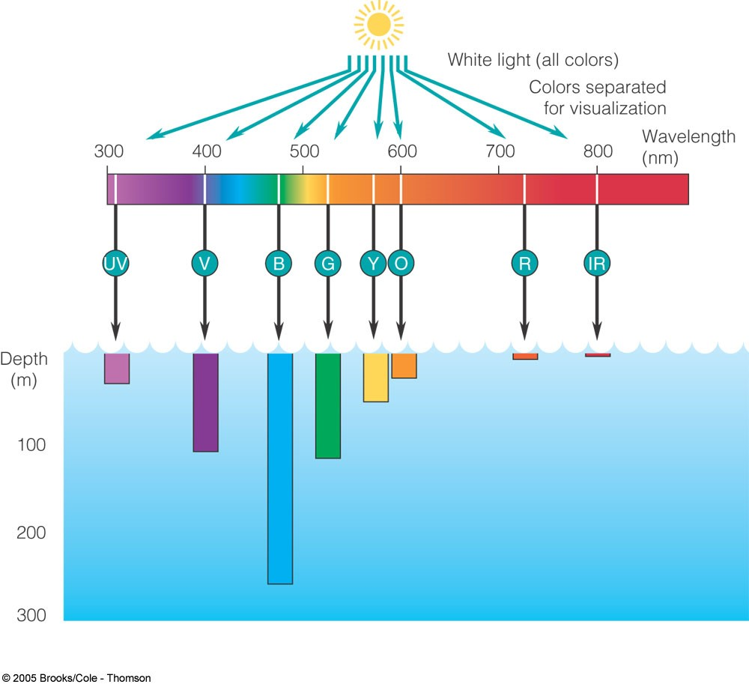

Salinity: if growing algae from freshwater sources, try adding salt to one treatment. This will simulate when there is run off from the salt used to melt snow on roads during winter, giving the students a lesson on the effect of human activity on phytoplankton growth.

Diversity of phytoplankton: try comparing the type and amount of phytoplankton growing from various water sources, e.g. a pond vs. a creek, or seawater vs. a pond. The type of phytoplankton growing can be compared using microscopes and a visual analysis of type of growth. This will give students an illustration of the many different types of phytoplankton there are.

Appendix 2
Nutrient Stock Concentrations and Making Dilutions

Nutrient | Compound | Formula | Stock Concentration
Nitrogen | Ammonium chloride | NH₄Cl | 50mM
Phosphorus | Sodium phosphate monobasic anhydrous | NaH₂PO₄ | 5.0mM
Iron | Ferric chloride hexahydrate | FeCl₃ 6H₂O | 0.5mM

Organisms require different amounts of each nutrient based off their biochemistry. Nitrogen is a component of proteins and DNA, and there are many nitrogen molecules in each of these biomolecules. Phosphorus is component of DNA and some lipids, but the number of phosphorus molecules per biomolecule is less than nitrogen. Iron is an essential cofactor for some enzymes (as opposed to a structural part of the biomolecule), therefore it has the lowest per cell requirement. The ratio of N:P:Fe in the stocks provided in this experiment mimics this natural cascade of nultrient requirements. We have provided N:P:Fe is the ratio 100:10:1. Therefore if 1ml if each is added to a culture the nutrient ratio will be “ideal”. The final concentration of each nutrient if 1ml of stock is added to a 500ml culture is in the table below.

Formula | Stock Concentration (C₁) | Volume of Stock Added (V₁) | Final Concentration in culture (C₂) | Volume of Culture (V₂)
NH₄Cl | 50mM | 1ml | 100μM | 500ml
NaH₂PO₄ | 5.0mM | 1ml | 10μM | 500ml
FeCl₃ 6H₂O | 0.5mM | 1ml | 1μM | 500ml

Making Dilutions
We encourage groups to test different concentrations and ratios of nutrients. Also, different culture volumes are likely to be used. For both cases groups must calculate different dilutions from the nutrient stock solutions provided. This can be done using the following equation. We encourage groups to make a table similar to the table above and fill in all values based on the equation below.

Concentration is measure of a known amount of a compound (solute) dissolved in a known volume (solvent). Molarity is the primary unit of concentration in chemistry, it has units of of moles/liter. Molarity is abbreviated with “M”

Using metric prefixes:
M= molar
mM= milimolar
μM= micromolar
nM= nanomolar

1M=1000mM
1mM=1000μM
1μM=1000nM

Calculating Dilutions:

Equation 1: C₁V₁=C₂V₂

C₁: Concentration of stock (molar units)
V₁: Volume of stock ADDED TO CULTURE (ml units)
C₂: Desired concentration in culture
V₂: Volume of culture (ml)

NOTE: All units must match. Use one concentration unit and one volume unit. This may require a metric prefix conversion.

Calculation Example

GOAL: You want to add equal concentrations of N, P, and Fe (10μM final concentration for all three) to a 250ml culture.

Create a table that reflects your goal
Formula | Stock Concentration (C₁) | Volume of Stock Added to culture (V₁) | Final Concentration in culture (C₂) | Volume of Culture (V₂)
NH₄Cl | 50mM |  | 10μM | 250ml
NaH₂PO₄ | 5.0mM |  | 10μM | 250ml
FeCl₃ 6H₂O | 0.5mM |  | 10μM | 250ml

Now, it is possible to see the knowns and unknown. The stock concentrations are not changeable and vary between compounds. The final concentrations are set at 10μM based on the decision stated in the goal. The final volume of the culture is set at 250 based off the size of the available container. The unknown is the volume of the stock that needs to be added to the culture. We can rearrange Equation 1 to solve for V₁ for each compound.

Equation 1: C₁V₁=C₂V₂

Rearranged to solve for V₁ V₁=(C₂V₂)/C₁

Now substitute the values for the knowns in the table above for the variables

Nitrogen: V₁ = (10μM x 250ml)/50mM

IMPORTANT NOTE: Before solving, all concentration and volume units must be the same! In this example we have μM and mM. We must convert these units, so we only have one. We will convert μM to mM.

10μM(1mM/1000μM) = 0.01mM
10μM=0.01mM

Replace and solve
Nitrogen: V₁ = (0.01mM x 250ml)/50mM
Nitrogen V₁ = 0.05ml

Now add that value back into the table and repeat the process for P and Fe. When you’re done the answers should be:

Formula | Stock Concentration (C₁) | Volume of Stock Added to culture (V₁) | Final Concentration in culture (C₂) | Volume of Culture (V₂)
NH₄Cl | 50mM | 0.05ml | 10μM | 250ml
NaH₂PO₄ | 5.0mM | 0.5ml | 10μM | 250ml
FeCl₃ 6H₂O | 0.5mM | 5ml | 10μM | 250ml

