Activity #1: Beyond the Volcano:
Modeling Volcanic Processes and Conducting Authentic Geologic Research
with Baking Soda and Vinegar Volcanoes

Lesson Summary
Use the common baking soda and vinegar volcano demonstration to model both authentic volcanic processes and scientific practices associated with geologic research.

Materials
Baking soda  Vinegar  Play-Doh for volcanic layers  Plastic cups  Abundant paper towels | Poster board/paper plates  Permanent marker and pencil  Straws for coring  Safety equipment: gloves, goggles, aprons

Next Generation Science Standards: Performance Expectations and Crosscutting Concepts

Performance Expectations | Crosscutting Concepts
4-ESS2-2. Analyze and interpret data from maps to describe patterns of Earth’s features  MS-ESS2-2. Construct an explanation based on evidence for how geoscience processes have changed Earth's surface at varying time and spatial scales  HS-ESS2-1. Develop a model to illustrate how Earth’s internal and surface processes operate at different spatial and temporal scales to form continental and ocean-floor features. | 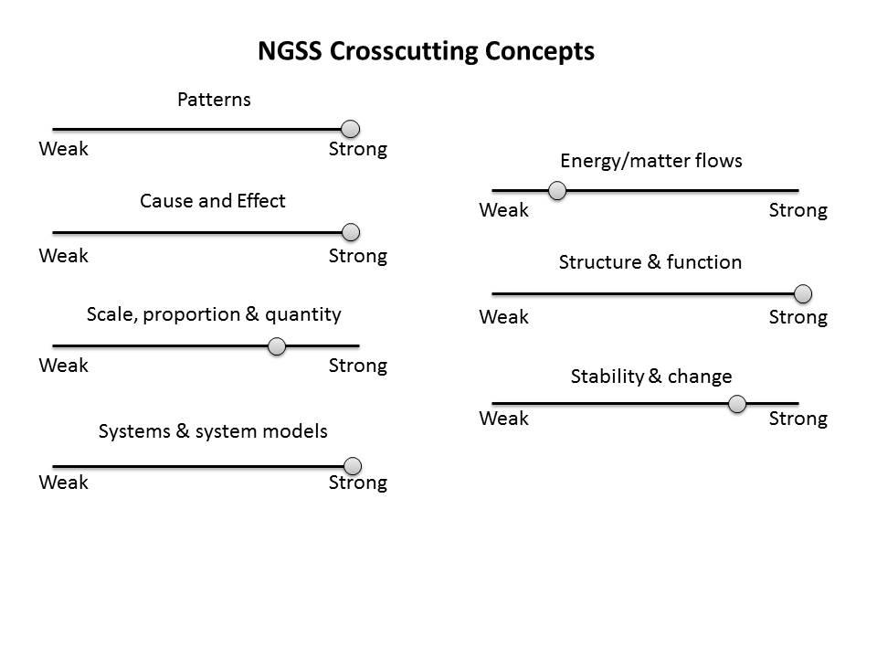

Strong connection to crosscutting concepts means that the activity has clear connections that are exemplars of the crosscutting concept. A weak connection indicates that there is either no part of the crosscutting concepts applies to the activity or the activity would have to be modified to develop these connections.

Teacher Background Information
- Many of the world’s volcanoes form along active plate tectonic boundaries with some notable exceptions (e.g., Hawaii volcanoes).
- Some volcanic eruptions are explosive near the source producing hot, but fluid lava that flows from the volcano’s crater and produce volcanic landscapes. Hawaiian volcanoes erupt and form in this manner. In Oregon, the Belknap shield volcano, which last erupted 1,500 years ago, formed due to several lava flows.
- Geologists who study volcanoes (volcanologists) examine, sample and measure layers of volcanic rocks to develop models for a volcano’s eruption history.

