Better Bananas Curriculum Guide
Timeframe:
One 50-minute class period
Target Audience:
Any Middle School (6-8) or High School (9-12) class
Materials:
- 2 Hat/bowl(s) to serve as gene pools for each team
- 2sets Trait List for Gene Pool, with traits cut up and folded (each team has a set in their own hat/bowl)
- 2 felt boards with cell cutouts on one side and chromosomes on the other
- 2 packs numbered felt adhering ping pong balls (1 pack for each team)
- Transgenesis Team Worksheet
- Gene Editing Team Worksheet
- GE and Transgenesis Activity Definitions
- Teacher cheat sheets:
  - DNA to RNA Translation
  - Possible Outcomes Sheet
Description:
In this activity, the class is divided into two different teams to work through activities that mimic the two separate processes scientists use to transfer genetic material into plant cells to modify existing genetic material. One team will follow the Transgenesis Track to understand how scientists use gene guns to add new traits, such as insect or drought resistance, into existing plant cells. The other team will follow the Gene Editing Track to mimic the process of using Agrobacterium to insert a CRISPR/Cas 9 molecule that allows scientists to edit existing genes within the plant cell, therefore changing the traits the plant expresses (e.g., improved yield or flavor).
This activity guide is developed for both high school and middle school classes. The structure of the activity is the same for both of these levels. However, there are additional, more in depth discussion questions in this curriculum guide that provide a platform for scaffolding the classroom conversation for students in with more advanced knowledge about these topics (“advanced”). Questions for students without much prior exposure to these topics are indicated as “emerging” questions.
Learning Objectives:
- Students will understand:
  - The conceptual process of how scientists insert DNA into a cell using a gene gun or agrobacterium
  - How those processes can also be used to insert CRISPR molecules that allow for more efficient gene editing
  - The differences between transgenesis and gene editing
  - When and why you would use transgenesis or gene editing to modify genetic material
- Students will be able to:
  - Translate DNA base pair sequences to their associated RNA sequence
  - Calculate their success rate and brainstorm ways to improve their success rate
Guiding Question(s):
Advanced:
- What are the differences between transgenesis and gene editing?
- When and why would you use transgenesis or gene editing?
- What is the difference between using Agrobacterium or gene guns to insert genetic material?
- When and why would you use Agrobacterium or gene guns to insert genetic material?
Emerging:
- What is transgenesis?
- What is gene editing?
- What is Agrobacterium and how is it used to transfer genetic material?
- What is a gene gun and how is it used to transfer genetic material?

Teacher Background:
This guide will use only scientific terms to refer to the items used in this activity. The table below indicates which item in the kit corresponds to each of the relevant scientific terms.
SCIENTIFIC TERM | ACTIVITY COUNTERPART
Gene Pool | Bowl/Container with strips of paper
Genetic Material | Strips of paper with DNA sequence
DNA/DNA Strand | Velcro Ball
This activity focuses on two different methods of modifying genetic material. These two processes, transgenesis and gene editing, are both very complex scientific processes. Transgenesis is the process of adding completely new genes that don’t exist anywhere else in the gene pool for the species into an organism. Gene editing involves adding, editing, or replacing existing genetic material. These processes are very different, but they follow these general steps:
Step | Description
#1: Identify Problem  Problem description provided in worksheet | Scientists or plant producers identify a "problem" that they would like to improve. For example, is the plant being eaten by a specific pest? Could the flavor of the plant be improved somehow? In our activity, the transgenic and gene editing teams are working toward a solution to delay ripening of the banana. Delaying banana ripening would reduce food waste and make it easier to transport bananas.
#2: Understand the biological processes that are involved with that problem  Included in activity | Once the problem is identified, scientists need to understand the biological processes that are associated with that problem. For example, banana ripening is primarily a result of 2 different biological pathways: the production of ethylene and the production of pectin. Scientists need to understand how these pathways work and whether they can change the pathway by adding completely new genetic material associated with a specific gene into the DNA (transgenesis) or editing existing genetic material within the DNA to disrupt the pathway (gene editing).
#3: Find Genetic Material  Included in activity | DNA is a universal language among all organisms. Scientists need to determine whether the genetic material associated with the gene they believe could delay banana ripening exists within the plant's gene pool or if they need to use genetic material from some other distantly related or unrelated organism. Luckily, if this problem has already been solved for another species, the DNA that was used in that process could also be used to improve this species. For example, if transgenic or gene editing methods had already been used to delay ripening for another species, scientists can try to insert that genetic material in the banana to see if it delays ripening.
#4: Insert Genetic Material into Plant Cells  Included in activity | At this point, scientists are able to insert the genetic material into the plant cells. There are 2 common methods for this. One uses a gene gun to "shoot" gold pellets that are coated with the new genetic material into a petri dish with plant cells that they want to add this material into. This method has a high degree of error: there is no certainty that the DNA coated pellets will land in the nucleus of the cell. The other method uses Agrobacterium, a naturally occurring soil bacterium to insert the new genetic material into the nucleus of the cell. Although this method provides certainty that the genetic material will be inserted in the nucleus, there is no guarantee that the material will be inserted into the portion of the chromosome that will allow it to be taken up by the plant and transcribed during DNA transcription processes. Both of these methods are used for transgenesis. However, the gene editing process more commonly uses the Agrobacterium method, especially to insert a CRISPR/Cas 9 molecule that will ensure the new genetic material will be inserted in the appropriate area of the chromosome.
#5: Grow Up Plant  Not included in activity | Scientists then grow the cell into the beginning of a plant by encouraging it to put on root growth and new stem growth ("shoots"). Through this process, scientists are able to determine which cells (now small plants) uptook the new DNA and is expressing the trait that is associated with it. Scientists are capable of doing this because they often include a DNA sequence associated with antibiotic resistance along with the DNA for the desired trait and therefore, cells that exhibit resistance to the bacteria will also have this new trait included.
#6: Expression Studies  Not included in activity | Plants are complex organisms and modifying DNA is a complicated task. Scientists conduct a variety of "expression studies" to confirm that the new material was accurately inserted. Expression studies are used to determine: if one or more copies of the genetic material were inserted into the cell (especially for genetic material that is inserted using the gene gun method), where exactly the new genetic material was inserted into the cell, and that the new genetic material does not affect the expression of any of the other traits of the plant.
#7: Cultivate New Plant  Not included in activity | Once scientists have confirmed that the genetic material was inserted appropriately and does not affect any of the other properties or characteristics of the plant, they will begin cultivating the plant. This can be done by propogating new plant individuals from clippings of the modified plant, cloning the modified plant, or breeding the new plant into other varieties of the plant that are commonly used.
In this activity, the class is divided into two different teams to work through activities that mimic the two separate processes scientists use to transfer genetic material into plant cells and modify genetic material. The entire class is working on addressing the same problem: delaying ripening of the banana. One team will follow the Transgenesis Track to understand how scientists use gene guns to add new genetic material into existing plant cells. The other team will follow the Gene Editing Track to mimic the process of using Agrobacterium to insert a CRISPR/Cas 9 molecule that allows scientists to edit existing genes within the plant cell, therefore changing the traits the plant expresses.
A diagram of the activity is as follows (transgenesis track in blue, gene editing track in green, activities included in both tracks are in black):
Step 1: Problem Identified in Worksheet (delaying ripening of banana)

Step 2: Decide which genes
(Gene Editing Track)
Step 2: Decide which genes
(Transgenesis Track)

Edit genes responsible for the pectin degradation biosynthetic pathway to slow down degradation

Edit genes responsible for the ethylene production biosynthetic pathway to slow down production
Add gene that reduces the amount of hormone that triggers pectin degradation
Add gene that reduces amount of hormone that triggers ethylene production

Step 4: Transfer genetic material to edit DNA into cell
(Agrobacterium)
Step 4: Transfer new genetic material into cell
(Gene Gun)
Step 3: Find genetic material to address the problem in the gene pool

Activity Definitions/Descriptions:
- Agrobacterium: Agrobacterium is a bacteria species that is very common in the soil. It is a virulent plant pathogen that is able to transfer its own genes into plant cells to cause tumors that feed the bacterium and allow it to reproduce. Because it is able to transfer DNA from itself into plants, it has become very important in genetic modification. Scientists are able to “disarm” the bacteria by removing the tumor inducing components of its existing DNA, insert new DNA associated with a specific trait, and use its existing mechanism to insert this new DNA into plant cells. This mechanism ensures that the new DNA is inserted into the nucleus of the cell without impacting other cellular processes.
- Gene gun: The gene gun is a modified shot gun that is used insert or transfer DNA into a plant cell by bombarding plant cells in a petri dish with millions of gold particles that are coated with hundreds of copies of DNA associated with the trait of interest. This device was first developed in 1984. Where the DNA is inserted in the cell using the method is random; it may not be inserted into the nucleus and therefore will not be successful. If the particles are successfully inserted into the nucleus of the cell, the DNA dissolves off of the gold material and can potentially insert into the chromosome.
- Genes: a unit of heredity which is transferred from a parent to offspring and is held to determine some characteristic of the offspring; a distinct sequence of nucleotides forming part of a chromosome
- Traits: a genetically determined characteristic; a distinguishing quality or characteristic, typically one belonging to a person
- Gene pool: the stock of different genes in an interbreeding population
- Transgenesis: the process of introducing a transgene (i.e. a new gene such as insect resistance) from one organism into another with the intent of enabling the latter to exhibit a new trait or characteristic that can be transmitted to its offspring
- Gene editing: refers to a group of technologies that give scientists the ability to change an organism's DNA. These technologies allow genetic material to be added, removed, or altered at particular locations in the genome. CRISPR/Cas 9 is one of the technologies used in gene editing.
  - CRISPR/Cas 9: Researchers create a small piece of RNA with a short "guide" sequence that attaches (binds) to a specific target sequence of DNA in a genome. The RNA also binds to the Cas9 enzyme. As in bacteria, the modified RNA is used to recognize the DNA sequence, and the Cas9 enzyme cuts the DNA at the targeted location. Once the DNA is cut, researchers use the cell's own DNA repair machinery to add or delete pieces of genetic material, or to make changes to the DNA by replacing an existing segment with a customized DNA sequence.
Pre-Activity Lead In (optional)
- To introduce students to the idea of ripening and the impact it can have on produce, buy a bunch of unripe bananas. Tell students that in a few days, they will be participating in an activity focused on delaying the ripening process. Ripening involves multiple biological pathways – of which, ethylene production is one. Put 1-2 bananas in a paper bag and leave the remaining bananas out to ripen. (NOTE: this reaction is also temperature sensitive – the bananas will ripen a lot more slowly if they are in a temperature less than 60 degrees).
  - Discussion Questions
    - Emerging:
      - Why did the banana in the bag ripen more quickly? (The bananas that are in a paper bag will ripen faster because the ethylene they are producing is trapped in the bag, whereas the bananas on the counter ripen more slowly because the ethylene is dispersed into the environment and has less of a direct impact on the banana.)
    - Advanced:
      - What are other factors that might play a role in how quickly a banana ripens? (temperature: bananas ripen faster in warm weather, if the banana is with other bananas that are also releasing ethylene)
      - Can you brainstorm ways we might be able to delay the ripening process? (put the banana in the fridge so temperature is held constant, hang bananas on a hanger so they are separated from other produce)
Activity Introduction:
- Prior to class: set up a transgenesis team station and a gene editing team station, each with a felt board, gene pools with genetic material, velcro-adhering ping pong balls, and student worksheets. The felt board should be set up at an angle approximately 10 feet away from each throwing spot for the transgenesis team and 5 feet away for the gene editing team.
- During class: ask students what they think the process of making a GMO is like: do they think it’s easy and very efficient or hard with lots of trial and error?
  - Advanced discussion questions: What are some of the challenges researchers might face in trying to insert new genetic material into a cell? (finding the genetic material associated with the trait of interest, getting it into the cell, making sure the cell incorporates that new material into the genome and replicates it, ensuring that the new genetic material doesn’t affect any of the other functions of the plant.)
Activity Procedure:
- Introduce students to the concepts of Agrobacterium, gene guns, and CRISPR/Cas9 by showing each of the following videos. We have included some questions for you to ask to encourage students to think about the specific concepts that will be important for the activity. Students could answer these questions as part of a think/pair/share exercise.
  - Gene gun (3:56 – 5:00 minutes)
    - What are some of the benefits of using a gene gun? (It allows the new DNA to get past the cell wall)
    - What are some of the downsides of using a gene gun? (There is no guarantee that the DNA will be inserted into the nucleus, might leave remnants of the gold pellet in the cell, could be inserted into other organelles and cause damage to the cell, it is hard to control where the DNA lands in the cell.)
  - Agrobacterium (5:00 – 8:38 minutes)
    - Are scientists developing these mechanisms or discovering them from the nature? (Agrobacterium is a common soil bacterium that invades plants and causes an infection, scientists were able to modify Agrobacterium to remove the pathogenic properties of it and use it as a method to transfer DNA into a cell)
    - What are some of the benefits of using Agrobacterium over the gene gun method? (Provides certainty that the DNA will be inserted into the nucleus)
  - CRISPR (1:09 – 3:18 minutes)
    - What does CAS 9 do? (it’s a nuclease that is capable of cutting DNA)
    - What is the benefit of using CRISPR/Cas 9? (It is efficient and able to make exact changes to the DNA)
    - How does CRISPR/Cas 9 “knock out” the expression of a gene? (the sequence of base pairs that corresponds to that gene is damaged during the DNA repair process)
- Introduce students to the activity by telling them that today they are going to be scientists and use hands-on activities to understand the different steps scientists go through to genetically modify a plant.
- Divide students in to 2 equal groups. One team will work on the transgenesis track (adding completely genes) and the other team will work on the gene editing (editing existing genes) track. Have each group go to their respective station.
- Provide each student with a Transgenesis Track Worksheet or Gene Editing Track Worksheet depending on what group they are in.
- Students read the information about banana in their worksheet. As a group, each team will decide which pathway they would like to investigate for adding or editing genetic material. Teams can either add or edit genetic material to (1) establish resistance to Fusarium wilt, (2) reduce the production of ethylene, or (3) reduce the degradation of pectin. Each of these three options has a GE or transgenic approach.
  - NOTE: the Fusarium option is not a viable option for delaying banana ripening. Teams that choose this option will be able to successfully insert this new genetic material into chromosome, but the teacher will need to address the fact that this gene is not related to delayed ripening in the discussion. This mimics the fact that sometimes scientists choose the wrong pathway to investigate and do not end up successfully addressing the problem they set out to address.
- Students need to find the genetic material that controls the trait they would like to add or edit in the gene pool.
  - There are 10 copies of each trait in the gene pool.
  - For each DNA strand the students would like to try to insert into banana cells, they must find a copy of the genetic material associated with their pathway and submit it to the teacher to randomly receive a numbered ball (e.g., if they find and submit 2 strips with the pathway on it, they will receive 2 numbered balls). Note that just because it has the appropriate pathway on one side, it might not have the appropriate DNA sequence for the gene editing or transgenesis team on the other side. The teacher will need to confirm that the team is submitting the appropriate genetic material to get the associated number of balls.
  - Each of the DNA strands students throw at the cells are numbered. Teachers will assign an outcome to each number regarding whether it is a successful insertion or failed insertion on the “Possible Outcomes” sheet.
- Scientists need to get the genetic material into the cell.
  - Transgenesis Track (Gene Guns):
    - Students in the group take turns throwing the ping pong balls at the plant cell side of the felt board until at least one makes it into the nucleus of the cell.
      - Note: they can throw multiple balls at the felt board at a time because gene guns often project multiple gold pellets covered with DNA at one time onto a petri dish of cells.
    - Once they get the ball (DNA) into the nucleus, teachers will make a note of which numbered ball(s) successfully made it. Only successful balls can be used in the next step. (*you can wait until this step to fill in your numbers on the “Possible Outcomes” sheet to control the outcome.)
    - Once the teacher confirms the previous step, students will take the successful ball(s) and flip over the board to the chromosome side.
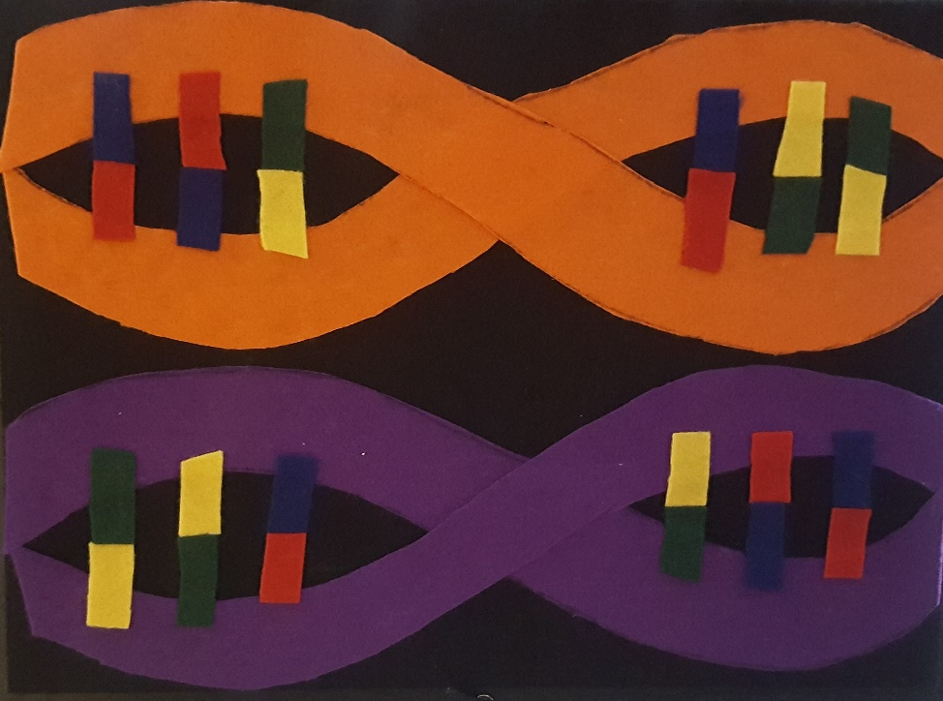
      - Make sure the board is flipped right side up. The nucleotides (red, blue, green, yellow pieces) should be in the following position:

    - As a team, students take turns throwing the ball until it lands on the chromosome. (Challenge: to add a level of complexity, students can choose to be blindfolded.)
    - Once the students land a ball on the structure of the chromosome, they will call the teacher over to confirm whether the DNA was successfully replicated.
      - First, verify that the DNA strand landed in the correct quadrant using the “DNA to RNA Translation” cheat sheet. The number in the column “associated chromosome quadrant” next to each pathway corresponds to the target quadrant (e.g., if they chose the ethylene pathway, they need to land the DNA in quadrant 3).
      - The quadrants are numbered as follows:
1 | 2
3 | 4
      - If they aren’t in the correct quadrant, they have to repeat the entire process, beginning with relocating the genetic material. (for the sake of time, you can allow them to skip the searching for genetic material step and start from the chromosome step).
      - If they landed in the correct quadrant of the chromosome, refer to your “Possible Outcomes” sheet to determine the outcome.
    - Students will keep track of how many throws it takes to get their new DNA successfully inserted. Students will calculate their success rate by dividing the number of DNA strands that adhered to the nucleus portion of the cell by the total number of DNA strands they threw at the felt board.
  - Gene Editing Track (Agrobacterium)
    - Team chooses a student to act as the guide RNA. This student will be responsible for translating the DNA sequence provided in the worksheet into an associated RNA sequence.
    - Students need to get the genetic material into the cell. As a team, students will throw the DNA at the cell side of the board. They can choose to throw one at a time or all at once. They will continue to throw until at least one makes it into the nucleus of one of the cells. *Students can choose to throw beyond getting 1 ball into the nucleus to increase their chances of success in the next step. Reveal this only if they ask.*
      - Once they get the DNA into the nucleus, teachers will make a note of which numbered ball(s) successfully made it. Only successful balls can be used in the next step. (*you can wait until this step to fill in your numbers on the “Possible Outcomes” sheet to control the outcome.)
    - Once the teacher confirms the previous step, students will take the successful DNA strands and flip over the board to the chromosome side.
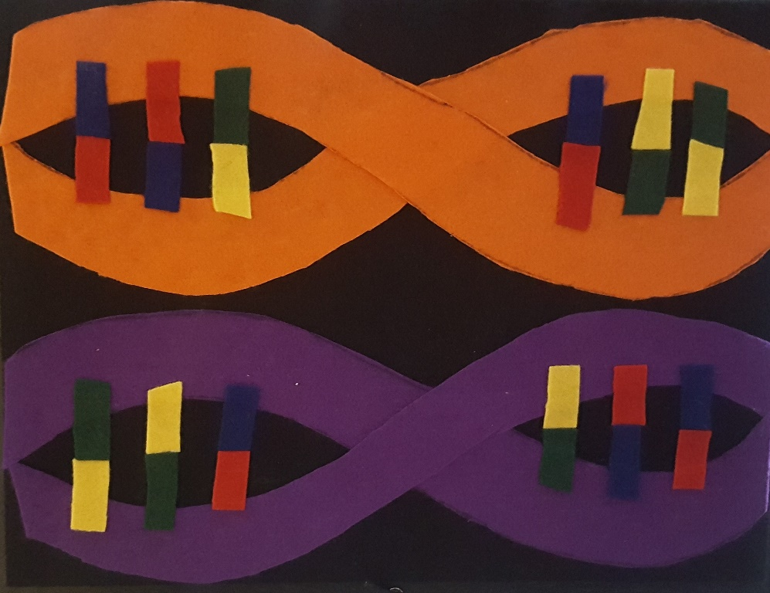
      - Make sure the board is flipped right side up. The nucleotides (red, blue, green, yellow pieces) should be in the following position:
      - The guide RNA student will translate the DNA sequence, which was found in the gene pool, to RNA (this can happen at any point prior to this moment; you can determine if you reveal this to the teams or not).
        - To determine where to place your DNA, this guide RNA student will use the DNA to RNA table to translate your DNA to the corresponding RNA sequence (this can happen as soon as you locate your DNA sequence in the gene pool).
DNA Nucleotides | RNA Pair
A - Adenosine | U – Uracil (replace T in RNA)
C - Cytidine | G – Guanine
T - Thymidine | A – Adenosine
G - Guanine | C - Cytidine

      - Once you have translated your sequence, show your teacher who will give you the 3-color RNA sequence. Record this color sequence.
        - Teachers, use the “DNA to RNA Translation” sheet to confirm they have translated the sequence correctly before giving them the target quadrant.
        - Using the “DNA to RNA Translation” sheet, give the guide RNA student the correct 3-color RNA sequence.
TEACHER CHEAT: Instead of requiring you to look for the correct color sequence, the board has also been divided into quadrants. The number in the “associated chromosome quadrant” column of the DNA to RNA translation sheet corresponds to the target quadrant. This arrangement is the same for both the transgenesis and genetic editing boards.
        - The quadrants are numbered as follows:
1 | 2
3 | 4
        - Example: if they chose the ethylene pathway, they need to land the ball in quadrant 3
  - Teams will then aim their DNA at that quadrant. Repeat until you successfully land on the chromosome in the correct quadrant.
- The students will then need to identify the corresponding 3-color DNA sequence using the table below. This will tell them where on the chromosome side to aim the DNA.
RNA COLOR | DNA PAIR COLOR
Blue | Red
Red | Blue
Yellow | Green
Green | Yellow

- The students will then throw the successful DNA strand(s) from step 3 until they land one in the target area.
- Once the students land a ball on the correct portion of the chromosome, they will call the teacher over to confirm whether the DNA was successfully replicated.
  - If they landed on the chromosome but aren’t in the correct quadrant, they have to repeat the entire process, beginning with relocating the genetic material. However, if they chose to land multiple balls in the nucleus in step 2, they can continue to use their remaining successful ball(s) to try to land in the correct spot. (for the sake of time, you can also allow teams to skip the search step and start from the chromosome step or you can allow the next team to take a turn).
  - If they landed in the correct quadrant of the chromosome, refer to your “Possible Outcomes” sheet to determine the outcome.
- Students will calculate their success rate: 1/(total number of balls thrown at all stages)
DISCUSS:
- Wrap up this activity with a class discussion focused on the differences between the two teams.
  - Emerging:
    - What is the success rate for the gene editing team?
    - What is the success rate for the transgenesis team?
    - Why are these two success rates so different?
  - Advanced:
    - What are some of the challenges that you faced when trying to insert new genetic material? (couldn’t get it inserted into the nucleus quickly, couldn’t get it into the right area of the chromosome; if it was inserted into the chromosome, it wasn’t taken up and replicated by the cell)
    - What are some ways that they could increase their success rates for the overall process? (throw more balls, have more cells on the board so the probability of getting the ball to stick to a cell is greater)
- If any of the teams chose the fusarium wilt option, ask the team to re-read the description of the gene (in the worksheet) and explain why they chose this gene to delay ripening. Explain that fusarium wilt is a disease caused by a fungus and that it is not involved in the ripening process of bananas. Discuss with students that sometimes scientists choose the wrong pathway or gene to modify. Although they can be successful in inserting this material into the chromosome, it doesn’t address the problem they were originally trying to solve (disease resistance is not equivalent to delayed ripening).
- Explain that this activity mimicked just one piece of the process of modifying the genetic material of an organism (inserting the new DNA into the cell). After inserting the material, scientists need to make sure that the new genetic material functions the way they wanted and doesn’t affect any other functionality of the plant.
  - Post-Insertion Overview
    - Discussion questions:
      - Emerging:
        - How do they create more plants with the gene after they have inserted it? (Cross the new plant back with itself, clip the plant and propagate from a clipping, clone the plant)
      - Advanced:
        - How many of the plants that had the new material inserted in them actually expressed the new trait? (Only a few – they suggest that of the few that had the new material inserted, fewer were able to grow in the selection material (petri dish with herbicide in it), which allows only those cells that had the new material and the herbicide resistance selection material inserted into them were able to grow.)
EXTENSION:
RESOURCES:
- Information about the various ways scientists can delay ripening in fruits, including banana.
  - https://www.isaaa.org/resources/publications/pocketk/12/default.asp
- CRISPR/Cas9 Overview
  - http://www.isaaa.org/resources/publications/pocketk/54/default.asp
Inside the Biotech Lab: How to genetically engineer a plant?
  - http://www.isaaa.org/resources/publications/insidethebiotechlab/download/InsideTheBiotechLab.pdf
NGSS/Common Core:

