Notes from SMILE Teacher Workshop (Winter 2018)

Challenges

Elementary
- Competition with sports
- Uncertainty of district funding
- Transportation for kids to get home
- Telling kids they can’t join they aren’t on grade level/don’t meet underserved needs
- Principal apathy
- Athletics and other activities that kids prioritize
- Long day!
- Waiting for parents to pick up kids (45 minutes this week)
- Parent trust
- Vying with sports program (basketball and cheerleading)
- Getting kids home
- Funds for field trips
- School meetings that conflict with SMILE
- Parents who don’t understand the program
- Unsupportive parents
- No time to prep
- Micromanaging administrators
- Limited experience outside of area
- Overscheduling limits activities

Middle School
- Sports and other activities draws kids away
- More hands on
- Diversity
- Too many after school options/sports
- Attendance issues – dropping out
- After school (lack of) energy
- Sports
- Storage
- SMILE teachers not confident in science
- Lack of administration support
- Attendance, especially after challenge day
- No elementary club
- No fun math lessons
- Lack of access to related field trips
- After school conflicts
- $

High School
- Ready to go activities
- Pre-planned activities
- Tired at the end of the day
- Too little time to put together materials /review lessons
- One more prep
- Coaches do not excuse club members to participate in meetings
- The road to college piece – needs to be better, more support and more activities
- SMILE teachers juggling multiple club/activities
- More physics
- Supplies and ideas (need more)
- Time
- Time
- $
- Sports schedule
- (Sports) Soccer season
- Kids committing to 67543 other clubs and sports
- Family cases (?) (students)
- Student family obligations
- Not enough math activities
- Travel distance

What works

Elementary
- Engaging activities
- Fun activities
- Teacher driven ideas
- Enthusiasm of the teachers
- SMILE support of teachers
- Support from OSU staff
- Treated as professionals
- Training from experts
- Community that feels safe
- Sense of family
- Believing all students are destined for success in college
- Students knowing it is okay to fail and try again
- Students feel safe to explore
- Feelings of community
- Food!!
- Having projects to share with kids
- Materials and lessons
- Kids who want to learn
- Excited kids willing to learn
- Tammi Talty
- Great students
- Pop Tarts
- Amazing teacher leaders
- PH 6 (picture of pteropod)
- Pteropods
- Genuine curiosity
- Small groups and two teachers
- Hands on fun activities
- FUN!
- I will find a way to help you!
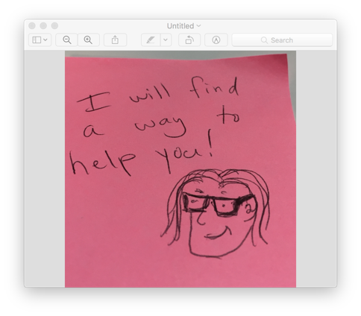

- Fish
- Units that build conceptual understanding
- Engaged lids
- Smart and engaged kids
- Instructional freedom
- Great kids! Teacher recommendations
- Team building
- Dedication!
- Great PD
- A pathway to college
- Outside resources like 4-H
- Outside -creeks
- Partnerships within the community 4-H
- Field trips and PD
- Working outside my specialty and learning from others
- Workshop ideas
- Great training
- Community w/other teachers + among kids
- SMILE budget to use as we see fit in our clubs
- Responsiveness of staff
- Support from SMILE staff
- Other SMILE teachers to bond with
- Archive of lessons on website
- Peace, love, care
- Everything
- The SMILEs (within a heart shape)
- The love (within a heart shape)
- Laughter
- The SMILES
- Workshops
- Exploration
- Hands-on
- Hands-on activities
- Team work
- FMSN
- Snacks and conversations
- Snacks
- Small groups

- Relationships
- Zoo overnight
- SMILE camp at 4-H center
- Field trips
- Conversations with SMILE leaders
- College visits
First year
- Being shown how we can use current/new knowledge to our lessons that are kid friendly
- Materials provided for clubs
- The flexibility to teach the lessons the students want
- Having/getting supplies and lessons provided

Middle School
- Busing
- On Wednesdays which is a late start day
- The students: Attendance, Enthusiasm, Willing to try!
- Our students wanting to belong to a special club
- 8th graders who returned from 6th and 7th
- Elementary pipeline
- Kids/students activities, Food, Us teachers
- Fun activities
- Team building activities (warm-ups)
- SMILE staff
- Workshops, Stipend
- Other opportunities for training (Sea Grant, Project Wild)
- SMILE, Snacks,
- Students’ motivation
- ME! Space, food, time, support, enthusiasm, advocating
- Posting activities beforehand
- A place where you can just experiment, try it out and people accept you. You don’t have to be perfect
- Consistency w/club advisors and routines that kids trust and feel safe with
- Different ways of learning
- Math and science
- Engineering
- Contact with college kids
- Collaborative work
- Good lesson plans on line
- Teachers’ time and dedication
- Kits
- Support from Admin
- SMILE program Team- Logistics, funding, support, kits

- Diversity (four quadrants)
  - OSU Support, $, $, Treats, Funding, Candy (money, hands on, place
to make friends, safety)
  - Students attending, Admin support, safe environment, We have a large after school club in place at our school – recruitment is ?
  - Building partnerships. Partner teacher, Relationships, Role models, Relationships, Relaxed atmosphere and focus on fun, hands on experiments, Personal, Trust
  - Relative activities to students, Engaging activities, Different activities, STEM, Curiosity, Interactive activities, Experiences, Competitions, Examples, More do, less talk
High School
- Julie’s organization
- Mr. ?
- 4-H and STEM Hub help
- Ideas from other SMILE teachers
- Accessibility
- Focal point of HS challenge event
- Feeder elementary and MS, advisors () do a great job w/the program
- Students willingness to take risks
- Students year-to-year memory of the club (culture)
- Low pressure environment
- Freedom to run the club for our specific students
- Accessibility
- Workshops, activities
- Supplies
- Engaging activities that keep the students interested
- Equipment from SMILE for the activities
- Tiffany Sagmiller is awesome (2nd ed)
- Being able to plan both independently as well as a community
- Great support from SMILE at OSU
- Supplies and ideas from OSU (more is good)
- Program support form employer
- Food
- Snacks
- Parents who encourage participation
- Excitement about challenge
- Trip to OSU as incentive
- Challenge experience
- SMILE norms
- SMILE student leaders
- Challenging activities
- Kids have a great attitude
- Science is fun
- Science and math in a no pressure, no grades environment
- Acceptance
- Curiosity
- Kids enjoy exploring

