Saving White City’s Air III: Wood to Electricity
(Advanced)

Objectives
- Understand how important steam is for generating and transporting heat from biofuels
- Understand how air pressure exerts force
- Differentiate the states of matter for water
- Estimate the volume difference between steam and water
- Apply the energy required to turn water into steam (specific heat of water, heat of vaporization, and heat of condensation
- Apply scientific concepts of air pressure and states of water to engineering designs

Skill Level: High school | Prep time: Minimal  Activity time: 20 minutes

Materials
- Ring stand
- Test tube
- Test tube tongs
- Long leather gloves
- Safety goggles
- One of the following heat sources:
  - Hot plate, with sand or oil bath
  - Heat gun (200 degree or higher)
  - Bunsen burner and wire gauze
- Large balloon (at least 11 inches in diameter when full)
- Distilled water

Next Generation Science Standards
Disciplinary Core Idea:
HS-ETS1.B: Developing Possible Solutions
HS-ETS1.C: Optimizing the Design Solution

Performance Expectations:
HS-PS3-3. Design, build, and refine a device that works within given constraints to convert one form of energy into another form of energy.
Practices  Asking questions / defining problems  Developing / using models  Planning / carrying out investigations  Analyzing / interpreting data  Math / computational thinking  Constructing explanations / design solutions  Engaging in argument from evidence  Obtaining / evaluate / communicate | Practices  Asking questions / defining problems  Developing / using models  Planning / carrying out investigations  Analyzing / interpreting data  Math / computational thinking  Constructing explanations / design solutions  Engaging in argument from evidence  Obtaining / evaluate / communicate

Background Information
Wood is a bioenergy source that has been use by humans since the dawn of civilization. We have relied upon wood to heat our homes and cook our food in almost every culture. However, it is sometimes more useful to convert wood into a different form of biofuel for a specific purpose. Wood can be converted into a solid (char or charcoal), liquid (bio-oil) or gas (synthesis gas). Without conversion, wood can have a low energy density and can be difficult to transport.
Wood can be converted into other biofuels using four thermal conversion methods (Carbonization, pyrolysis, gasification, and combustion). When wood is burned for fuel, it goes through a multi-step process of breakdown and then combustion. None of this can happen without adding heat to the wood. As we all know, we can’t light a piece of paper without first adding a small amount of heat from a match or lighter.
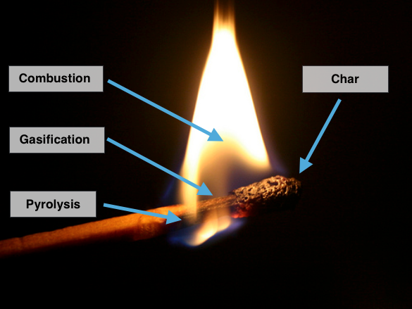
Figure 1. Thermal conversion in a simple match Photo Ref
The earliest method to modify wood into a higher density fuel was to make charcoal. Charcoal is made when wood is heated to a low temperature without oxygen. Charcoal burns very cleanly and produces more heat energy per mass than wood. Char (similar to charcoal) is the black material left after a match burns.
Another way to convert wood into a more-useful energy source is to make bio-oil out of it through a process called pyrolysis. Heating wood without oxygen creates pyrolysis vapors that condense into a liquid. The resulting alternative fuel is easy to burn and the bio-oil can be transported efficiently, although it can’t be directly burned in cars. It can be burned for electricity generation and heat. You can sometimes see a sticky, black oil at the base of a match flame. This is bio-oil and it can be captured for processing into an upgraded cleaner substance.
Another way to convert wood is to heat it with a small amount of oxygen in a process called gasification. This generates a burnable gas (also called synthetic gas or syngas) that can be burned in a generator for electricity. In a match, it is primarily gasification that creates the gasses that are burned in the flame.
Finally, wood can be burned directly – through combustion. During combustion, gases are burned to generate heat and smoke. If wood is used to generate steam, it can be burned in a boiler without any conversion. The steam can be used for heat in homes or factory processes or to turn a turbine.
In situations where steam is not needed, one of the other forms of biofuel might be more appropriate. Charcoal can be transported more easily than wood and was used to power cars in World War II. Bio-oil and syngas can be piped to generator engines, where solid wood cannot. It can also be more efficient to convert the wood into another product before burning it. While thermal conversion processes were invented for over 100 years ago (the first gas lamps were fueled by wood gas) they still have their place in a comprehensive energy strategy today. No one biofuel is lkely to solve our energy challenges on its own.
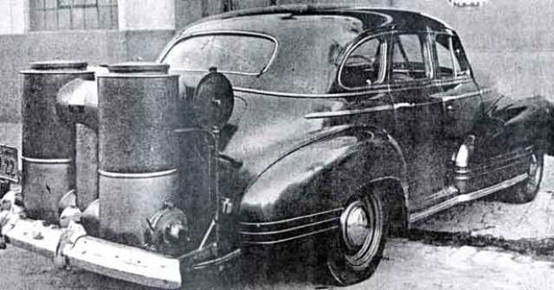
Figure 2. Gasifier installed on a vehicle during the 1940’s Ref
New technologies are making these processes even more efficient and producing fewer waste products. It is even possible that we might drive cars powered by a derivative of bio-oil or syngas in the future.
Biofuel Thermal Conversion Summary
- Carbonization (Low heat, no oxygen) – Produces charcoal
- Pyrolysis (Medium heat, no oxygen) – Produces bio-oil
- Gasification (Medium heat, low oxygen) – Produces synthesis gas, syngas
- Combustion (High heat, high oxygen) – Produces heat, soot, and smoke

Steam has been used for thousands of years to power devices. Hero of Alexander, an early Greek scientist and philosopher, described the first steam engine in the first century AD. Although his steam engine was more of a novelty than a device to perform serious work, it demonstrated that steam could be harnessed for human purposes.
In the 1700’s and 1800’s steam became the workhorse behind many engines of the industrial revolution. Engines using steam powered mine pumps, locomotives and factories. Steam engines were popular because they could operate on just about any fuel source then available such as coal and firewood. As new fuels became available in the early 1900’s (gasoline and diesel) the steam engine lost popularity as a driver of technology. That does not mean that steam is no longer used today, however. Steam is used today to generate power in nuclear reactors, natural gas, and coal plants. Because steam can be generated from many heat sources, steam turbine systems are common in the alternative energy field where they generate electricity from solar, geothermal, and biofuel sources. In the bioenergy field, fuel sources include bio-gas, sawdust, wood pellets, hog fuel and even municipal solid waste are used to create steam.
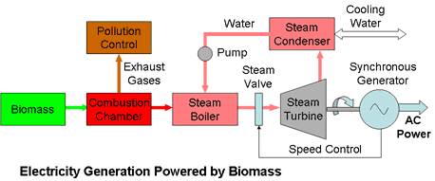
Figure 2. Typical schematic of a biomass power generation system. Ref
This activity explores using combustion to turn biomass, like the White City wood chips, into electricity. In a typical power generation system (see Figure 2) biomass is carried on a conveyor into a boiler that burns the fuel and turns water into steam. The large expansion of steam (as shown in the demo below) is sent at high pressure into a steam turbine. The spinning blades power an AC generator that delivers electricity to the power grid. After exiting the steam turbine, the steam is sent to a condenser where it turns back into water. It is important to recycle the water because it is very pure and difficult to get, and this process uses large quantities of water that would be wasted into the environment. Students will design a simple model of a biomass steam turbine plant that includes all these components. Figure 3 below shows a diagram of a 20-megawatt biomass boiler, similar to what could be installed in White City.
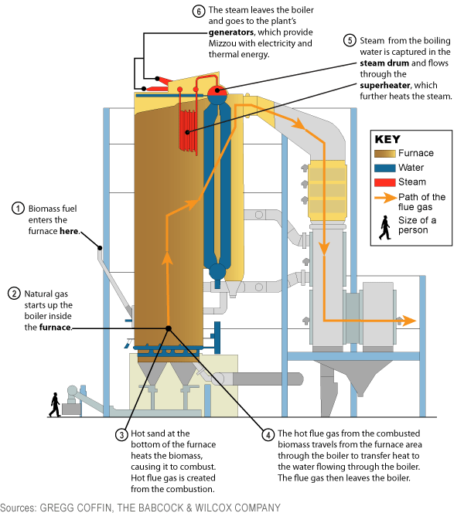
Figure 3. Biomass Boiler that turns wood into steam. Ref

Engage
The following true story is to provide a context for the demo and design project in this activity.
White City, Oregon has a problem – they are drowning in wood chips. This sleepy town of 5,000 people had (in 2013) the distinction of having one of the largest piles of wood chips in the state of Oregon. Biomass One, a power generation company, opened their land to accept wood chips from nearby wood companies.
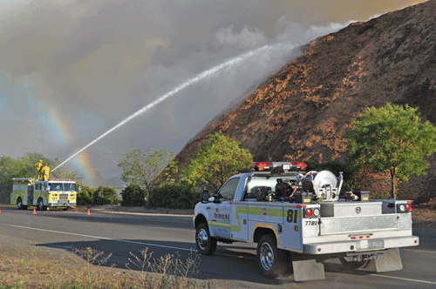
Figure 1. Wood chip pile in White City, Oregon. Ref
The community responded and has continued to bring wood chips and bark. They burn the wood chips to generate electricity, but their facility isn’t able to run all the time. Over the years, the company has struggled to process the chips to keep up with the supply of wood, causing the chip pile to grow. In 2013, the wood chip pile covered about five football fields (6 acres) to a depth of about 40 feet and weighed 130,000 tons. As the pile has gotten older, bacteria have begun degrading the wood and causing heat. In the summer, hot temperatures cause the interior of the pile to get to hot that it often bursts into flames. In addition to the potential loss of the pile, the fires threaten nearby buildings and often cover the town in a blanket of choking smoke. Help the town of White City and Biomass One develop a way to use this immense pile of wood chips to generate more electricity for the town.
Students need to understand how important steam is to energy production in the United States. Recounting the history of steam usage (from the background section) will set the stage for this discussion. Understanding the properties of steam will allow students to design a boiler system that can recycle the steam generated.

Explore
Experimental Questions:
- How much steam can be generated from one mL of water?
- How could this expansion be harnessed?
- How could this steam be recycled after it powers a turbine?

Procedure:
- Fill a test tube with 1 mL, 2 mL and then 3 mL of distilled water (more than 1 mL could pop the balloon).
- Mark the 1, 2, and 3 mL lines on the beaker.
- Blow up two balloons a couple times and let the air back out (this pre-stretches the balloon).
- Attach one of the balloons to the top of the test tube (the second one is a spare).
- Attach the test tube to the ring stand so the base can be heated with the heat source.
- Apply heat to the bottom of the test tube (using the gloves) with the heat source. Take care not to bring the heat source in contact with the balloon, your skin or any flammable material.
- Allow the balloon to expand to its maximal size (this should be about 10 inches).
- Remove the balloon from the heat source as soon as the water has completely boiled.
- Measure the maximum size of the balloon.
- Estimate the volume of water that has been turned into steam by using the lines draw in 2) above.
- Allow the balloon to cool and contract.

Explain
- Ask the students to work in pairs to estimate the volume increase of the water as it turns from a liquid into a gas. They can use the volume of starting water and the equation for the volume of a sphere (4/3πr3) to complete this estimation. The expansion should be about a 500x increase.
- Ask the students to determine the theoretical expansion of water when it turns into steam. They can use the idea gas law equation, PV = nRT figure this out (if they are familiar with it).
  - Start with one mole of water (18 cc or .018 liters) to make the calculation easier.
  - The equation can be rearranged to yield V=nRT/P
    - V (volume) = unknown
    - n (number of molecules) = 1 mole
    - R (gas constant) = 8.314 J/K-mol
    - T (temperature in Kelvins) = 372 K (at boiling point)
    - P (pressure in kilopascals) = 101 kpa
  - Using the values above yields V = 30.6 l of steam.
  - Dividing 30.6 l by .018 l of water we started with gives 1705
  - Water expands 1705 times (ideally) when it is converted from liquid to gas
- Ask the students why the balloon didn’t reach the ideal volume? Often some students will have seen condensation on the inside of the balloon before the heat is removed.
- Why did the water take so much time to convert from liquid to gas? Discuss concept of heat of vaporization. Water requires a large amount of heat to bring it to boiling (310 J/g) and (2260 J/g) to vaporize it.
- What problems might an engineer have when boiling water for a steam turbine?
- A large amount of water is wasted if the steam is allowed to escape after it is used by a steam turbine. How could this water be captured and recycled?
- What problems would an engineer have when trying to get the steam to condense back in to liquid? Help students understand that the same heat required to turn water into steam is required to be removed to turn it back into water. 2260 J must be absorbed by the surroundings to turn 1705 cc of steam into 1 cc of water.

Resources
Additional Resources:

- Proper heating of test tubes – CRS Scientific
- Heat of vaporization – Kent Chemistry
- Energy content in various biofuel feedstocks
- Biomass Boilers
- How does a condenser work? -- GEA

Resources Used:
- How to get steam into a balloon – eHow
- The magic of steam – Boys and Girls Science and Tech Club

