Saving White City’s Air I: Wood to Electricity

Objectives
- Differentiate thermal conversions of wood (pyrolysis, gasification, combustion)
- Understand the uses for each thermal conversion product.

Skill Level: Middle school | Prep time: Minimal  Activity time: 20 minutes

Materials
- Candle
- Matches

Next Generation Science Standards
Disciplinary Core Idea:
MS-ETS1.B: Developing Possible Solutions
MS-ETS1.C: Optimizing the Design Solution
Performance Expectations:
MS-PS1-6. Undertake a design project to construct, test, and modify a device that either releases or absorbs thermal energy by chemical processes.
Practices  Asking questions / defining problems  Developing / using models  Planning / carrying out investigations  Analyzing / interpreting data  Math / computational thinking  Constructing explanations / design solutions  Engaging in argument from evidence  Obtaining / evaluate / communicate | Crosscutting Concepts  Patterns  Cause and effect: Mechanism / explanation  Scale, proportion, and quantity  Systems and system models  Energy / matter: Flows, cycles, conservation  Structure and function  Stability and change

Background Information
Wood is a bioenergy source that has been use by humans since the dawn of civilization. We have relied upon wood to heat our homes and cook our food in almost every culture. However, it is sometimes more useful to convert wood into a different form of biofuel for a specific purpose. Wood can be converted into a solid (char or charcoal), liquid (bio-oil) or gas (synthesis gas). Without conversion, wood can have a low energy density and can be difficult to transport.
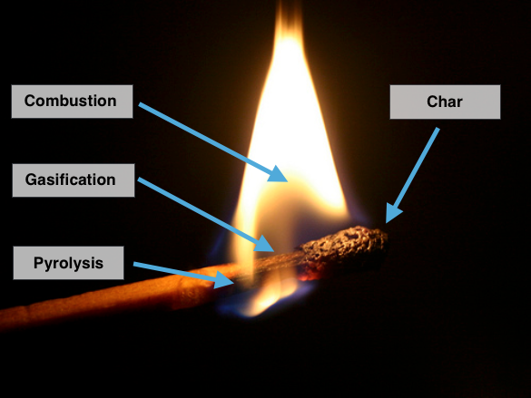

Wood can be converted into other biofuels using four thermal conversion methods (Carbonization, pyrolysis, gasification, and combustion). When wood is burned for fuel, it goes through a multi-step process of breakdown and then combustion. None of this can happen without adding heat to the wood. As we all know, we cannot light a piece of paper without first adding a small amount of heat from a match or lighter.
Figure 1. Thermal conversion in a simple match Photo Ref
The earliest method to modify wood into a higher density fuel was to make charcoal. Charcoal is made when wood is heated to a low temperature without oxygen. Charcoal burns very cleanly and produces more heat energy per mass than wood. Char (similar to charcoal) is the black material left after a match burns.
Another way to convert wood into a more-useful energy source is to make bio-oil out of it through a process called pyrolysis. Heating wood without oxygen creates pyrolysis vapors that condense into a liquid. The resulting alternative fuel is easy to burn and the bio-oil can be transported efficiently, although it cannot be directly burned in cars. It can be burned for electricity generation and heat. You can sometimes see a sticky, black oil at the base of a match flame. This is bio-oil and it can be captured for processing into an upgraded cleaner substance.
Another way to convert wood is to heat it with a small amount of oxygen in a process called gasification. This generates a burnable gas (also called synthetic gas or syngas) that can be burned in a generator for electricity. In a match, it is primarily gasification that creates the gasses that are burned in the flame.
Finally, wood can be burned directly – through combustion. During combustion, gases are burned to generate heat and smoke. If wood is used to generate steam, it can be burned in a boiler without any conversion. The steam can be used for heat in homes or factory processes or to turn a turbine.
In situations where steam is not needed, one of the other forms of biofuel might be more appropriate. Charcoal can be transported more easily than wood and was used to power cars in World War II. Bio-oil and syngas can be piped to generator engines, where solid wood cannot. It can also be more efficient to convert the wood into another product before burning it. While thermal conversion processes were invented for over 100 years ago (the first gas lamps were fueled by wood gas) they still have their place in a comprehensive energy strategy today. No one biofuel is likely to solve our energy challenges on its own.
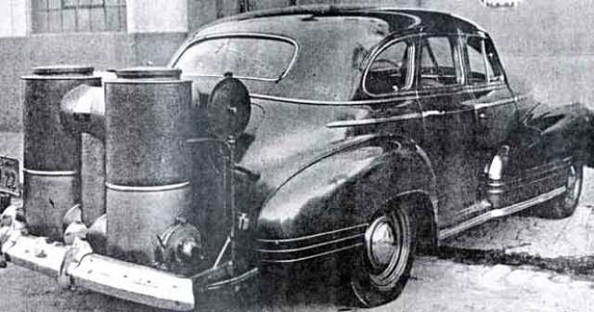
Figure 2. Gasifier installed on a vehicle during the 1940’s Ref
New technologies are making these processes even more efficient and producing fewer waste products. It is even possible that we might drive cars powered by a derivative of bio-oil or syngas in the future.
Biofuel Thermal Conversion Summary
- Carbonization (Low heat, no oxygen) – Produces charcoal
- Pyrolysis (Medium heat, no oxygen) – Produces bio-oil
- Gasification (Medium heat, low oxygen) – Produces synthesis gas, syngas
- Combustion (High heat, high oxygen) – Produces heat, soot, and smoke

Students observe a match burning in this activity to learn about the types of thermal conversion processes. Although a match appears to be a simple process, the chemical processes that occur can be used to turn biofuels into useful energy.

Engage
The following true story is to provide a context for the demo and design project in this activity.
White City, Oregon has a problem – they are drowning in wood chips. This sleepy town of 5,000 people had (in 2013) the distinction of having one of the largest piles of wood chips in the state of Oregon. Biomass One, a power generation company, opened their land to accept wood chips from nearby wood companies.
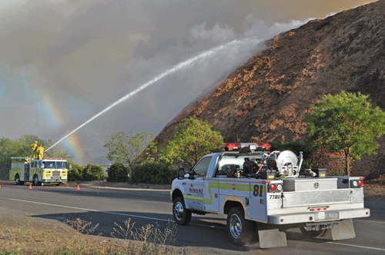
Figure 1. Wood chip pile in White City, Oregon. Ref
The community responded and has continued to bring wood chips and bark. They burn the wood chips to generate electricity, but their facility isn’t able to run all the time. Over the years, the company has struggled to process the chips to keep up with the supply of wood, causing the chip pile to grow. In 2013, the wood chip pile covered about five football fields (6 acres) to a depth of about 40 feet and weighed 130,000 tons. As the pile has gotten older, bacteria have begun degrading the wood and causing heat. In the summer, hot temperatures cause the interior of the pile to get to hot that it often bursts into flames. In addition to the potential loss of the pile, the fires threaten nearby buildings and often cover the town in a blanket of choking smoke. Help the town of White City and Biomass One develop a way to use this immense pile of wood chips to generate more electricity for the town.
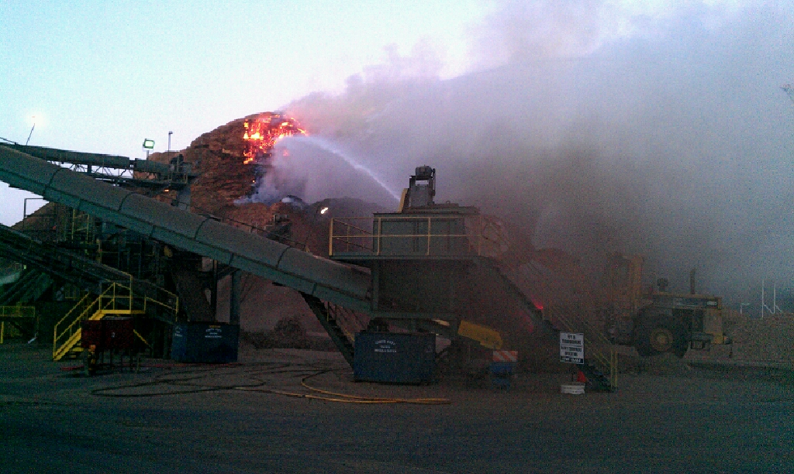
Figure 2. Fire burning at White City, Oregon wood chip pile. Ref

Explore
Experiment Questions:
- Describe what you observe when a match burns.
- How can we harness the process of burning wood to generate biofuels and electricity?

Procedure:
- Ask the students get a piece of paper and something to write with.
- Stand in a location where every student in the class can see you.
- Ask the students to write down everything they observe during the demonstration.
- Light the match, holding it horizontal. Allow it to burn to the end before extinguishing.
- Give the students time to write their observations.
- Ask the students to talk about their observations in pairs.
- Conduct a class discussion about what they observed. Probe regarding other senses than sight.
- Discuss the different types of thermal conversions (see Figure 1). Don’t tell the students how these conversions might apply to the match.
- Burn the match again and ask them to apply their new knowledge to the burning match. Where might these processes occur?
- Ask the students to talk about their observations in pairs.
- Conduct a class discussion about what they observed. Tie their observations to the three types of thermal conversions

Explain
- What have the students learned about observation through the demo?
- How might these thermal conversion processes be related to the creation of coal, oil, and natural gas?
- What do you think is happening to the molecules of wood during the conversion process? Is this a chemical change or a physical change?
- What are some of the advantages of converting wood to bio-oil or bio-gas?
- What type of plant would need to be created to perform this conversion on a large scale?

Resources
Additional Resources:

- Bioenergy conversion technologies
- Bioenergy conversion technologies list
- Bioenergy conversion types
- Pyrolysis processes
- Gasification
- Sawdust combustion boiler / water heater
- Biomass One catches fire in White City -- YouTube
- Biomass bark pile ignites again – Mail Tribune
- Build a bio-gas stove

Resources Used:
- Elementary Engineering Design Process – Boston Museum of Science

