Hydraulics with Syringes

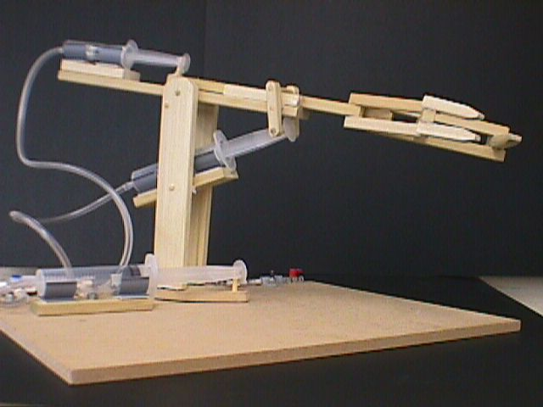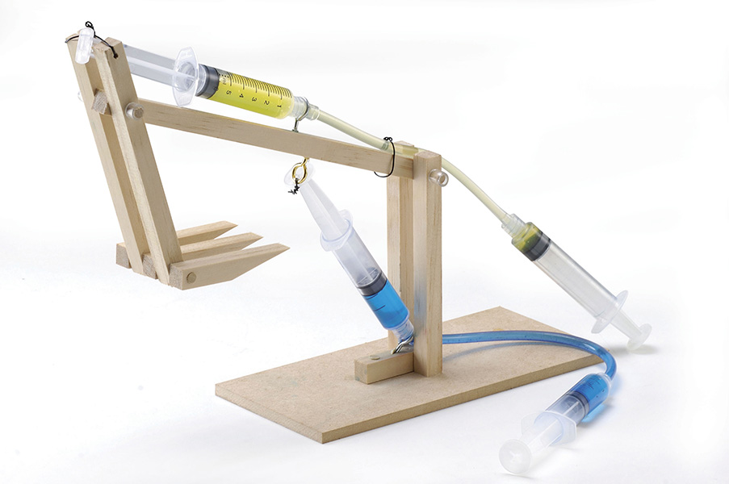

Time needed: 1 hour  Goal: Create a functional mechanical arm that uses hydraulic systems to operate. | Materials needed:  - Plastic syringes – 1 cc, 5 cc, 10 cc, 20 cc, and 60 cc  - Plastic tubing  - Cardboard, poster board, wood scraps, or other sturdy materials to construct arm  - Scissors or Exacto knife to cut cardboard or poster board (students may need assistance with this)  - Binder clips or brass brads (for use with cardboard and poster board)  - Bolts, nuts, screws, and washers (for use with wood or other harder materials)  - Hot glue gun  - Popsicle sticks  - Dixie cups  - Water dyed with different colors  - Duct tape  - Other items that may be useful to students’ designs (rubber bands, dowels, etc.)  - Ping pong balls

Introduction: In this activity, students will gain an understanding of how hydraulic systems work by building a mechanical arm using syringes, tubing and water to create a hydraulic system. They will explore how different forces can be transmitted to perform work, and discover how to make their design efficient.

Background: Hydraulic systems are commonly used in many every day applications. Car brakes, airplane wheels, tire jacks, log splitters and various pieces of heavy construction equipment all utilize hydraulic systems in order to perform work. Hydraulic systems are also used in situations that are too difficult or dangerous for people to deal with directly or in automated systems.

How do hydraulic systems work? The basic idea behind hydraulics is that force is applied at one point, and that force is then transmitted to another point using an incompressible fluid. This incompressible fluid is nearly always oil. Hydraulic systems allow users to perform tasks that involve large amounts of weight. Without these systems, the user would not have the strength to complete the task.

In many hydraulic systems, the concept of hydraulic multiplication is integrated to make the system even more effective. Hydraulic multiplication involves trading force for distance in a system. For example, imagine that you have two pistons of differing surface areas. The smaller of the pistons is engaged and forces the incompressible fluid into the piston with the greater surface area. The larger piston is able to multiply the force exerted by the smaller piston over its surface area. This allows the user to engage the system with little effort, but still deliver a tremendous amount of force.

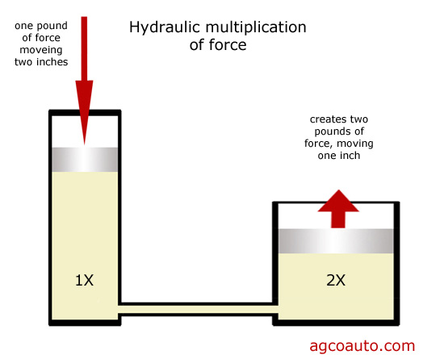

Challenge: Using the materials provided, build a mechanical arm that uses hydraulic systems to operate different joints of the arm. The arm should be able to pick up and move a ping-pong ball either by pinching/grasping it or scooping it up.

Procedure:
- Using two syringes, water, and a piece of plastic tubing, demonstrate to students how a hydraulic system works.
- Divide the class into groups of 3 or 4 students each. Let the students know that they will be compiling a “portfolio” of sketches, design ideas, notes, and a summary for presentation at the end of the project.
- Have each group brainstorm the necessary components of the mechanical arm and make at least 3 sketches of possible design ideas. If they are struggling to come up with ideas, you can show them photos of similar mechanical arms or they can research photos. Here is a link to a great video showing a very simple hydraulic arm: http://www.youtube.com/watch?v=GSNXQGEu2ew#t=58. For an example that is a bit more complex, this video is excellent: http://www.youtube.com/watch?v=Qeg0y5AAmtI.
- Once the students have made their sketches, they should construct and test their mechanical arm. In their tests, they should note changes, modifications, and failures and successes on their sketches.
- Encourage students to think about designs that would fail, and how they can prevent failures. What do they need to do to create a stable, efficient arm that can complete the challenge?
- Allow students to redesign, reconstruct, and retest their designs. Once they have finalized their design, have them compile a brief summary of their design and construction process, including documenting their failures and thoughts about how to improve their design.
- Give the students time to compile the pieces of their portfolio. They will then present their finished hydraulic arm to the other groups and discuss their design and building process.

Ponder this:
- What went well in your design process?
- What could you have done differently?
- How did you determine if your design would fail or succeed?
- Describe one part of your arm that you had to redesign.
- Did you borrow any ideas from preexisting designs that you researched, or from any of the other groups?
- If you had more time and/or different materials, what would you have done differently?

Extensions:
- To make the arms more precise and intricate, experiment with using more syringes in the design.
- Try picking up heavier objects with the arm, such as empty soda cans or golf balls, or smaller objects, such as coins or cotton balls.
- Challenge students to make something different using hydraulic systems. For example, some folks made a scorpion: http://www.youtube.com/watch?v=xrYJWXoOOtk
- It’s easy to look at tractors and construction equipment to see where hydraulic systems come into use. Have students brainstorm where hydraulic systems are also used – car brakes, elevators, airplane wheels and wing flaps, torpedo tubes on submarines, crane arms, hoists and lifts, flight simulators, machine tool drives

Next Generation Science Standards

Disciplinary Core Idea:
ETS1.A: Defining and Delimiting Engineering Problems
ETS1.B: Developing Possible Solutions
ETS1.C: Optimizing the Design Solution
Performance Expectations:
MS-ETS1-2. Evaluate competing design solutions using a systematic process to determine how well they meet the criteria and constraints of the problem.
MS-ETS1-4. Develop a model to generate data for iterative testing and modification of a proposed object, tool, or process such that an optimal design can be achieved.
HS-ETS1-2. Design a solution to a complex real-world problem by breaking it down into smaller, more manageable problems that can be solved through engineering.

Practices  Asking questions / defining problems  Developing / using models  Planning / carrying out investigations  Analyzing / interpreting data  Math / computational thinking  Constructing explanations / design solutions  Engaging in argument from evidence  Obtaining / evaluate / communicate | Crosscutting Concepts  Patterns  Cause and effect: Mechanism / explanation  Scale, proportion, and quantity  Systems and system models  Energy / matter: Flows, cycles, conservation  Structure and function  Stability and change

Background Resources:

http://www.teachengineering.org/view_activity.php?url=collection/wpi_/activities/wpi_hydraulic_arm_challenge/wpi_hydraulic_arm_challenge.xml

http://science.howstuffworks.com/transport/engines-equipment/hydraulic.htm

